Name: _______________________________

Gangs of New York

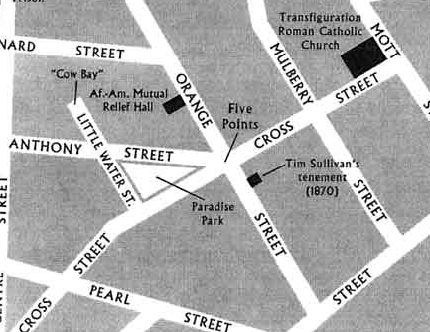
Reputation of the Five Points:
It is virtually impossible to overstate how notorious the lower Manhattan neighborhood called the Five Points was throughout the 1800s. It was said to be the roost of gang members and criminals of all types, and was particularly known as the home turf of flamboyant gangs of Irish immigrants.

The Location Provided the Name Five Points:
The Five Points took its name because it marked the intersection of three streets, Anthony, Cross, and Orange, which came together to form an irregular intersection with five corners. In the past century the Five Points has essentially disappeared, as streets were redirected and renamed. And modern office buildings and courthouses were constructed on what had been a slum known around the world. The Five Points, in the mid-1800s, was known primarily as an Irish neighborhood. The public perception was that the Irish, many of whom were fleeing the Great Famine, were criminals. And the appalling slum conditions and pervasive crime of the Five Points only contributed to that attitude. While the neighborhood was predominantly Irish in the 1850s, there were also African-Americans, Italians, and various other immigrant groups.

Shocking Conditions Prevailed in the Five Points:
Reform movements of the mid-1800s spawned pamphlets and books detailing horrendous urban conditions. And it seems that mentions of the Five Points always figure prominently in such accounts. It's hard to know how accurate the lurid descriptions of the neighborhood are, as the writers generally had an agenda and an obvious reason to exaggerate. But accounts of people essentially packed into small spaces and even underground burrows seem so common that they are probably true. A large building which had been a brewery in colonial times was a notorious landmark in the Five Points. It was claimed that up to 1,000 poor people lived in the "Old Brewery," and it was said to be a den of unimaginable vice, including gambling and prostitution and illegal saloons. The Old Brewery was torn down in the 1850s, and the site was given over to a mission whose purpose was to try to help neighborhood residents.

Famous New York Gangs Called the Five Points Home:
There are many legends about street gangs which formed in the Five Points. The gangs had names like the Dead Rabbits, and they were known to occasionally fight pitched battles with other gangs in the streets of lower Manhattan.

Main Characters
- Amsterdam Vallon (Leonardo DiCaprio)- Main character in the movie whose father was killed by “The Butcher.”
- Bill “The Butcher” Cutting (Daniel Day-Lewis)- The man heading the American Party that is strongly opposed to immigrants. He and his gang (party) does the dirty work for William Marcy “Boss” Tweed.
- Jenny Everdeane (Cameron Diaz)- A street smart woman who lives in the Five Points.
- William “Boss” Tweed (Jim Broadbent)- He was the political boss of New York City in the 1860s. His headquarters, located on East 14th Street, was known as Tammany Hall. He fixed elections, controlled the city's mayor, and rewarded political supporters. His primary source of funds came from the bribes and kickbacks that he demanded in exchange for city contracts.
- Happy Jack Mulraney (John C. Reilly)- the police officer who is responsible for collecting the taxes.
Historical Inaccuracies in Gangs of New York

- When Monk’s funeral procession is going down the street, the dog on Bill’s porch appears to be a Doberman. This dog breed did not exist until the 1890s.
- The prayer said at the beginning of the movie (“Saint Michael, the Archangel, defend us in battle…” was composed by Pope Leo XIII in 1884. The movie is set in the 1860s.
- In the scene where Bill is throwing knives at the girl on stage, right after he comes off the stage a flag drops. The flag has 50 stars on it.
- At the end of the movie, you see a skyline picture of New York which highlights the World Trade Center Towers. These towers are not in the right location. They are too close to the Brooklyn Bridge.

