Name: ________________________________
US History on Film

Base your answers to the following questions on Steven Spielberg’s movie, Saving Private Ryan, starring Tom Hanks, Edward Burns, Matt Damon, and Tom Sizemore.

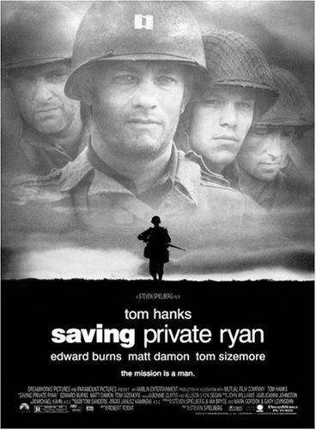
- Why was it so important to the military officers to find Private Ryan and to bring him home?

- Give THREE examples demonstrating Captain Miller’s (Tom Hanks) leadership characteristics.

- Why did Captain Miller decide to let the German solider go free? Explain.

- Why were some of the US soldiers resentful towards Private Ryan?

- The Second World War saw the introduction of new technology in warfare. List three new pieces of military technology and explain their purpose/significance to warfare.
New Technology | Significance

- What did Corporal Upham mean when he said, "War educates the senses, calls into action the will, perfects the physical constitution, and brings men into such swift and close collision in critical moments that man measures man.” Explain.

