Name:____________________________ Date:___________

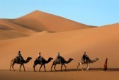
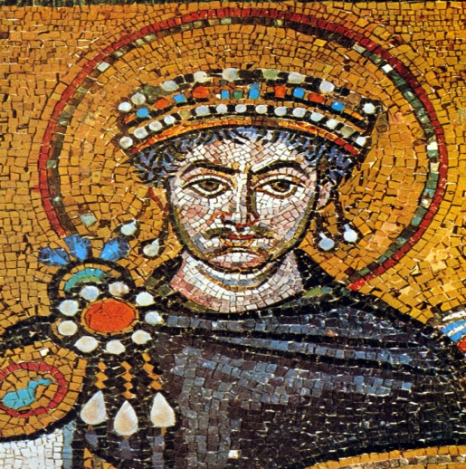
Unit 7: The Byzantine Empire
&
West Africa

Essential Question: How do regional and global trade networks impact world cultures?

SECTION 1: THE BYZANTINE EMPIRE:
- Justinian’s Code: Code of laws created by Emperor Justinian; based off of the Roman Twelve Tables of Law. It is still used in some form by international law today.
- Autocrat: A sole ruler with complete authority.
- Icons: Conventional religious images.
- Mosaics: Pictures or decorations made of small, usually colored pieces of stone or glass.
- Schism: A formal division in, or separation from, a church or religious body.
- Czar: Russian Emperor. From the word: Caesar.
- Hagia Sophia: A great architectural monument built during the Byzantine Empire; means “Holy Wisdom.” Began as a church, later became a mosque.
- Emperor Constantine: Roman Emperor who rebuilt the Greek city of Byzantium renaming it Constantinople. From this “New Rome,” roads fanned out from the Balkan region of South East Europe to the Middle East and North Africa. In time, the eastern Roman Empire became known as the Byzantine Empire with Constantinople as its capital.
- Constantinople: Capital of the Byzantine Empire; center of trade.
- Eastern Orthodox Christianity: Of or consisting of the Eastern churches that form a loose federation according primacy of honor to the patriarch of Constantinople.

SECTION 2: WEST AFRICA
- Ghana, Mali, and Songhai: Ancient African Empires, known for their extensive trade in gold and salt along the trans-Saharan trade route.
- Sahara Desert: World’s hottest desert, third largest desert in the world.
- Desertification: A type of land degradation in which a relatively dry land region becomes increasingly arid, typically losing its bodies of water.
- Bantu: A family of Niger-Congo languages spoken in central and southern Africa. The Bantu population migrated to parts of south Africa over time.
- Great Rift Valley: Located in Africa, where it is believed that early humans first originated.
- Mansa Musa: Became a great emperor and expanding his kingdom; converted to Islam; brought Muslim influence back to Mali after making the Hajj.
- Timbuktu: During the Mali Empire, Timbuktu became a great trade city and center for learning. It is located on the Niger River.
- Ibn Battuta: A Moroccan scholar and traveler who is known for the accounts (journals) of his travels, and his excursions to Africa (Mali Empire), India, and other parts of Asia.
- Kinship: The state or fact of being kin- connected by blood; family.
- Slash and Burn Agriculture: A farming method in which people clear fields by cutting and burning trees and grasses, the ashes of which serve to fertilize the soil.

