Chapter 11: OVERVIEW OF CHEMICAL EVIDENCE

Learning Goals and Objectives

* What is quantitative & qualitative chemical analysis
* What are the key questions in deciding upon a particular analytical method
* What is meant by precision & accuracy in a measurement
* What is the SI system of measurement and how do significant figures work
* What are the basic concepts underlying modern atomic theory
* What is the Law of Conservation of Mass
* How are balanced chemical reactions employed in analytical chemistry
* What is the mole and how is it used
* What are the chemical and physical properties of matter
* What are mixtures and how are their components separated
* How does chromatography work
* What is meant by chemical (classical) analytical methods
* How do gravimetric and volumetric analyses work

**11.1: OVERVIEW OF CHEMICAL EVIDENCE**

What is *analytical chemistry*?

What processes are used to accomplish the goals of analytical chemistry?

Read Pg. 11.4. List at least 5 uses of analytical chemistry.

**11.2: METHODS IN ANALYTICAL CHEMISTRY**

PRELIMINARY QUESTIONS THAT MUST BE ANSWERED TO DETERMINE THE BEST ANALYTICAL METHOD:

1) Is the technique qualitative or quantitative?

Define *qualitative:*

Define *quantitative:*

*Describe some examples of qualitative & quantitative analysis in forensics:

2) What sample size is needed?

*Describe the variation in sample sizes required to complete an analysis.

3) What type of sample preparation is required?

*Sometimes a sample can’t be analyzed as-is from the crime scene. What is a common sample

preparation that must be completed before analysis?

4) What is the level of analysis required? *How ______________________ of a determination is needed.*

5) What are the detection limits (analytical concentrations of the method? *What is the lowest concentration that can be detected.*

*Example: Examining a bullet –

6) Is the technique destructive or non-destructive?

*If analysis is preformed on the painting, *Mona Lisa,* what type of technique is required?

7) Is the instrument available?

*Because of maintenance, staff and monetary restraints, certain labs may not have the equipment

necessary. What could be done in this situation?

8) Is it admissible in court? *Is the technique & data obtained from it admissible in court. Several consideration must guide the selection of analytical techniques:*

1. The technique must provide ___________________ and ___________________ information.

* Must be ______________________ rather than prejudicial.

For example: Examination of a lead pipe:

1. Analytical techniques must meet the requirements of either the _______________ or

_____________________ standard.

9) Cost of the analysis? *Depending on the case, an expensive test may not be justified.*

10) Are there any interferences expected? *Will a substance interfere with the results of the test?*

*Example: The Marsh test –

11) How are analytical results verified?

*Why is it ideal to be able to verify results using chemical methods & spectroscopic methods?

Define *presumptive test:*

Define *confirmatory test:*

Define *analyte:*

**11.3 : ATOMS, MOLECULES AND SEPARATION SCIENCE**

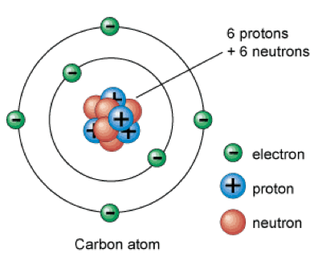

Nucleons:

What part of the atom is extremely dense?

___________________________

|  |  |  |  |
| --- | --- | --- | --- |
| PARTICLE | MASS | CHARGE | LOCATION IN ATOM |
|  |  |  |  |
|  |  |  |  |
|  |  |  |  |

Atomic Number:

Atomic Mass:

*Atomic Mass Unit:

In a neutral atom the number of protons & electrons are _________________________________. This will make the overall charge ‘zero’.

Cation: An atom with _________________________ electrons than protons.

*Has a _____________________________ charge

Anion: An atom with _________________________ electrons than protons.

*Has a _____________________________ charge

Elements:

*For atoms to be from the same element, they all must have the same number of _________________

Periodic Table of Elements:

Organized by increasing

__________________________.

Isotopes:

Shorthand/Notation for isotopes:

Example –

Carbon with masses of 12 & 14

Molecules & Compounds: Why are the following two molecules considered to be *isomers*?

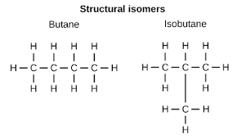

Conservation of Mass:

*Using the given balanced equation, identify the following:*

*\*Identify the reactants and products*

*\*How many molecules are there of each substance*

*\*How many atoms of each element are there on the reactant and product side*

C2H8 (g) 4 O2 (g) 🡪 2 CO2 (g) + 4 H2O (l)

_____________ ______________

Molecules of: C2H8: ______________ O2:____________ CO2: __________ H2O: __________

Reactants: Atoms of C:_____ H:_____ O:_______ Products: C:_____ H:_____ O:______

*Determine the molecular masses for each of the following:*

1. *CaCO3*
2. *C21H23NO5*
3. *CuSO4 . 5H2O*

Mole – Mass Conversion: Moles x Molecular mass = Grams

Grams / Molecular mass = Moles

*1 mole = _______________________ individual atoms or molecules

*How many moles are present in…*

1. *27.84 g of CH4 b) 96,000 g of NH3*

Chemical Formulas: The law of Constant Composition

*Which of the following are molecular formulas (unreduced) and which are empirical formulas (reduced)?*

*NaCl _________________ C6H12 ____________________ H2O_______________________*

Percent Composition 🡪 Empirical formula:

1) Assume a 100 gram sample (percent is out of 100)

2) Convert % 🡪 grams

3) Convert grams 🡪 moles

4) Calculate the mole ratio. Divide each mole value by the smallest mole value calculated.

5) Use these answers as your subscripts

*What is the empirical formula of a substance that contains 40.0% carbon, 6.7% hydrogen and 53.3% oxygen by mass?*

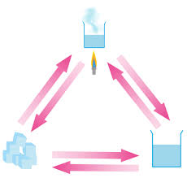STATES OF MATTER: Label the diagram with 1) the three different phases and 2) the phase change that takes place at each arrow.

Physical vs. Chemical Properties: What is the different between physical and chemical properties?

Intrinsic (intensive) property:

Extrinsic (extensive) property:

Solution Chemistry – The compound dissolved in a solution is called the _______________________ and the

concentration of a solution is measured by it’s ___________________________.

Pure Substances & Mixtures: Recreate the flowchart of pure substances and mixtures from your textbook. Add examples to each type of matter.

PURIFICATION METHODS

Many methods have been developed to separate mixtures into their pure components. There are two types of separation methods: Physical & chemical separation

*Physical Separation:*

Density Properties:

Solubility:

Boiling point/melting point:

Chromatography:

|  |  |  |  |
| --- | --- | --- | --- |
| **Technique** | **Stationary Phase** | **Mobile Phase** | **Uses** |
| **Paper chromatography** |  |  |  |
| **Gas Chromatography** |  |  |  |
| **High Performance Liquid Chromatography** |  |  |  |
| **Gel Chromatography** |  |  |  |

Retention Factor, Rf:

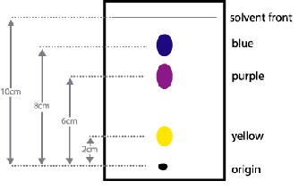

Retention Time:

*Chemical Separation:*

**11.4 : CLASSICAL METHODS IN ANALYTICAL CHEMISTRY**

Physical Analysis:

Classical Methods:

*Field test:

Uses-

*Spot Tests:

Uses-

*Gravimetric Analysis:

Uses –

*Combustion Analysis:

Uses-

*Volumetric (Titrametric) Analysis:

Uses-

*Immunoassay:

Uses-

**REVIEW: Chapter 11 Separation Techniques & Classical Methods (analytical chemistry)**

|  |  |  |
| --- | --- | --- |
| **Chromatography** | **How Does It Work?** | **What is it used for? Pros? Cons?** |
| **Field Test** |  |  |
| **Spot Test** |  |  |
| **Volumetric (Titrametric) Analysis** |  |  |
| **Gravimetric Analysis** |  |  |
| **Combustion** |  |  |

