Chapter 9 – Key Issue #4 – Why do Countries Face Obstacles to Development?
MODELS OF DEVELOPMENT
Liberal Models
- All countries are capable of development
- Economic disparities are a result of short term inefficiencies in local or regional market forces

Structuralist Models
- Regional disparities are a structural feature of the global economy
- Things have come to be organized or structured in a way and cannot be changed easily

Self-Sufficiency Model
- For most of the twentieth century, self-sufficiency, or balanced growth, was the more popular of the development alternatives.
- The world’s two most populous countries, China and India, adopted this strategy, as did most African and Eastern European countries.
- A country should spread investment as equally as possible across all sectors of its economy, and in all regions.
- Reducing poverty takes precedence over encouraging a few people to become wealthy consumers.
- The approach nurses fledgling businesses by isolating them from competition of large international corporations.
- Countries promote self-sufficiency by setting barriers that limit the import of goods from other places.
  - Tariffs, quotas on imports, licensing for importers
- The approach also restricts local businesses from exporting to other countries.

India: Example of the Self-Sufficiency Approach
- For many years India made effective use of many barriers to trade.
- Businesses were supposed to produce goods for consumption inside India.
- If private companies were unable to make a profit selling goods only inside India, the government provided subsidies, such as cheap electricity, or wiped out debts.
- The government owned not just communications, transportation, and power companies, a common feature around the world, but also businesses such as insurance companies and automakers, left to the private sector in most countries.

Problems with the Self-Sufficiency Alternative
- The experience of India and other LDCs revealed two major problems with self-sufficiency:
  - Too much government control left businesses with little incentive to improve
  - Inefficiency: self-sufficiency protects inefficient industries. Companies protected from international competition do not feel pressure to keep abreast of rapid technological changes.
  - Large bureaucracy: the second problem was the large bureaucracy needed to administer the controls. A complex administrative system encouraged abuse and corruption.

International Trade Model or Rostow’s Model of Development
The international trade model of development calls for a country to identify its distinctive or unique economic assets. According to the international trade approach, a country can develop economically by concentrating scarce resources on expansion of its distinctive local industries (I.e. oil In Kuwait)
Rostow based his theory on two ideas:
- If some countries can do it, why can’t others?
- In the past, LDCs contained an abundant supply of raw materials sought after by MDCs. Without colonial influences, why can’t they sell these materials and generate funds to promote development?

- According to the international trade model, each country is in one of these five stages of development.
1. The traditional society.
2. The preconditions for takeoff.
3. The takeoff.
4. The drive to maturity.
5. The age of mass consumption.

- The model assumes that less developed countries will achieve development by moving along from an earlier to a later stage. (Liberal model)
- A country that concentrates on international trade benefits from exposure to consumers in other countries. Concern for international competitiveness in the exporting takeoff industries will filter through less advanced economic sectors.
  - The traditional society.
    - society has not yet started to develop
    - Engaged in agriculture and other “nonproductive activities” like military and religion
  - The preconditions for takeoff.
    - an elite group initiates economic activities
    - Investment in infrastructure, which stimulates an increase in productivity
  - The takeoff.
    - rapid growth in limited economic activities, other sectors remain dominated by traditional practice.
  - The drive to maturity.
    - Modern technology diffuses to a variety of industries, rapid growth, workers become more skilled and specialized
  - The age of mass consumption.
    - economy shifts from production of heavy industry to consumer goods
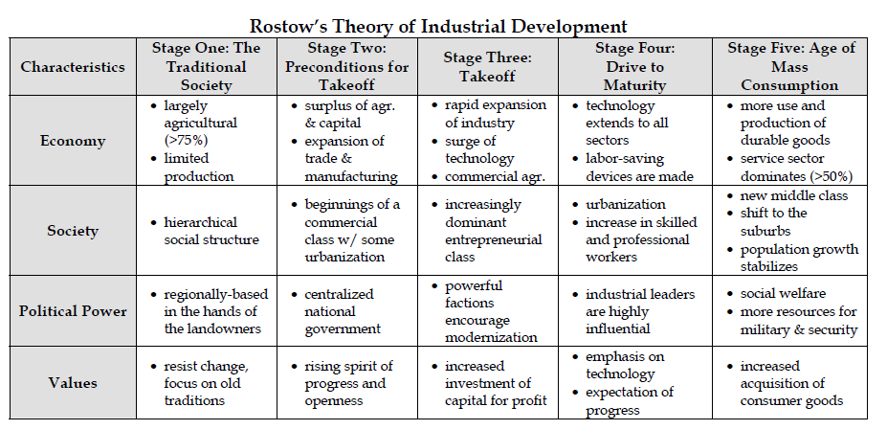

Examples of International Trade Approach

Petroleum-Rich Persian Gulf States
- This region was one of the world’s least developed until the 1970s, when escalation of petroleum prices transformed these countries overnight into some of the wealthiest per capita.
- Persian Gulf countries have used petroleum revenues to finance large-scale projects.
- The landscape has been further changed by the diffusion of consumer goods.
- Some Islamic religious principles, which dominate the culture of the Middle East, conflict with business practices in more developed countries.
- Women are excluded from holding most jobs and visiting public places.

The Four Asian Dragons
- Also among the first countries to adopt the international trade alternative were South Korea, Singapore, Taiwan, and Hong Kong.
- Singapore and Hong Kong, British colonies until 1965 and 1997, respectively, have virtually no natural resources.
- Both comprise large cities surrounded by very small amounts of rural land.
- South Korea and Taiwan have traditionally taken their lead from Japan.
- Lacking natural resources, the four dragons promoted development by concentrating on producing a handful of manufactured goods, especially clothing and electronics
- Low labor costs enable a higher profit margin

Problems with the International Trade Alternative
- Three problems have hindered countries outside the Persian Gulf and the four Asian dragons from developing through the international trade approach:
  - Uneven resource distribution
  - Market stagnation/decline
  - Increased dependence on MDCs

Recent Triumph of the International Trade Approach
- Despite problems with the international trade approach, it has been embraced by most countries as the preferred alternative for stimulating development.
- During the past quarter century, world wealth (as measured by GDP) has doubled, whereas world trade has tripled, a measure of the growing importance of the international trade approach.
- India, for example, dismantled its formidable collection of barriers to international trade during the 1990s.
- Countries converted from self-sufficiency to international trade during the 1990s for one simple reason: overwhelming evidence that international trade better promoted development.
- In the case of India, under self-sufficiency between 1960 and 1990, GDP grew by 4 percent per year, much lower than in Asian countries that had embraced international trade.
- After adopting the international trade alternative in the early 1990s, India’s GDP grew 7 percent per year during the 1990s.

Dependency Theory
- Structuralist alternative to Rostow’s model
- Political and economic relationships between countries and regions control and limit the economic development of less well off regions
- Dependency helps sustain the prosperity of the dominant regions and little hope for economic prosperity in regions and countries that have traditionally been dominated by external power
- In essence, industrialized nations continue to take resources from developing countries due to neocolonialism (entrenchment of the colonial order such as trade and investment, under a new guise)- which widens the development gap

