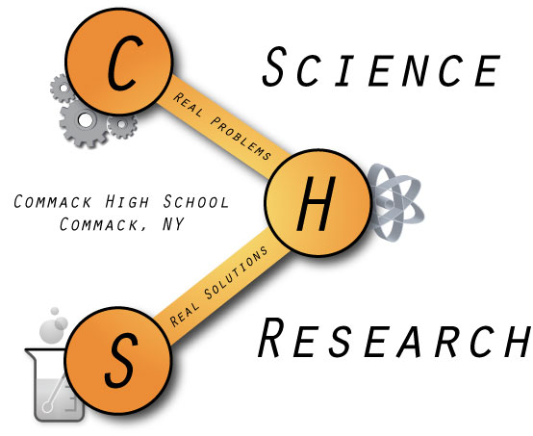
Commack High School
Research Class of 2014

Zan Asif
New Paltz University 7-Year Accelerated Medical Program
Does a Change in Host Affect the Number of Melittobia digitata and/or Melittobia australica Offspring Produced?

Daniella Azoulay
New York University
A Bioinformatic Approach to Vizualizing and Identifying Conserved Cardiac Developmental Networks

Stephanie Badir
St. John’s University
New York State Nurses’ Comfort and Knowledge Caring for Students with Diabetes Mellitus: A Cross Sectional Study

Anthony Bisulco
Northeastern University
The Development of a Practical Notification System to Identify Solar Disturbances

Christina Cabana
Carnegie Mellon University
The Use of Genetic Spike-in Controls to Quantify Absolute Population Abundances in the Bacterial Microbiome

Justin Cheung
Stony Brook University 8-Year BE/MD Scholars for Medicine Program
Gold Nanoparticles: The Efficient Synthesis of Catalytically Active Nanoparticles using a One-Pot Method

Diana Hagedorn
Stony Brook University
An Investigation of the Effects of Variable Diets in Drosophila melanogaster

Hugh Han
Johns Hopkins University
The Effects of El Niño – Southern Oscillation on Precipitation Fluctuation and Extremities in Terrestrial Biomes from 1948–2011, Inclusive

Greta Huang
University of California, Berkeley
An Investigation of BHBM-Grafted Gold Nanoparticles as Drug Delivery Agents for Treatment of CryptoCOCKosis

Sarah Lamorte
New York University
Creating a Method for the Detection and Identification of the Unknown Compounds in Resveratol

Samuel Luber
Tulane University
When is the Cheapest Time to Buy an American Airlines Ticket?

Marissa Mathew
St. John’s University
Transcription Regulation of miRNA

Chimdindu Obinero
Duke University
A Study of the Effect of Various Therapeutic Substances on the Neurophysiological Capabilities of Drosophila melanogaster of Alzheimer’s disease

Claire Regan
Binghamton University
The Relationship between the APP Mutation in Alzheimer’s disease and Ethnic and Geographic Factors

Tracey Rosenlicht
Stony Brook University
Effects of Colored Overlays on Computer Vision Syndrome (CVS): A Comparative Study Through Different Interfaces

Zachary Shushan
University of Delaware
Does a Change in Host Affect the Number of Melittobia digitata and/or Melittobia australica Offspring Produced?

Rakia Syed
Stony Brook University
The Correlation between Technology Use and Self-Perceived Happiness

Noah Tollin
University of Georgia
Dispersal of Resistant Bacteria (Escherichia coli K-12) among German Cockroaches (Blattella germanica)

James Whittaker
Lehigh University
Modeling an Energy Efficient House Influenced by a Natural Design

Joshua Zweig
Columbia University
Classification of Abnormalities in 3-Dimensional Mammograms via an Artificial Neural Network

