IB SL Physics: Error Practice Problem
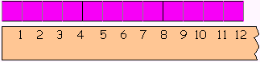
Based on the centimeter ruler and the two dark lines, find:

- Start Length: ________________ +- ___________ cm

- End Length: ________________ +- ___________ cm

- Distance: ________________ +- ___________ cm

If the length makes a square find its perimeter and area:

Answers:
- 4.0 +- 0.5 cm
- 8.0 +- 0.5 cm
- 4.0 +- 1.0 cm
- Perimeter: 16.0 +- 4.0 cm
- Area: 16 +- 8 cm squared

