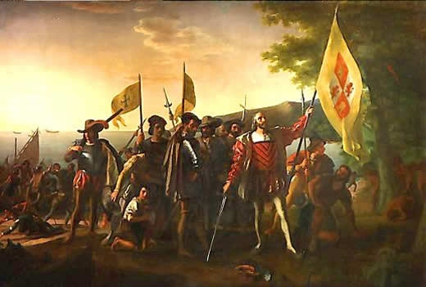
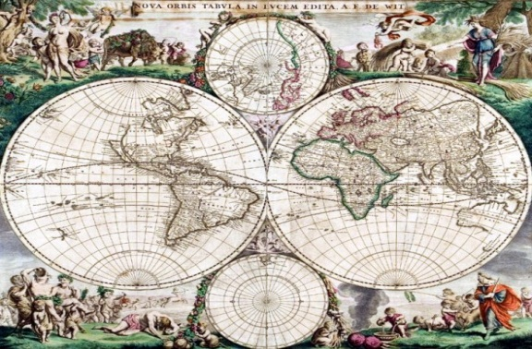
The Age of Exploration
c. 1492-1800

SECTION 1: The Search for Spices:

Astrolabe: A device used by sailors to measure the height of the sun or a star above the horizon. With this information, they could determine both the time of day and the latitude where they were located.
Circumnavigate: To sail around the world.
Prince Henry the Navigator: Portuguese explorer and prince who founded navigation schools for mapmakers, instrument makers, shipbuilders, scientists, and sea captains to perfect their trade. He also wished to spread the Christian faith.
Treaty of Tordesillas: A 1494 agreement between Portugal and Spain, declaring that newly discovered lands to the west of an imaginary line in the Atlantic Ocean would belong to Spain and newly discovered lands to the east of the line would belong to Portugal.
Vasco da Gama: Portuguese explorer who began exploring the east African coast, and the western coast of India. He helped to find a direct sea route to India.

SECTION 2: Latin American Civilizations

Chinampas: A method of ancient Mesoamerican agriculture which used small, rectangle-shaped areas of fertile land to grow crops on the shallow lake beds in the Valley of Mexico.
Incas: Native South American people whose empire, based in Peru and covering the Andean Mountain region, lasted from the 12th century until the mid-16th century. The Incas were sophisticated engineers, architects, and artists who had a highly complex social structure. The descendants of the Incas form roughly half of today’s population of Peru.
Mayas: Native American people of Central America and southern Mexico whose culture flourished between the 4th and 89th centuries CE.
Quipu: an arrangement of knotted strings on a cord, used by the Inca to record numerical information.
Tenochtitlan: Founded by the Aztecs, it developed into an extraordinary urban center in the 1500s. It contained significant urban planning, trade markets, temples, and government buildings. It was larger than London or any other European capital of the time.
Terrace Farming: A new form of agriculture in which stepped ridges constructed on mountain slopes help retain water and reduce erosion.
Tikal: A spectacular Mayan city and major center in northern Guatemala.

SECTION 3: Conquest of the Americas

Columbian Exchange: The global transfer of plants, animals, and diseases that occurred during the European colonization of the Americas.
Conquistadors: The Spanish soldiers, explorers, and fortune hunters who took part in the conquest of the Americas in the 16th century.
Encomiendas: A grant of land made by Spain to a settler in the Americas, including the right to use Native Americans as laborers on it.
Mercantilism: An economic policy under which nations sought to increase their wealth and power by obtaining large amounts of gold and silver and by selling more goods than they bought.
Middle Passage: The voyage that brought captured Africans to the West Indies, and later to North and South America, to be sold as slaves – so called because it was considered the middle leg of the triangular trade.
Montezuma: Aztec emperor when the first contact between indigenous civilizations of Mesoamerica and European explorers took place.
Triangular Trade: The transatlantic trading network along which slaves and other goods were carried between Africa, England, Europe, the West Indies, and the colonies in the Americas.

