Commack Middle School 7th and 8th Grade Orchestra
2020-2021 School Year

Welcome orchestra students and parents!

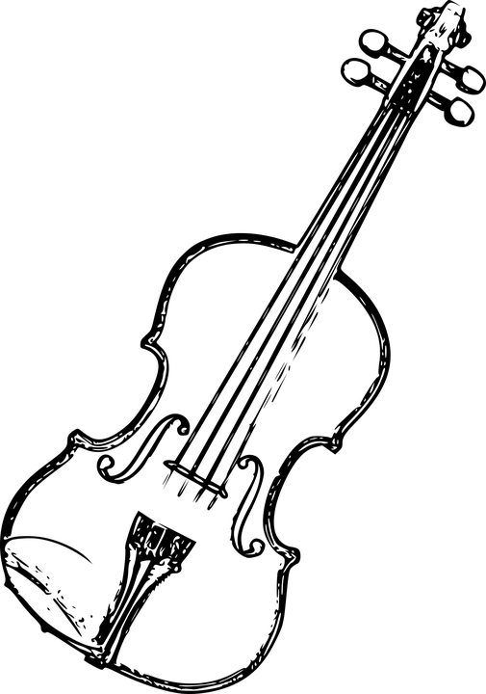
I hope you all had a restful summer vacation and are feeling excited for the new school year. In this letter you will find an orchestra supply list for the school year, information about renting instruments, lessons, and the grading policy for this course. You will also find my contact information at the end of this letter. Please read it and have the necessary supplies ready to use at home for your child by September 21st.

Supplies:
All students will need to purchase the following for home:
- Essential Elements Book 2 for their instrument
- 1 inch three ring binder and pencil to keep at home
- Rosin and a cleaning cloth for their instruments
- Folding stand
- Violins and violas will need a shoulder rest
- Cellos and basses will need a rockstop

Instrument rentals:
All violin students should rent their instrument from a local music store.
Violas, cellos, and basses can either rent their instrument from a local music store or rent one from the school district.

Instrument rentals from school:
This year we will be offering instrument rentals from the school district as we have in the past. Please know we will be discussing the procedure for instrument rentals during the first days of school. Information for rental payment and contracts will be posted on Google Classroom and on my school website in the following days.

Grading Policy:
60 % Participation
20 % Lessons
20 % Google Classroom Assignments

Lessons:
In addition to our regular zoom sessions, students will also participate in pull out zoom lessons every 8 days during their virtual learning day. This means that if your child has orchestra on A days, their pull out zoom lesson will also be on A days. If your child has orchestra on B days, their pull out zoom lesson will also be on B days.

Lesson Schedules:
A lesson schedule will be posted on Google Classroom and on my website. Please know that students will not miss the same class more than twice in one marking period.

Classroom Expectations:
Although orchestra will be quite different this year, students are still held to the same expectations that they are in school. This means that students should be on time to their class and lessons, prepared with their instruments and music, and ready to learn!
Class updates will be posted on Google Classroom and on my website regularly. In addition, please know that students will not be expected to bring their instruments or music back and forth with them between school and home. All of their supplies and instruments for orchestra class and lessons should stay home this year.

If you have any questions or concerns, please feel free to contact me at bfoti@commack.k12.ny.us.
I am looking forward to a wonderful year of music!
Musically yours,

Bonnie Foti
CMS Orchestra Director

