Name: _______________________________
Global History on Film
Operation Valkyrie
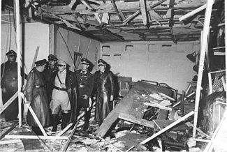
The most famous assassination attempt on the life of Adolf Hitler took place on July 20, 1944 at the Wolfsschanze or Wolf’s Lair headquarters near Rastenburg, East Prussia. The plot was codenamed Operation Valkyrie and was led by the German aristocrat and army officer Claus Schenk Graf von Stauffenberg in conjunction with General Friedrich Olbricht and General Ludwig Beck of the German general staff. The plot was the culmination of a more widespread anti-Nazi German resistance movement to overthrow Hitler and the Third Reich.

Stauffenberg began his military career in the 1920s before the Nazis came to power. Although he was never a member of the Nazi party, he did support Hitler’s invasion of Poland at the outbreak of the World War II in 1939 and was wounded in action in Africa in 1942. It was not until 1942-43 that Stauffenberg became one of the central figures of the German resistance movement within the Wehrmacht and by July 1944 he was the main driving force behind the plot to assassinate Hitler.

There were several assassination attempts on Hitler’s life before Stauffenberg finally went ahead with Operation Valkyrie in July 1944. Accompanied by his aide, Lieutenant Werner Von Haeften, Stauffenberg attended Hitler’s military conference at the Wolfsschanze in East Prussia, carrying a bomb in his briefcase. The location of the conference was unexpectedly changed at the last minute from the underground Führerbunker to the main briefing room above ground due to the hot weather. At around 12:30pm Stauffenberg made an excuse to use a nearby washroom and armed the first bomb. A guard knocked, urging him to hurry as the meeting was going to begin, so he left behind a second bomb with Von Haeften. He returned to the briefing room and placed the briefcase under the conference table next to Hitler. After a few minutes, he took a pre-arranged telephone call and left the room. The briefcase was then moved by Colonel Heinz Brandt. At around 12:45pm the bomb exploded, destroying the conference room and killing three officers and a stenographer. Hitler survived, shielded from the blast by the solid-oak conference table leg. Stauffenberg and Von Haeften drove to a nearby airfield, convinced that Hitler was dead, as no one could have possibly survived the explosion. On his return to Berlin, Stauffenberg, General Friedrich Olbricht and General Ludwig Beck of the German general staff put their military coup into action, but when it was later announced by radio that Hitler had survived, the conspirators soon realized that the coup had failed. They were hunted down to their Bendlerblock offices in Berlin, where they surrendered after a brief shoot-out.

The conspirators were condemned to death. Beck committed suicide while Stauffenberg, von Haeften, Olbricht and another officer, Albrecht Mertz von Quirnheim, were executed by a firing squad. Over the coming months, it is estimated that over 7,000 Germans were killed or sent to concentration camps as Hitler took revenge on the enemies of the Third Reich. The conspirators, however, had the final victory. Less than a year later, Hitler had committed suicide and the Second World War in Europe was at an end.

Name: _______________________________
Global History on Film

Characters
- Ludwig Beck- a German general and Chief of the German General Staff during the early years of the Nazi regime in Germany before World War II. Beck was never a member of the Nazi Party. He became a major leader within the conspiracy against Hitler, but when the plot failed, Beck was arrested. Reportedly he made an unsuccessful attempt at suicide, and was then shot dead.
- Friedrich Olbricht- a German general and one of the plotters involved in the attempt to assassinate Adolf Hitler.
- Otto-Ernst Remer- a German Wehrmacht officer who played a decisive role in stopping the 1944 plot against Adolf Hitler. During the war he was wounded nine times in combat. He is considered the "Godfather" of the post-war Nazi underground.
- Fritz Erich Fellgiebel (4 October 1886 – 4 September 1944) was a German Army general and a conspirator in the 20 July plot to assassinate Nazi dictator Adolf Hitler

Base your answers to the following questions on Bryan Singer’s movie, Valkyrie starring Tom Cruise, Bill Nighy, and Carice van Houten.

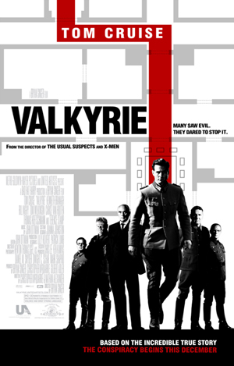
- What causes Stauffenberg to lose his faith in Hitler?

- Stauffenberg perceived “patriotism” as being different from “loyalty” to the country’s leader. Define both words and explain the difference between the two.

- Do you think it was worth the risk to the conspirators’ families in order to kill a tyrant such as Hitler?

- Why does the Bombing fail to kill Hitler? Give three reasons

- Why do you think some people were so loyal to Hitler? Was it just a fear or was there more to it than that? Explain.

- Major-General Henning von Tresckow (Kenneth Branagh) believed that it was more important that the conspirators try to overthrow Hitler’s regime than for the plot to actually succeed. Why did he think this? Do you agree with him?

Historical Inaccuracies
- In the scene where Hitler arrives in Russia the plane he arrives in is Ju-52. This is incorrect. The plane he actually flew in was an FW-200 Condor. Because the condor flew at a much higher altitude is one of the reasons the bomb failed to go off.
- The table leg where Colonel Claus Schenk Graf Von Stauffenberg places the bomb was a "stout" (block) leg not a peg leg as shown in the scene. This was the critical difference in saving Hitler's life, because Colonel Brandt, trying to get a better view of the map, moved the briefcase to the other side of the stout block, away from Hitler. The blast thus blew away from Hitler, and ironically toward Brandt, who died from it.
- Hermann Göring is not wearing his "Blue Max" WWI medal. It should have been around his neck, with his Grand Cross. Another character ('Pompous General') is correctly shown wearing his Blue Max.
- The P-40's that attack the Germans in the beginning of the movie have the Flying Tiger teeth painted on them. The Flying Tigers were based in China during WWII. However, shark mouth was often used on the P-40 by other units, such as 112 squadron RAF - not just by the Flying Tigers; P-40's in the movie in fact clearly have the correct British camouflage for North Africa.

