Name:_______________________ Period:_________

Unit II: Ancient Greece

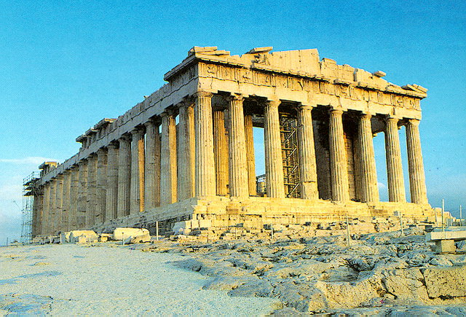

1. **Athens:** Ancient Greek city-state that emphasized education and democracy.
2. **Sparta:** Greek city-state had the greatest military power of Greece and played a catalytic role in the history of Peloponnese.
3. **Straits:** Narrow water passage connecting two bodies of water.
4. **Polis:** city-state in Ancient Greece. The fundamental political unit of ancient Greece after about 750 BC.
5. **City-State:** A political unit made up of a city and the surrounding lands.
6. **Acropolis:** Known as “high city” – a hilltop fortress of ancient Greek city-states.
7. **Monarchy:** A form of government in which a king or queen exercises central power.
8. **Oligarchy:** A form of government ruled by a small elite group of people.
9. **Democracy:** A form of government in which the people hold ruling power.
10. **Direct Democracy:** A system of government in which citizens participate directly rather than through elected officials.
11. **Tyrant:** A tyrant (Greek) was originally one who illegally seized and controlled a governmental power in a polis; ruler who uses power oppressively or unjustly.
12. **Legislature:** A law making body.
13. **Phalanx:** In ancient Greece, a group of soldiers that attacked in close formation, protected by their overlapping shields and projecting spears.
14. **Citizenship:** The state of being vested with the rights, privileges, and duties of a citizen; the character of an individual viewed as a member of society.
15. **Socrates:** A classical Greek Athenian philosopher. Credited as one of the founders of Western philosophy.
16. **Plato:** A classical Greek philosopher, mathematician, student of Socrates, writer of philosophical dialogues.
17. **Aristotle:** A classical Greek philosopher and polymath, a student of Plato and teacher of Alexander the Great.
18. **Pericles:** Pericles was the leader of Athens at the time of the building of the Parthenon and the Peloponnesian War. He believed that all male citizens should take part in government regardless of wealth or social class. Since he was such a skilled and wise leader, the period from 460 BC to 429 BC is often known as a golden age or the “Age of Pericles.”
19. **The Funeral Oration:** Speech given by Pericles at the funeral of Athenians slain in battle. In this speech, Pericles praised the Athenian form of government.
20. **Hellenistic Culture:** Alexander the Great’s blending of Persian, Greek, Indian, and Egyptian cultures. This is an example of cultural diffusion.
21. **Militarism:** The belief or desire of a government or people, that a country should maintain a strong military capability and be prepared to use it.
22. **Pythagoras:** Greek philosopher, mathematicians, and founder of the religious movement called Pythagoreanism. Founder of the math theorem: a2+b2=c2.
23. **Hippocrates:** Greek physician of the Age of Pericles; came up with the Hippocratic Oath.
24. **Parthenon:** The Parthenon is a temple on the Athenian Acropolis in Greece, dedicated to the Greek goddess Athena, whom the people of Athens considered their virgin patron.
25. **Golden Age:** A time in a society when a civilization experiences peace and prosperity and when cultural advancements are at their highest point.
26. **Alexander the Great:** Military leader and king of the Greek city-state Macedonia, he created one of the largest empires in the ancient world. He was undefeated in battle and considered one of the world’s most successful generals. Cultural diffusion spread as a result of his expanding empire.