Cubist Movement: 20th century art style; best represented by Spanish artist Pablo Picasso; rendered familiar objects as geometrical shapes. Below is an example of Cubism, found in the painting “Guernica” by Picasso, completed in 1937.

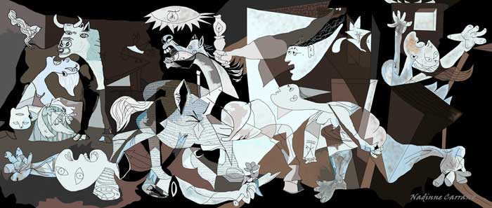

Search for clues in the painting…
- Circle what you see in the painting. Annotate around the painting describing what you see.
- What emotion do you feel when examining the painting? Why does it make you feel this way?
Background
What would be the best way today to protest against a war? How could you influence the largest number of people? In 1937, Picasso expressed his outrage against war with Guernica, his enormous mural-sized painting (it is approximately eleven feet tall and twenty-five feet wide!) displayed to millions of visitors at the Paris World’s Fair. It has since become one of the twentieth century’s most powerful indictment against war, a painting that still feels intensely relevant today.

In 1936, a civil war began in Spain between the democratic Republican Government and fascist forces, led by General Francisco Franco, attempting to overthrow them. On April 27, 1937, Hitler’s powerful German air force, acting in support of Franco, carpet bombed the village of Guernica in northern Spain, a city of no strategic military value. It was history’s first aerial saturation bombing of a civilian population. It was a cold-blooded training mission designed to test a new bombing tactic to intimidate and terrorize the resistance. For over three hours, twenty five bombers dropped 100,000 pounds of explosive and incendiary bombs on the village of Guernica, reducing it to rubble. Twenty more fighter planes strafed and killed defenseless civilians trying to flee. The devastation was appalling: fires burned for three days, and seventy percent of the city was destroyed. A third of the population, 1,600 civilians, were wounded or killed.

Picasso hears the news
On May 1, 1937, news of the atrocity reached Paris where Picasso was living. Eyewitness reports filled the front pages of local and international newspapers. Picasso, sympathetic to the Republican government of his homeland, was horrified by the reports of devastation and death. Guernica is his visual response. After hundreds of sketches, the painting was done in less than a month and was then delivered to the World’s Fair’s Spanish Pavilion, where it became the central attraction. Accompanying it were documentary films, newsreels and graphic photographs of fascist brutalities in the civil war. Rather than the typical celebration of technology people expected to see at a world’s fair, the entire Spanish Pavilion shocked the world into confronting the suffering of the Spanish people.
Later, in the 1940s, when Paris was occupied by the Germans, a Nazi officer visited Picasso’s studio. “Did you do that?” he is said to have asked Picasso while standing in front of a photograph of the painting. “No,” Picasso supposedly replied, “you did.”

World traveler
When the fair ended, the Spanish Republican forces sent Guernica on an international tour to create awareness of the Spanish Civil War and raise funds for Spanish refugees. It traveled the world for 19 years and then was loaned for safekeeping to The Museum of Modern Art in New York. Picasso refused to allow it to return to Spain until the country “enjoyed public liberties and democratic institutions,” which finally occurred in 1981. Today the painting permanently resides in the Reina Sofia, Spain’s national museum of modern art in Madrid.

1. Based on the reading, what is the theme of Guernica?

2. Looking back at the work, how is Picasso’s point of view expressed through artistic expressions and symbolism?

3. What issues would you create through art?
http://mentalfloss.com/article/63103/15-fascinating-facts-about-picassos-guernica

