Name__________________________________________ Period_____ Date___________________
Aim: To what extent did nationalism inspire the unification of Italy?

Do Now: Brainstorm three aspects of society that bond people together as a community or nation.
1.
2
3
------------------------------------------------------------------------------------------------------------------------------------------
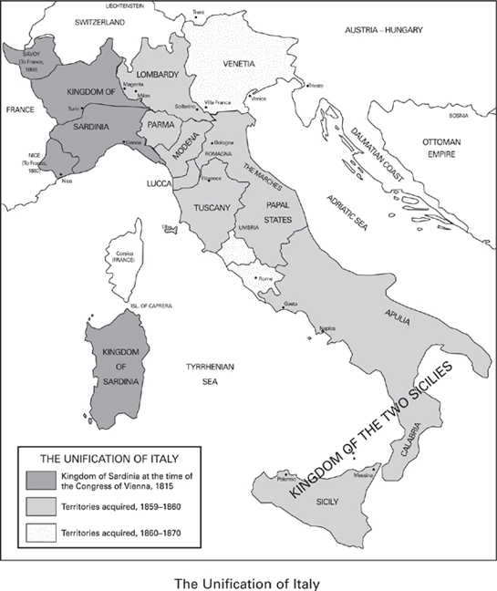
Historical Context
In the mid-nineteenth century, Italy was a tangle of foreign-controlled small kingdoms. Austria controlled Venetia, Lombardy, and Tuscany in the north. France controlled Rome and the Papal States in the mid-section. And Spain controlled the Kingdoms of Two Sicilies (which included Sicily and the “foot” of Italy including Naples) in the south. Only the divided kingdom of Sardinia (part of which was an island in the Mediterranean) was controlled by Italians.
France occupied various Italian states during the Napoleonic Wars (early 1800s), which brought French Revolutionary ideas like freedom and equality to the Italian peoples. At the Congress of Vienna, Italian nationalists hoped to end centuries of foreign rule and achieve unity. To Prince Metternich, the idea of a unified Italy was laughable. As a leader from Austria, he along with other world leaders hoped to hold onto their Italian states. By the early 1800’s, though, Italian patriots were determined to build a new, united Italy. The unification was brought about through the leadership of of three strong men – Giuseppe Mazzini, Count Camillo di Cavour, and Giuseppe Garibaldi.

1. Explain how the French Revolution, and in turn, the Congress of Vienna, influenced the Italian states circa 1815.

2) How do you think nationalism helped motivate the Italian people to unify and fight for independence from foreign rule? Enhance your answer by providing one piece of analysis.

Leader#1. Giuseppe Mazzini: “The Soul” of Italian Unification
In the 1830s, a nationalist leader, Giuseppe Mazzini, founded an organization called, Young Italy. The goal of this secret society was “to constitute Italy, one, free, independent, republican nation.” In 1859, Mazzini helped set up a revolutionary republic in Rome. However, French forces, at the request of the Pope, squashed the rebellion. Like many other nationalists, Mazzini spent much of his life in exile, plotting and dreaming of a united Italy. Despite his hardships with regards to Italy, Mazzini went on to help found other nationalistic organizers including Young Europe, Young Germany, and Young Switzerland.

The following is an oath the members of Mazzini’s Young Italy were asked to take:
3) What was the goal of Mazzini’s organization? Were they successful?
In the name of God and of Italy;
By the embarrassment I have when I stand before the citizens of other lands knowing that I have no rights of citizenship and no national flag;
I believe in the mission given God to Italy and in the duty of every Italian to try to fulfill it.
I devote myself wholly and forever to make Italy one free, independent republican nation.

Leader#2. Camillo di Cavour: “The Brains” of Italian Unification
After 1848, leadership of the Italian nationalist movement passed to the Kingdom of Sardinia. Sardinia’s constitutional monarch, Victor Emmanuel II, hoped to join other states to his own. In 1852, Victor Emmanuel made Count Camillo di Cavour the prime minister of Sardinia. Cavour’s goals would be to end Austrian power in Italy and take control of the provinces of Lombardy and Venetia. In 1858, Cavour orchestrated a deal with Napoleon III (Bonaparte’s nephew) to form an alliance with France. A year later, Cavour provoked a war with Austria, hoping to gain control of Lombardy. Meanwhile, nationalist groups in other northern Italian regions overthrew Austrian rulers. The Italian people were demonstrating very clearly their desire to expel the Austrians. These states then joined with Sardinia to form an alliance.

“Nationalism has become general; it grows daily; and it has already grown strong enough to keep all parts of Italy united despite the differences that distinguish them.” –Camillo di Cavour

4) According to Cavour’s quote above, what role did nationalism play in the unification of Italy?

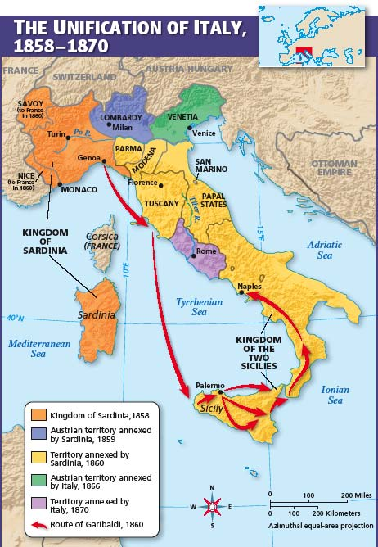
Leader #3. Giuseppe Garibaldi: “The Sword” of Italian Unification
Giuseppe Garibaldi joined the nationalist group, Young Italy, in 1833. Due to his affiliation with the group, Garibaldi was forced into exile twice. However, he found a strong ally in Camillo di Cavour, the Prime minister of Sardinia. Garibaldi led Sardinian troops in the war against Austria. By 1860, Garibaldi had recruited a force of 1,000 red-shirted soldiers ready to fight for Italian unity. Cavour provided weapons and allowed two ships to take Garibaldi and his Red Shirts south to Sicily. With surprising speed, Garibaldi’s forces won control of Sicily, crossed to the mainland, and marched triumphantly north to Naples. In 1861, Italy was unified into one country under the rule of King Victor Emmanuel II.

5) Identify one enduring issue from social studies that relates to this reading section. Be sure to explain how it relates with two supporting piece of information!

