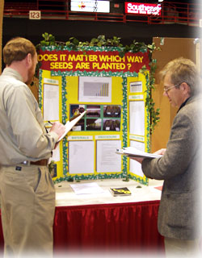
How to Impress the Science Fair Judge
Who are the Judges?
Judges are regular people with regular jobs
They are usually professionals in their fields
Sometimes they are professors at academic centers or they may work for big companies
They have a special interest in science, education and research
They are volunteers
They are not meant to be scary or intimidating

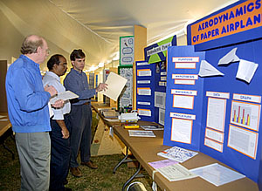
Review the Criteria for Judging
Get the judging sheet
See where emphasis is placed

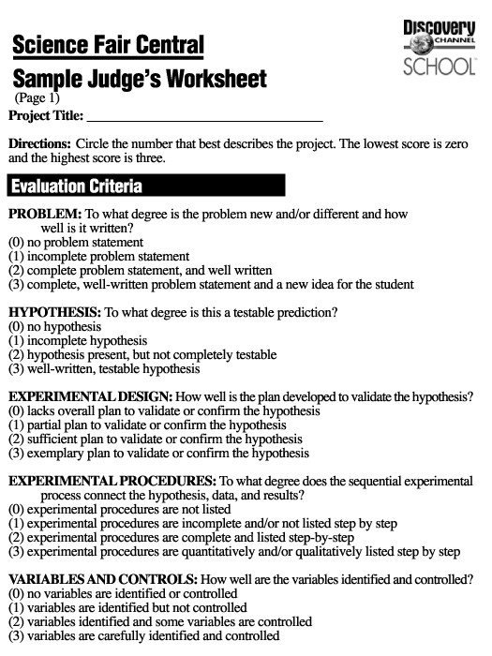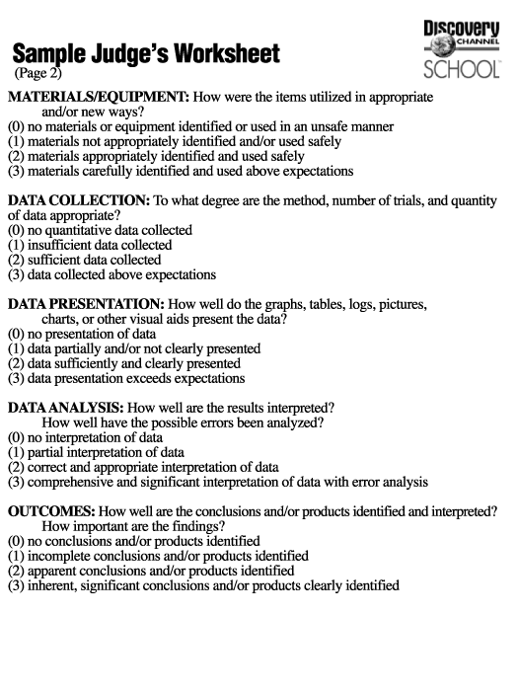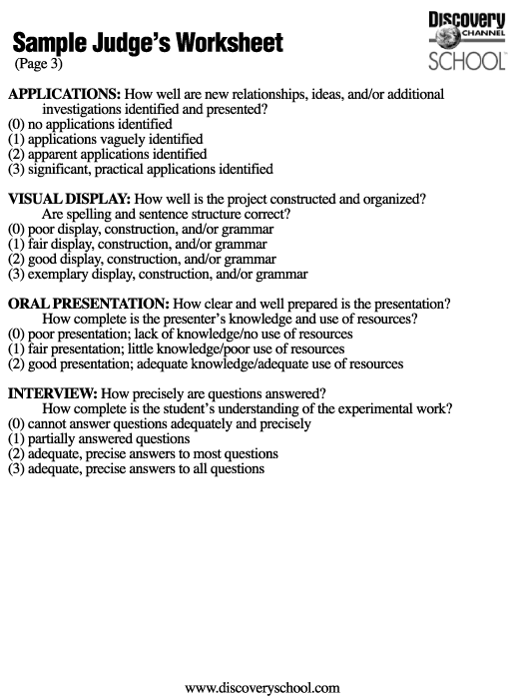
Judging Sheet
Mental Prep
Know your stuff
Be confident
Get Sleep the Night Before
Eat a good breakfast
Dress Neatly and Conservatively
Don’t eat, chew gum, clutch a soft drink, slouch
Play your “A” Game


First Impressions Count

First Impressions Really Count!
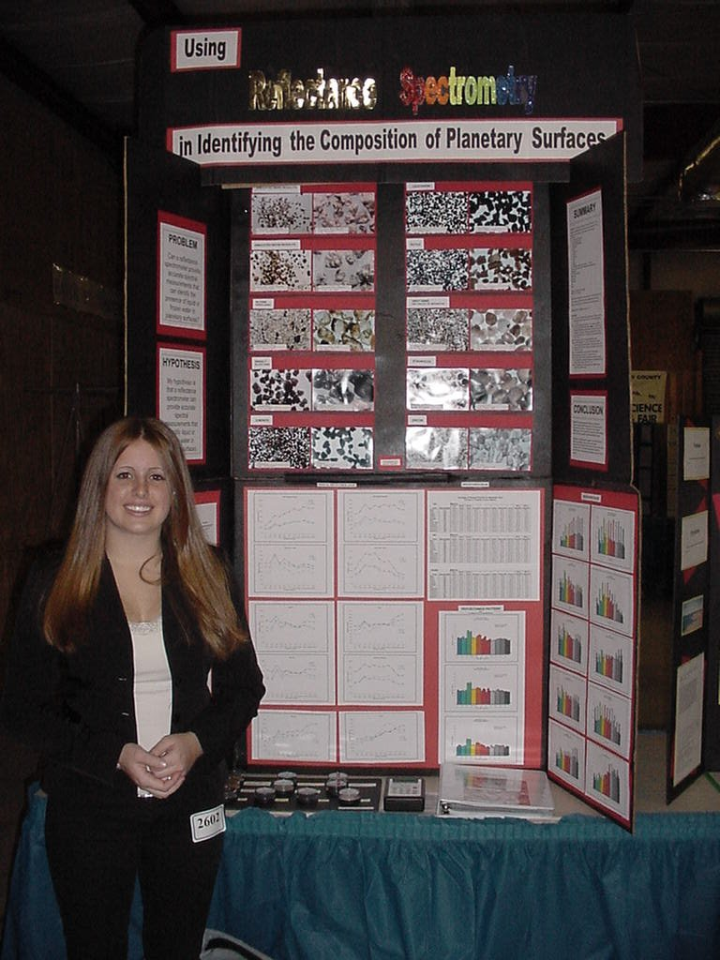
It’s easy to make a good first impression
First Impressions
Dress the part- no spikes, low pants, wild hairstyles, nose rings
Act the part-don’t act bored, sullen, disinterested
Use manners-politeness and respect go a long way with the judges

Prepare a Killer Notebook and Display!
It’s the first thing the judge looks at
It attracts attention from far away
First Impressions Count
The Judge should be able to quickly read some of the key information on the backboard
Have your Log Book available-make sure that it is complete, fairly neat
Have Copies of Abstract and Scoring Sheet available for the judge
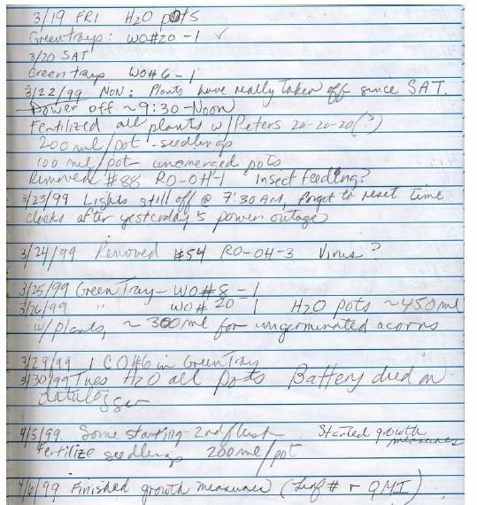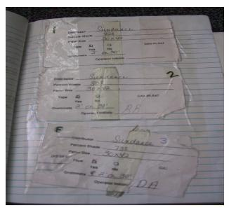
Example Log Books
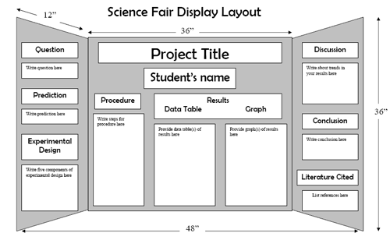
Displays
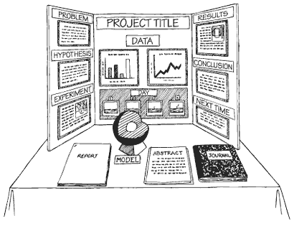
Displays
Displays
Neat and Organized, Not Flashy and Showy
Good Opening Hypothesis
Thorough research and bibliographical notation
Concise writing, a clear conclusion, neatness
Typed computer printouts and relevant photos
Organized Logbook-no doodles or cartoons
Display relevant equipment if allowed
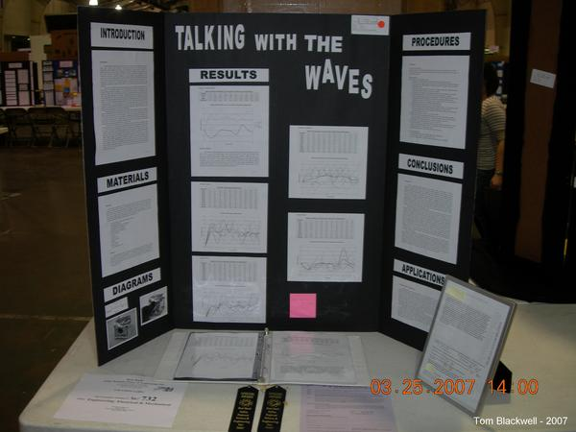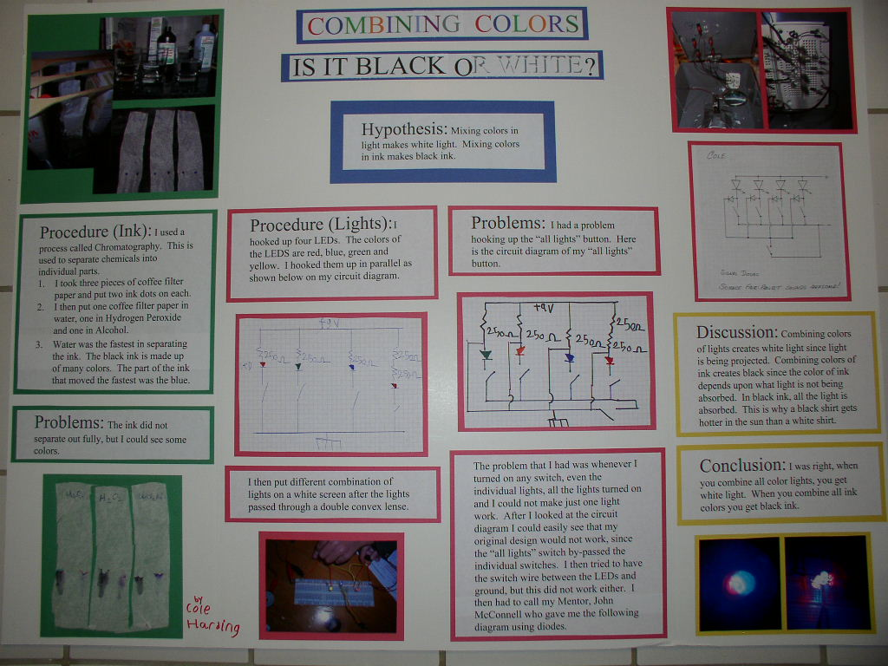
Example Displays

Why the Display has to shine

Judging
Remember Judges are regular people
Talk to them like you are telling a story
Be Confident
Use your manners
Be truthful
If you don’t know the answers, don’t make something up
Be enthusiastic
Make sure to tell the judge why you decided to do your project- real life connection

In order to Win you have to ACE the interview
At LISEF the students have 6 mins to present
Judges were advised to limit each project to a 15 min evaluation
They were advised to give each project a numerical score between 0 and 100 based on certain criteria-see scoring sheet
They were advised to strongly consider not only the quality of the work, but also how much guidance was provided to the student
They were asked to challenge and test the students to see if the project was truly theirs

Practice, Practice, Practice
Practice in front of family, friends, teachers, pets
You should know your speech so well that if you are interrupted that you could pick it up where you left off or say it in a different order
Be positive, make sure to use eye contact, no mumbling, Be confident, No Fear, No Wimpiness
Use your board to point out the details that you are trying to emphasize

So after your speech, what happens?
Yikes, it’s question time
They can ask you anything about the project-be ready
If you don’t know the answer don’t make something up-Judges know when you are confabulating
You could turn it around and make it positive, “I never thought of that before. I don’t know the answer to your question but it is very interesting” Write it in your notebook to show that you are serious about remembering it.
If you don’t understand the question, ask them to rephrase the question
Sometimes the judge will ask a silly question or keep asking the same question- do not show impatience or disrespect, do not make them feel inferior

Prepare the Answers
How did you come up with the idea for this project?
What did you learn from your background research?
Tell me more about the disease/gene you are studying.
How long did it take you to build/do the project? When did you do it?
Where did you do your experiment?
Explain this chart/graph/results to me.
Did you have any errors in your project? How did you correct for them?
How much time did you spend on your project?
Did you try something else that didn’t work?
If you could do this over what would you do differently?
Can you explain how your project relates to (some kind of scientific principal)?
What is the real life application for your project?
Who helped you with the project and how much of it was done independently?
What are you planning for future studies?
What is the most important thing you found out by doing this project?
How is this different from others that you researched?
Did you acquire any new skills while doing the project?

Other Misc. Tips
Don’t let silence happen. Give one of the “mini-speeches” and point something out. E.g.. Review one of the charts, pictures, graphs

Emphasize that you did this project on independently. Judges despiseit when the project was given to the student and they just followed the instructions like a cookbook.

Treat anyonewho visits your board like a judge. You don’t know who it could be- It could be the judge’s relative or friend. They might pass on comments to the judge.

If your project was an experimental “failure” think of it as a great opportunity to discuss what could have been done differently-judges love when you can think critically and “outside the box” If you are doing a group project make sure all the members participate in the presentation and in the answering of questions.

If you have time at the end ask the judge where they work and what field they work in. Sometimes they will give you their contact information and who knows- that could lead you into their lab etc.

Ask them for feedback. Use it to update your project for the next fair.


Remember it’s your project

