Name ___________________________________________ due: 5/15 - this counts as 3 hw points

**Parallel and Perpendicular Lines Regents Review #4**

***You must show work for this to get full credit!!!!***

1. Which equation represents a line that is parallel to the line whose equation is ?

|  |  |
| --- | --- |
| 1) |  |
| 2) |  |
| 3) |  |
| 4) |  |

2. In the diagram below, transversal  intersects  and  at *V* and *W*, respectively.

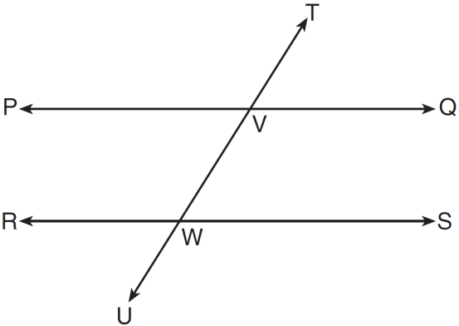

If  and , for which value of *x* is ?

3. Which equation represents a line that is perpendicular to the line whose equation is ?

|  |  |
| --- | --- |
| 1) |  |
| 2) |  |
| 3) |  |
| 4) |  |

4. Which line is perpendicular to the line whose equation is ?

|  |  |
| --- | --- |
| 1) |  |
| 2) |  |
| 3) |  |
| 4) |  |

5. Which equation represents the perpendicular bisector of  whose endpoints are

 and ?

|  |  |
| --- | --- |
| 1) |  |
| 2) |  |
| 3) |  |
| 4) |  |

6. The equation of line *k* is . The equation of line *m* is . Lines *k* and *m* are

|  |  |
| --- | --- |
| 1) | parallel |
| 2) | perpendicular |
| 3) | the same line |
| 4) | neither parallel nor perpendicular |

7. The equations of lines *k*, *p*, and *m* are given below:

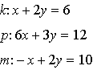

Which statement is true?

|  |  |
| --- | --- |
| 1) |  |
| 2) |  |
| 3) |  |
| 4) |  |

8. Two lines are represented by the equations  and . For which value of *m* will the lines be parallel?

|  |  |
| --- | --- |
| 1) |  |
| 2) |  |
| 3) | 3 |
| 4) | 12 |

9. Two lines are represented by the equations  and . Determine whether these lines are parallel, perpendicular, or neither. Justify your answer.

10. Given two lines whose equations are  and , determine the value of *b* such that the two lines will be perpendicular.

11. Points  and  lie on . Points  and  lie on . Which statement is true?

|  |  |
| --- | --- |
| 1) |  |
| 2) |  |
| 3) | and  are the same line. |
| 4) | and  intersect, but are not perpendicular. |

12. What is an equation of the line that passes through the point  and is perpendicular to the line whose equation is ?

|  |  |
| --- | --- |
| 1) |  |
| 2) |  |
| 3) |  |
| 4) |  |

13. A transversal intersects two lines. Which condition would always make the two lines parallel?

|  |  |
| --- | --- |
| 1) | Vertical angles are congruent. |
| 2) | Alternate interior angles are congruent. |
| 3) | Corresponding angles are supplementary. |
| 4) | Same-side interior angles are complementary. |

14. Find an equation of the line passing through the point  and perpendicular to the line whose equation is .

15.

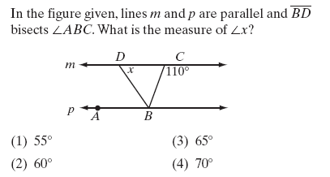

16. Which line is parallel to the line whose equation is  and also passes through the point ?

|  |  |
| --- | --- |
| 1) |  |
| 2) |  |
| 3) |  |
| 4) |  |

17. The coordinates of the endpoints of  are  and . The equation of the perpendicular bisector of  is

|  |  |
| --- | --- |
| 1) |  |
| 2) |  |
| 3) |  |
| 4) |  |

18. Which statement describes the lines whose equations are  and ****?

|  |  |
| --- | --- |
| 1) | They are segments. |
| 2) | They are perpendicular to each other. |
| 3) | They intersect each other. |
| 4) | They are parallel to each other. |

19. Triangle *ABC* has vertices , , and . Which equation represents the perpendicular bisector of ? *(please use scrap graph paper and go through all 4 steps showing all the work)*

|  |  |
| --- | --- |
| 1) |  |
| 2) |  |
| 3) |  |
| 4) |  |

20.  In the accompanying diagram, given:

http://regentsprep.org/regents/math/geometry/MultipleChoiceReviewG/Quadri1.gif

What is the value of *x*?

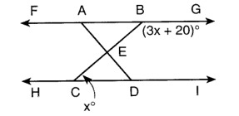

21. In the diagram at the right, parallel lines *a* and *m* are cut by transversal *t,*

*m<*1 = 4*x* + 16 and *m<*2 = 2*x* - 22.  Find *m<*1.

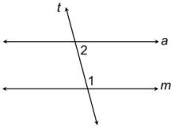

22. In the diagram at the right, lines *a* and *m* are parallel with transversal *t.*  Find the number of degrees in the angle labeled *x.*

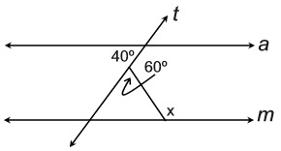

23. The diagram at the right, line *a* is parallel to line *b*, and line *t* is a transversal.  If *m<*1 = 97 and *m<*2 = 44, find *m<*3.

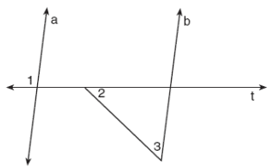

24. In the diagram at the right, lines *f* and *g* are parallel, and lines *a* and *b* are parallel.

The *m<x* = 75.  What is the value of *m<y + m<z* ?

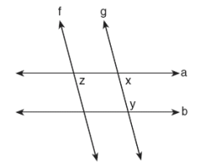

25. Given: ∆ *ABC* and ∆*EDC*, *C* is the midpoint of *BD* and *AE*

Prove: *AB ll* *DE*



26. Given: *AB ll* *DE, BD bisects AE at C*

*Prove: AB  DE*



