Biology Midterm
Practice Regents Questions

Name ____________________________ Period _____ Date __________
Ms. De Pinto
Page Left Intentionally Blank

Biology Midterm Regents Review Sheet
Use this review sheet to help you study for the Biology Midterm Exam in January. Not everything covered on the exam will be on this review sheet, but knowing the ideas and concepts given here will greatly assist your preparation for the midterm. Lab techniques from the Diffusion Through a Membrane Lab as well as other class labs be addressed in the midterm examination (ex: making a wet-mount slide, using a microscope, knowing your indicators). You may review these lab activities in extra help. Good luck!

70 THINGS TO KNOW FOR THE MIDTERM EXAM

Cells & Cell theory
- Cells that need a large amount of energy have many mitochondria.
- Ribosomes are the organelle of protein synthesis.
- Living things come from existing living things.
- Viruses lack organelles, the ability to perform basic life functions, and are considered nonliving.
- Cells come from other cells.
- Mitochondria and chloroplasts contain their own DNA.
- From smallest to largest the sequence of biological organization is:

    - organelle cell tissue organ organ system organism

- Cellular respiration produces carbon dioxide (CO2) and photosynthesis uses the CO2 in a cycle.
- Genetic information is stored in nucleic acids (DNA & RNA) in the nucleus of eukaryotic cells.
- The phospholipid bilayer cellular membrane functions in cell excretion.
- Chloroplasts are the site of ATP generation and photosynthesis in plants.
- Cellular membranes have protein transport molecules that span the membrane.
- Membrane transport molecules may use passive or active transport to move substances.
- Active transport uses energy to move substances against the concentration gradient; i.e. low concentration to high concentration.
- Hypotonic is lower substrate concentration outside a cell than is inside a cell.
- Isotonic is equal substrate concentration outside and inside a cell.
- Hypertonic is a higher substrate concentration outside than is inside a cell

Experimental Design & Understanding Biology
- Cell theory was developed following advances in microscopes.
- A hypothesis is a testable idea you support with experimentation.
- A valid experiment only has one experimental variable at a time.
- A control group has no experimental variable added to it.
- Microscopes allow less light through under higher power magnification.
- Depth of field decreases under higher power magnification.
- Staining increases the contrast of items to be seen.

MR STRANGER (Properties of Living things)
- Know ALL eight MR STRANGER properties!
- Excretion is the removal of cellular metabolic wastes.
- Reproduction is not required for an organisms’ survival.
- Regulation controls and coordinates life activities in a cell or organism.
- Metabolism is needed for something to be ‘alive’.
- Transport is moving materials across cellular membranes and between cells.
- All life process aim to maintain homeostasis, or a general dynamic equilibrium.

Biochemistry
- Simple sugars (monosaccharides) are the basis for synthesizing larger polysaccharide molecules.
- Most sugars end in -ose.
- Amino acids (peptides) are the basis for synthesizing larger polypeptide (protein) molecules.
- Enzymes have specificity of shape for molecules.
- Enzymes have optimal ranges of temperature and pH.
- Enzymes will have a faster reaction rate as substrate is added until the enzyme rate levels out.
- Organic molecules must contain carbon (C), hydrogen (H), and oxygen (O).
- Starches, fats, proteins, and nucleic acids are complex molecules made from simple molecules.
- Lipids work as cell membrane structures and long term energy storage.
- An enzyme is named for the molecule it works with, i.e. protease protein; lipase lipids.
- Most enzyme end in -ase.
- The energy ‘locked’ in covalent bonds is released during cellular respiration.
- Glucose is a 6-carbon hexagon shaped simple sugar that is the basis for cellular respiration.
- Starch and cellulose are long chains of sugars (polysaccharides).

Lab Practices
- Diffusion across a membrane is passive if no additional energy is used. Diffusion in the lab was passive.
- Diffusion moves from high concentration to low concentration. Water movement is a special type of diffusion (osmosis).
- Selective permeability allows some items to pass through a membrane and restricts others.
- In the diffusion lab starch molecules were too large to fit through the membrane. Glucose, iodine, and water pass freely through the membrane.
- The red onion cell lost water (plasmolysis) when salt water was placed on the slide. The red onion cell gained water when distilled water was placed on the slide.

Cells and Cell Growth
- Small cells allow easier transport of substances than do larger cells.
- Cell division is actually cell multiplication (one becomes two).
- Chromosomes provide instructions for cell processes.
- Chromosomes are not visible until the coiled up in prophase.
- Chromosomes duplicate before cell division (ex: mitosis &meiosis).
- The cell cycle is growth, life, and division of the cell.
- Most of a cell’s “life” is done in Interphase.
- Mitosis comes AFTER Interphase and is the division of the cell.
- Mitosis occurs in single, multiple, and very complex organisms.
- Mitosis creates IDENTICAL copies (clones) of the parent cell.
- Phases of mitosis are Prophase, Metaphase, Anaphase, & Telophase (PMAT).
- In prophase, chromosomes become visible because the chromatin coils up.
- In metaphase, chromatids line up in the middle of the cell.
- In anaphase, the chromatids split at the centromeres, and one-half goes to each cell end.
- In telophase, the cell divides up the organelles and begins to reform two nucleuses.
- Cytokinesis is NOT a part of mitosis, but the last step before interphase begins again.
- Cytokinesis finishes dividing the cell contents and forms two identical daughter cells.
- The function of the cell cycle & mitosis is to make cells for growth, repair, and duplication.
- Cancer is uncontrolled cell growth caused by a problem with the DNA instructions.
- DNA may be damaged by mutagens (ex: toxins, radiation), disease, & age.
- Damaged DNA causes the cells to follow “wrong” instructions, and the cancer cells grow uncontrolled.
- Damaged DNA causes the wrong proteins to be created, and they cell cannot function as intended.
Scientific Method Regents Review #1
The presence of air is believed to be important for root growth in bean plants. The apparatus available to conduct an investigation is shown below. There are enough bottles and other materials to have multiple setups. Air (for aeration) can be bubbled into the bottle through the rubber tube.
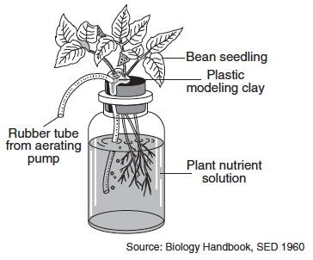
Design an experiment to test the effect of aeration on the growth of roots of bean seedlings. In your answer, be sure to:
- state one hypothesis the experiment would test

- describe how the control group will be treated differently from the experimental group

- identify the dependent variable in the experiment

- state one reason why many setups should be used in both the experimental and control groups

- state one reason why several different kinds of seedlings were not tested in this experiment
Page Left Intentionally Blank

Scientific Method Regents Review #2
1. Which activity would be an appropriate first step when designing an experiment?
- reporting a conclusion based on multiple experimental trials
- researching the problem, using information from a variety of sources
- creating a data table to organize experimental observations
- repeating the experiment with a different hypothesis
2. Students noticed that some of their classmates have a hard time concentrating during class. They thought it may have some connection with the fact that these students consume energy drinks just before class. An experiment was proposed to find out if there is a connection between energy drinks and the lack of ability to concentrate in class. A properly designed experiment to determine this would include having
- the whole class drink energy drinks and no water at all, for the entire time of the experiment
- the whole class drink water and no energy drinks at all, for the entire time of the experiment
- the students drink both water and an energy drink just before class
- half the students drink water and the other half drink an energy drink just before class
Base your answer to questions 3-5 on the information below and on your knowledge of biology.
An experiment was carried out to answer the question “Does the pH of water affect the growth of radish plants?” Two groups of ten radish plants were set up. One group was watered with water having a pH of 3.0, and the other group was watered with water having a pH of 7.0. Both groups of plants received the same amount and intensity of light, the same amount of water, and they were grown in the same type of soil. The heights of the radish plants were measured every 2 days for a period of 2 weeks.
3. Which sentence is a possible hypothesis that was tested in this experiment?
- Does the pH of water affect the growth of radish plants?
- Will the amount of water alter the heights of the radish plants?
- The temperature of the water will affect the heights of the radish plants.
- The pH of the water will affect the heights of the radish plants.
4. Which activity might help to increase the validity of this experiment?
- repeating the experiment several times
- using two different types of radish seeds in each group
- using the same pH for both groups of plants
- placing one set of plants in sunlight and one in darkness
5. What was the dependent variable in this experiment?
- heights of the plants 3. pH of the water
- temperature of the water 4. type of soil

6. Daphnia are freshwater organisms sometimes referred to as “water fleas.” Design an experiment that could be used to test the effects of temperature on the size of a daphnia population. In your experimental design, be sure to:
- state a hypothesis to be tested

- describe how the control group will be treated differently from the experimental group

- identify the independent variable in the experiment
- identify the type of data that will be collected
- State one way to increase the validity of the experiment

Life Processes and the Cell Regents Review Questions

Part 1. Life Processes
1. Organisms undergo constant chemical changes as they maintain an internal balance known as
- interdependence 2. homeostasis 3. synthesis 4. recombination
2. Which term includes all the activities required to keep an organism alive?
- growth 2. excretion 3. metabolism 4. nutrition
3. The activity of a single-celled organism is represented in the diagram below.
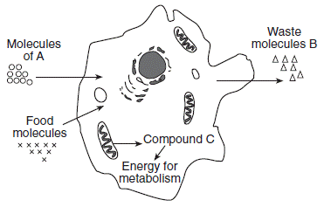
Which concept is best illustrated by this diagram?
- The life functions performed by single-celled organisms are different from the life functions performed by complex organisms.
- Single-celled organisms carry out life functions that are essential for survival.
- Since single-celled organisms lack organs, they can survive only in moist environments.
- Single-celled organisms contain one organelle that performs all the life functions.
Part 2. Cell Organelles
4. Which sequence represents structures organized from most complex to least complex?
- chloroplast → guard cell → leaf → oak tree
- guard cell → chloroplast → leaf → oak tree
- oak tree → guard cell → leaf → chloroplast
- oak tree → leaf → guard cell → chloroplast
5. Single-celled organisms are able to maintain internal stability because they
- have multiple organ systems
- work with other cells
- contain structures that perform life functions
- carry out photosynthesis to produce food
6. Which statement best describes the organelles in a cell?
- All organelles are involved directly with communication between cells.
- Organelles must work together and their activities must be coordinated.
- Organelles function only when there is a disruption in homeostasis.
- Each organelle must function independently of the others in order to maintain homeostasis.
7. The diagram below represents two cells viewed using the same magnification with the same microscope.
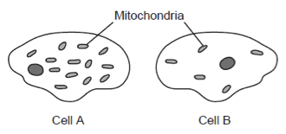
One possible conclusion that can be drawn about the activity of these two cells is that
- more active transport occurs in cell B than in cell A
- more active transport occurs in cell A than in cell B
- cell B uses some of the extra mitochondria to make food
- cell A is a plant cell since it has a cell wall
8. Which cell structures are correctly paired with their functions?
- The mitochondria produce enzymes, and ribosomes transport them.
- The ribosomes make proteins, and the nucleus stores genetic information.
- The cell membrane makes enzymes, and cytoplasm transports them.
- The vacuole stores genetic information, and chloroplasts make proteins.
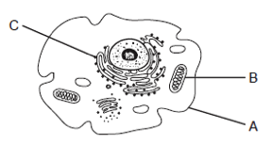
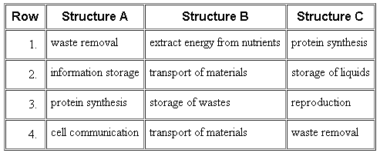
9. Structures in an animal cell are represented in the diagram below. Which row in the chart correctly identifies the functions of structures A, B, and C?

10. An ameba, a one-celled organism, can move, ingest, and transport materials within the cell, because it has
- organs 2. organelles 3. tissues 4. systems
Part 3. Cell Transport
11. Which substance can enter a cell by diffusion without having to be digested?
1. water 2. protein 3. starch 4. fat
12. A function of cell membranes in humans is the
- synthesis of the amino acids 3. production of energy
- replication of genetic material 4. recognition of certain chemicals

13. A substance is most likely to diffuse into a cell when
- it is a large organic food molecule such as protein or starch
- it is enclosed in an organelle such as a vacuole
- the concentration of the substance is greater outside the cell than inside
- the pH of the substance is greater than the pH of the cell
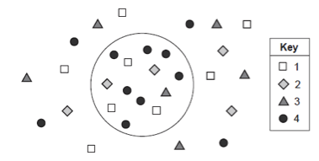
14. The diagram below represents a cell and some molecules in its environment.
Which molecule would require the use of energy in order to be brought into the cell?
- 1
- 2
- 3
- 4

15. The diagram below represents what occurred when an onion cell and a red blood cell were placed in distilled water.
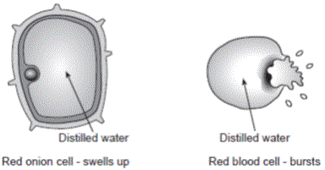
The best explanation for why the onion cells do not burst, while red blood cells often do, is that
- the red blood cells have only a cell membrane, which does not protect them from bursting
- the onion cells do not have a cell wall that could protect them from bursting
- the onion cells have a cell membrane, which can protect them from bursting
- the red blood cells have a cell wall, which does not protect them from bursting

Page Left Intentionally Blank
Biochemistry Regents Review
1. One effect of uncontrolled diabetes is that the blood might develop an acidic pH. As a result, cells may not be able to regulate their internal pH. Within these cells, this could cause a disruption of the function of biological catalysts known as
- enzymes 2. toxins 3. antibodies 4. antigens
2. In order to enter cells and be useful to the body, starch must be
- absorbed through the skin 3. broken down into fats and water
- digested into simple sugars 4. converted to carbon dioxide and ATP
3. The function of a specific enzyme is most directly influenced by its
- molecular size 2. physical shape 3. carrying capacity 4. stored energy
4. Which statement explains the importance of maintaining a constant internal environment to ensure proper enzyme functioning?
- Changes in pH and temperature will cause the enzyme reaction rate to be too fast.
- Temperature and pH determine amino acid sequences in enzymes.
- Changes in pH will change the genetic instructions of enzymes.
- Increasing the temperature and pH can alter the specific shape of enzymes.
5. Which group consists entirely of organic molecules?
- protein, oxygen, fat 3. protein, starch, fat
- water, carbon dioxide, oxygen 4. water, starch, protein
6. Organisms living in a bog environment must be able to tolerate nitrogen-poor, acidic conditions. Bog plants such as the Venus flytrap and sundew are able to obtain their nitrogen by attracting and consuming insects. These plants produce chemicals that break down the insects into usable compounds.
Which compounds present in insects are composed of the amino acids that provide the Venus flytrap and sundew with much of their nitrogen?
- proteins 2. sugars 3. carbohydrates 4. fats

7. All chemical breakdown processes in cells directly involve
- reactions that are controlled by catalysts
- enzymes that are stored in mitochondria
- the production of catalysts in vacuoles
- enzymes that have the same genetic base sequence

Base your answers to questions 8-9 on the diagram below and on your knowledge of biology. The diagram represents a portion of a starch molecule.
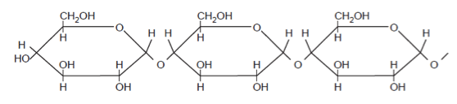
8. The energy in this molecule is stored
- in the bonds between atoms
- in the oxygen found in the molecule
- when the carbon atoms break off
- when water breaks this molecule apart
9.The building blocks for this molecule are
- amino acids 2. simple sugars 3. Fats 4. molecular bases
10. A fully functioning enzyme molecule is arranged in a complex three-dimensional shape. This shape determines the
- specific type of molecule it interacts with during a reaction
- rate at which the enzyme breaks down during a reaction it regulates
- pH of all body systems
- temperature of the products of the reaction it regulates
Base your answer to questions 11-12 on the diagram below, which represents a metabolic process, and on your knowledge of biology.
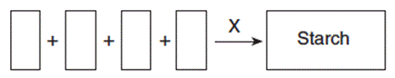
11. The letter X in the process represents
- an antibody 2. a hormone 3. a receptor 4. an enzyme
12.This process best represents
- the bonding of amino acids to form a starch molecule
- the digestion of amino acids to form a starch molecule
- the bonding of simple sugars to form a starch molecule
- the digestion of simple sugars to form a starch molecule
Photosynthesis - Respiration Regents Review
1. The equations represent two biochemical processes that occur in living organisms. The letter X represents a molecule produced from process 1.
Process 1: oxygen + glucose → carbon dioxide + water + X
Process 2: carbon dioxide + water → oxygen + glucose
Which process occurs in the cells of a green plant leaf?
- process 1, only 3. neither process 1 nor process 2
- process 2, only 4. both process 1 and process 2
2. Which two processes are responsible for keeping the percentage of atmospheric oxygen at relatively constant levels?
- circulation and coordination 3. respiration and coordination
- respiration and photosynthesis 4. photosynthesis and circulation
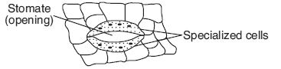
3. The diagram to the right represents specialized cells in the surface of the leaf of a green plant.
The main function of these cells is to
- change the size of the stomate to regulate water loss
- close the stomate to keep dust and dirt out of the leaf
- directly provide leaf cells with the water involved in photosynthesis
- allow newly formed glucose to be released from the leaf
4. The energy used to obtain, transfer, and transport materials within an organism comes directly from
- ATP 2. DNA 3. Sunlight starch
5. Some sea slugs store chloroplasts obtained from algae they have ingested. The chloroplasts continue to carry out photosynthesis within the slugs. What advantage would this activity be to these sea slugs?
- The slugs with chloroplasts can synthesize some of their own food.
- The slugs with chloroplasts no longer need to carry out respiration.
- The chloroplasts provide the slugs with camouflage that protects them from UV radiation.
- The chloroplasts contain enzymes that allow the slugs to digest starch.
6. More energy can be released from a fat molecule than from a glucose molecule because the fat molecule contains more
- Genes 2. organic compounds 3. chemical bonds 4. mitochondria

7. During the process of photosynthesis, energy from the Sun is converted into
- chemical energy in the bonds of inorganic molecules
- chemical energy in the bonds of organic molecules
- enzymes used to produce inorganic molecules
- enzymes used to produce organic molecules
8. Plant cells can synthesize energy-rich organic molecules, and later break them down to extract that energy for performing life processes. These activities require direct interaction between the
- chloroplasts and vacuoles 3. cell walls and ribosomes
- chloroplasts and mitochondria 4. ribosomes and mitochondria
9. A biological process that occurs in plants is represented below.
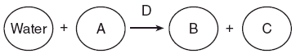
Which row in the chart below identifies the lettered substances in this process?
Row | A | B | C | D
 | enzymes | oxygen | carbon dioxide | glucose
 | carbon dioxide | glucose | oxygen | enzymes
 | glucose | enzymes | oxygen | carbon dioxide
 | oxygen | glucose | carbon dioxide | enzymes
10. A cell in the leaf of a corn plant contains more chloroplasts than a cell in the stem of a corn plant. Based on this observation, it can be inferred that, when compared to the cell in the stem, the cell in the leaf
- synthesizes more sugar
- has a higher chromosome count
- produces fewer proteins
- uses less carbon dioxide
11. As it grows from a seed to a mature plant, a plant will grow taller and thicker. Which are abiotic factors most responsible for the increase in the mass of the plant?
- water, minerals, bacteria
- sunlight, oxygen, plant receptors
- minerals, water, plant enzymes
- water, sunlight, carbon dioxide

12. Which process is most closely associated with the regulation of water loss from the leaves of trees?
- digestion of water within the cytoplasm in the leaf cells of the trees
- synthesis of protein by the chloroplasts in the leaf cells of the trees
- movement of water through leaf openings controlled by the guard cells
- absorption of nitrogen through leaf openings controlled by the guard cells
13. The buildup of waste products in muscle cells that are active might cause
- digestion
- cellular respiration
- increased fatigue
- decreased heart rate
14. The diagram below represents a cell structure involved in converting energy stored in organic molecules into a form used by animal cells.
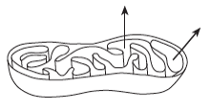
The arrows represent the movement of which substances?
- carbon dioxide and sugar
- oxygen and ATP
- ATP and carbon dioxide
- oxygen and sugar
15. Photosynthesis and respiration are alike in that they both
- require the Sun as a direct source of energy
- result in the production of glucose molecules
- require specific catalysts
- occur within mitochondria

Page Left Intentionally Blank

Reproduction Regents Review
1. The diagram represents events that occur during embryonic development. Letters A through E represent structures.
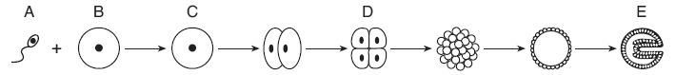
Between which two letters does mitosis occur?
- A and B 2. B and C 3. A and C 4. C and D
Base your answers to the next question on the diagram below. The diagram represents the reproductive systems of the human female and male.
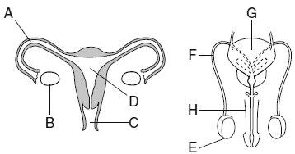
2. Which structure(s) produces cells that have the potential to become gametes?
- A and H 2. B and E 3. C and G 4. D and H
3. A human skin cell contains 46 chromosomes. A frog sperm cell contains 12 chromosomes. Which pair of numbers shows the chromosome number of a normal gamete from each of these species?
- human 46; frog 12 3. human 46; frog 24
- human 23; frog 24 4. human 23; frog 12
4. Which expression correctly represents a reproductive process that usually occurs in humans where 2n is equal to the number of chromosomes in each body cell?
- n + n → n 3. n + n → 2n
- n + 2n → 2n 4. 2n + 2n → 4n
5. Which processes lead to the greatest variety of genetic combinations?
- asexual reproduction and cloning 3. meiosis and fertilization
- meiosis and mitosis 4. cloning and mitosis

6.Which structure is correctly paired with its function?
- ovary — provides milk for newborns 3. testis — development of sperm
- placenta — storage of released eggs 4. uterus — produces estrogen
7. Which sequence best represents sexual reproduction?
- mitosis → gametes → zygote → fertilization
- gametes → meiosis → mitosis → fertilization
- fertilization → gametes → meiosis → zygote
- meiosis → gametes → fertilization → zygote
8. Asexual reproduction produces offspring that each contain
- genetic information from one parent
- genetic information from two parents
- less genetic information than either parent
- a unique combination of genetic information
9. The diagram below represents a form of cellular reproduction.
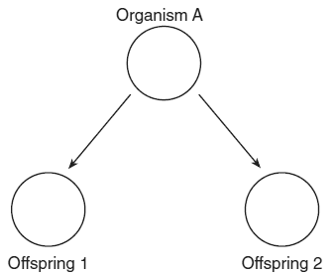
As a result of this process, offspring 1 and offspring 2 will have
- the same number of genes but different traits
- a different number of genes but the same traits
- the same number of genes and the same traits
- a different number of genes and different traits
10. A human cell that contains all of the information necessary for the growth and development of a complete organism is
- a sperm cell
- a gamete
- a zygote
- an egg cell

