Name________________________________________________ Midterm Review #8 due:____________

In order to get full credit for this, you must give a good/great attempt at the Proofs, question numbers 6,7,8,9,10. If you are struggling with them, don’t know what to do, etc., be proactive! Go to extra help, email Mr. Martino with specific questions, etc.!! No excuses!!!

1. Determine the length of line segment GH rounded to the nearest hundredth: G(-1, 9) and H(4, 8)

2. Determine the Midpoint of line segment GH: G(-1, 9) and H(4, 7)

3. M(2,1) is the Midpoint of line segment CD, and point C has coordinates C(3, -2). Find the coordinates of point D.

4. Determine the equation of a line parallel to the line represented by the equation $y=\frac{1}{4}x+1$ and passes through the point (-4,8)

5. Determine the equation of a line perpendicular to the line represented by the equation $y=\frac{1}{4}x+1$ and passes through the point (-4,8)

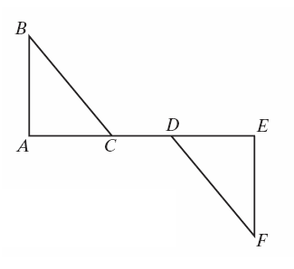6.Given:  and .

Prove: 

7.

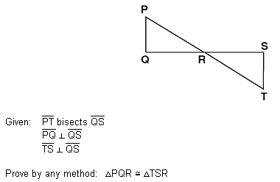

8.

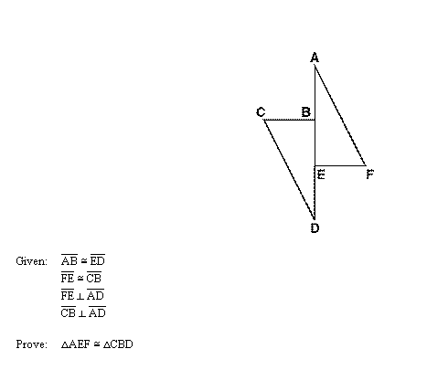

9.

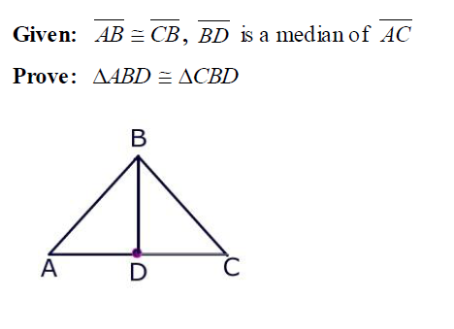

10. Given:  and  intersect at *B*, , and  bisects .

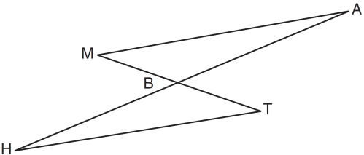

Prove: 

11. In the accompanying diagram of triangles *BAT* and *FLU*,  and .

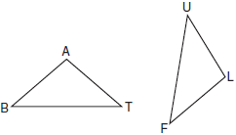

Which statement is needed to prove ?

|  |  |
| --- | --- |
| 1) |  |
| 2) |  |
| 3) |  |
| 4) | None of the above |
|  |  |

12. In the diagram below, .

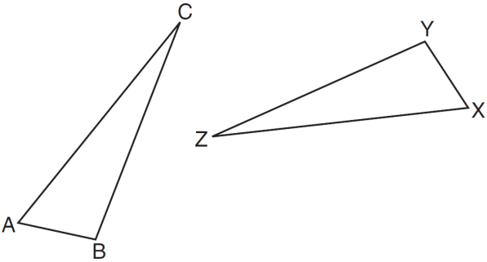

Which statement must be true?

|  |  |
| --- | --- |
| 1) |  |
| 2) |  |
| 3) |  |
| 4) |  |

13. Given: ∆*BAC* and ∆*EDF*, 



Which additional piece of information is *not* sufficient to prove ?

(1)  and  (3)  and 

(2)  and  (4)  and 

14. Which of the following pairs of triangles can *not* be proved congruent by AAS?

