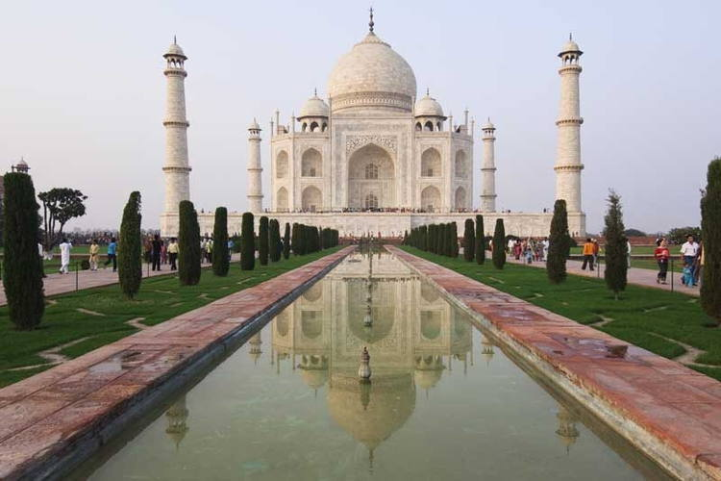
Pre-AP World Throwback!
- In the first centuries of Mughal rule in India, this religion reached its peak of influence as a political and cultural force in South Asian history: ___________________________________

- Under Mughal emperors, these two religions blended:
___________________, __________________.

- Which religion was practiced by the majority? _______________________________.

- The Mughal emperor _______________________________ pursued a policy of Muslim and Hindu cooperation, promoting religious tolerance, encouraging inter-marriage, doing away with the non-Muslim head tax, promoting Hindus to government ranks, promoted art and architecture of both major religions.
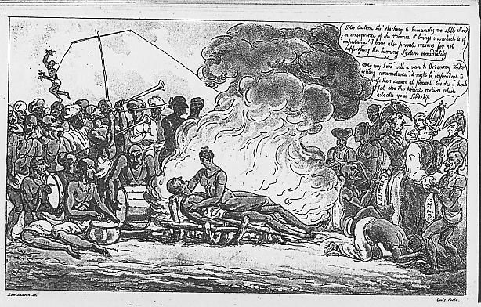
- Although it was legally outlawed under Mughal rule, the practice of ______________ was still practiced. In the dynasty’s later years, caste restrictions of women increased, widow remarriage of Hindus nearly disappeared, child marriage grew more popular lowering the age limit, and the seclusion of upper-caste Hindu and Muslim women was more strictly enforced. Child infanticide of girls increased.

- The ______________________________ were instrumental in the decline of the Mughal Empire in India. Sir Robert Clive became the chief representative of the _____________________________________, taking control of Indian trade by the region on Bengal, and taking the lands surrounding the city of Calcutta. From there, it was a march inland.

