 |  |  |  |  |  |  |  |  |  | curriculum.newvisions.org/social-studies  Timothy Lent - tlent@newvisions.org  Kameelah Rasheed - krasheed@newvisions.org | 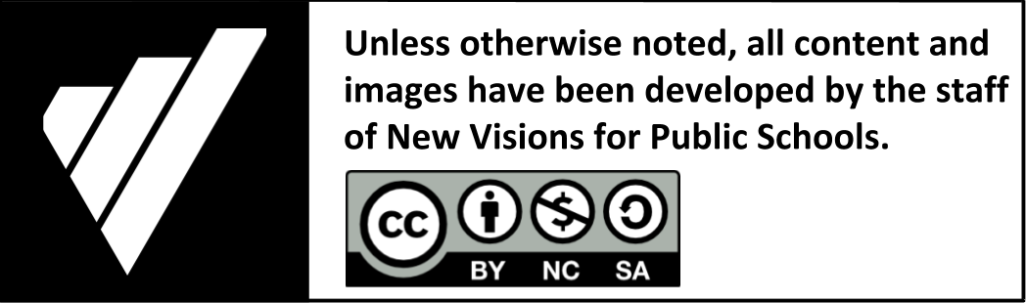
Please Read: We encourage all teachers to modify the materials to meet the needs of their students. To create a version of this document that you can edit:
1. Make sure you are signed into a Google account when you are on the resource.
2. Go to the "File" pull down menu in the upper left hand corner and select "Make a Copy." This will give you a version of the document that you own and can modify.
Teacher Overview
Go directly to student-facing materials!

SQ 15. What led to independence movements in the Western Hemisphere in the 18th and 19th centuries?

Unit Essential Question(s): How do new ideas spark change? Do these changes last? Link to Unit
Supporting Question(s): What led to independence movements in the Western Hemisphere in the 18th and 19th centuries?
Objective(s):
- Contextualize independence movements in the Western Hemisphere in the 18th and 19th centuries.

Vocabulary
The following words are introduced or reinforced in this lesson. Reference the unit vocabulary tracker for more information. Click here for the New Visions Global History glossary.
Word/Phrase  (part of speech) | Definition
abolish (v.) | to stop something from happening or end something
counter-revolutionary (n.) | a person who reacts to a revolution in which those originally in power try to counteract the changes that took place as a result of the revolution
Creole (n.) | a person of European descent born in an overseas colony
equality (n.) | the state of being equal
Father MIguel Hidalgo (n.) | (1753-1811) a Mexican Roman Catholic priest who was a leader of the Mexican War of Independence
fraternity (n.) | friendship and mutual support
French Revolution (n,) | (1789-1799) a political revolution during which the lower and middle class in France, frustrated over social, economic, and political problems in the country and inspired by Enlightenment ideas overthrew King Louis XVI and tried to institute a more democratic government
Haiti (n.) | a nation in the Caribbean Sea that shares the island of Hispaniola with the Dominican Republic
Haitian Revolution (n.) | (1791-1804) a successful slave revolt and revolution that led to Haiti’s independence from France
José de San Martín (n.) | (1778-1850) an Argentine general and leader of South America’s independence movement from Spain
liberty (n.) | the freedom to do what you’d like to do
mestizo (n.) | a person of mixed Native American and European descent in Spanish colonies
Mexican War of Independence (n.) | (1810-1821) an armed conflict that led to Mexico’s independence from Spain
mulatto (n.) | A person of mixed African and European descent in Spanish colonies
Napoleon Bonaparte (n.) | military leader and later emperor of France who brought order and stability towards the end of the Revolution. He attempted to conquer all of Europe, but failed and was eventually exiled to a remote island for the rest of his life
Napoleonic Wars | (1803-1815) a series of major wars in Europe during which Napoleon Bonaparte I attempted to conquer the continent, after his final defeat Napoleon was exiled to an island in the Atlantic Ocean and European powers redrew the borders in the continent at the Congress of Vienna
nationalism (n.) | strong feelings of support for one's nation
peninsulare (n.) | a person born in Spain who lived in a Spanish colony
Simón Bolívar (n.) | (1783-1830) leader of Latin American Independence movements in South America
sovereignty (n.) | the power of a state to rule itself
St. Domingue (n.) | the name for Haiti when it was a French colony
Toussaint L'Ouverture (n.) | (1743-1803) an ex-slave and leader of the Haitian Revolution

Formative Assessment Possible Responses
These responses represent possible answers to the formative assessment tasks in this lesson. They are not the only correct answers. Create your own list of possible responses before using this resource with students to anticipate student misconceptions and adjust your instruction.

Content and Vocabulary Checklist
Use the checklist below to assess the use of important content and vocabulary in the unit.
Self  Yes/No | Teacher  Yes/No | Did you use the content and vocabulary below in your response?
 |  | French Revolution
 |  | Napoleon
 |  | Toussaint Louverture, Simón Bolívar, José de San Martín, or Father Hidalgo
 |  | independence

Event: The Independence Movement in Haiti, South America, or Mexico
Who?  individuals, groups of people, regions, nations involved | Toussaint Louverture, the French, Napoleon | Simón Bolívar, José de San Martín, the Spanish, Napoleon | Father Hidalgo, the Spanish, Napoleon
When?  date, year, era, “before __,” “after __” | 1791-1804 | 1810-1820 | 1810-1821
Where?  continents, regions, countries, geographic features nearby, describe the geography if relevant | Haiti | Throughout South America (except Brazil) | Mexico
How?  describe the process that took place | Through a slave revolt, then the French enlisted slaves to fight against other countries like the Spanish in exchange for freedom. In response to a renewed attempt to institute slavery by Napoleon, the Haitians were successful | Led by people like Simón Bolívar, José de San Martín who were well educated and trained military leaders from fighting for Spain against Napoleon, South Americans drove the Spanish out and declared independence | After a failed attempt, revolutionaries started smaller underground groups. One, led by Father Hidalgo, started the revolution  Though the first attempt failed, Mexico was successful after upper class Creoles and military leaders turned on the Spanish
Why?  use words and phrases like “led to,” because, and so to show connections between events and to explain why | The French created a social hierarchy in which slaves, who were a majority of the people in the colony, and free Mulattoes were less than Europeans.  Ideas of the Enlightenment and French Revolution inspired those rebelling  France | Inspired by ideals from the Enlightenment and French revolution about self government  The social structure set up by the Spanish was inequitable | Inspired by ideals from the Enlightenment and French revolution about self government  The social structure set up by the Spanish was inequitable
Combined Contextualization  Why did it happen when and where it happened? | Between 1791 and 1804, a slave revolt in Haiti became a revolution for the country’s independence from France. They fought against an inequitable social structure and to end slavery. Led by Toussaint L'ouverture, the Haitians were successful in defeating the French and freeing their country. | Starting in 1810, South American independence movements against Spain led by people like Simón Bolívar and José de San Martín were successful in driving out the Spanish. The leaders of the movements were educated in Enlightenment principles and inspired by the French Revolution. They were also well trained from fighting for Spain against Napoleon. | Spanish rule in Mexico created an unequal social structure that many, like Father Hidalgo who started the revolution disagreed with. He started a revolt that was initially unsuccessful, but found success when the cause gained support from upper class Creoles who had military training.

NYS Social Studies Framework
Key Idea | Conceptual Understandings | Content Specifications
10.2: ENLIGHTENMENT, REVOLUTION, AND NATIONALISM: The Enlightenment called into question traditional beliefs and inspired widespread political, economic, and social change. This intellectual movement was used to challenge political authorities in Europe and colonial rule in the Americas. These ideals inspired political and social movements. (Standards: 2, 3, 5; Themes: MOV, TCC, GEO, SOC, GOV, CIV) | 10.2c Individuals and groups drew upon principles of the Enlightenment to spread rebellions and call for revolutions in France and the Americas. | Students will examine the evidence related to the impacts of the French Revolution on resistance and revolutionary movements, noting the roles of Toussaint L’Ouverture and Simon Bolivar.

Social Studies Practices
NYS Social Studies Practices | New Visions Student Social Studies Practices
Gathering, Using and Interpreting Evidence (A1, A5)  Chronological Reasoning and Causation (B1, B3) | Contextualize Connect Cause and Effect

NYS Common Core Learning Standards
Reading | Writing | Speaking and Listening
Craft and Structure:  CCSS.ELA-LITERACY.RH.9-10.4: Determine the meaning of words and phrases as they are used in a text, including vocabulary describing political, social, or economic aspects of history/social science. | Text Types & Purposes:  CCSS.ELA-LITERACY.WHST.9-10.1: Write arguments focused on discipline-specific content. | Comprehension and Collaboration:  CCSS.ELA-LITERACY.SL.9-10.1: Initiate and participate effectively in a range of collaborative discussions (one-on-one, in groups, and teacher-led) with diverse partners on grades 9-10 topics, texts, and issues, building on others' ideas and expressing their own clearly and persuasively.

Drawings
The following Google Drawings are used in this lesson. We often place uneditable versions of these drawings in lesson resources because they are better image quality. If you would like to change the images, edit the drawings below and replace the images in the following pages.
Creoles
(Europeans born in the colonies)
Africans and Native Americans
Mestizos
(People of mixed Native American
and European descent)
Mulattoes
(People of mixed African and European descent)
Peninsulares
(born in Spain)

Associated Classroom Posters
Student Social Studies Practices Poster

Objective: | What led to independence movements in the Western Hemisphere in the 18th and 19th centuries?  - Contextualize independence movements in the Western Hemisphere in the 18th and 19th centuries.

Introduction
➡Directions: Examine the maps below and complete the See-Think-Wonder chart.
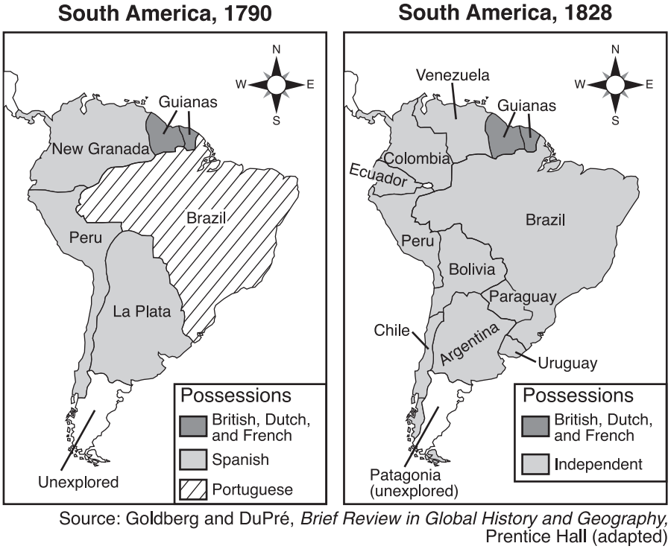  Source: Goldberg and DuPré, Brief Review in Global History and Geography, Prentice Hall (adapted) from the NYS Global History and Geography Regents Exam. | See  Identify at least two things you see in the maps to the left.
Think
What might have caused the changes in the maps from 1790 to 1828?
Wonder
What questions do you have about the information in the maps?

The French Revolution inspired other political revolutions.

The actions taken by the citizens in France to rebel against their government and the ideas of “liberty, equality, and fraternity,” democracy, and nationalism inspired independence movements in Haiti, South America, and Mexico.

French, Latin American and Haitian Revolutions: A Timeline
1789-1799 | 1791-1804 | 1810-1818 | 1820 |  |  | 1821-1824
French  Revolution | Haiti fights independence war and wins independence from France | Argentina fights war for independence and wins independence from Spain | Columbia fights war for independence and wins independence from Spain |  |  | Venezuela, Peru, Ecuador and Bolivia fights war for independence and wins independence from Spain
 |  | 1810-1820
 |  | Mexico fights war for independence and wins independence from Spain

Contextualize | The Haitian Revolution (1791-1804)  ➡Directions: Read the text and examine the map below, then answer the accompanying questions.

Prior to its independence, Haiti was a French colony known as St. Domingue. St. Domingue’s slave-based sugar and coffee industries were fast-growing and successful, and by the 1760s it was the most profitable colony in the Americas. With the economic growth, however, came increasing exploitation of the African slaves who made up the overwhelming majority of the population.  The Haitian Revolution was the result of a long struggle on the part of the slaves in the French colony of St. Domingue, but was also initiated by the free Mulattoes [people of both African and European descent] who had long faced the trials of being treated as semi-citizens. There were several slave rebellions in the Western Hemisphere, but the Haitian Revolution was the most successful. This had a lot to do with the influence of the French Revolution. The ideals of the revolution inspired rebellion and the events of the French Revolution gave the oppressed people of St. Domingue an opportunity to rebel. The Haitian Revolution would go on to serve as a model for those affected by slavery throughout the world.  There were three distinct classes in St. Domingue. First, there were the Whites, who were in control. Then there were the free Mulattoes, who straddled a very tenuous position in Haitian society. While they enjoyed a degree of freedom, they were repressed by the White power structure. For example, free Mulattoes were outlawed from holding office. Mulattoes were allowed to own land but society’s restraints made it highly unlikely that they could profit from it. Next came the slaves who, in Haiti, suffered under some of the harshest treatment found in the Caribbean. Slaves in Haiti were legally considered property and had no rights.  The French Revolution provided the Mulattoes and slaves with an opportunity and an inspiration after having witnessed the successful insurrection in France against the government’s long-standing denial of equal representation of the Third Estate. This was such a revolution in the structure of French society that its news spread like wildfire and was exactly the stimulus the slaves and Mulattoes in Haiti needed to inspire their revolt.  Adapted from: “Toussaint Louverture,” UNESCO.org; “The United States and the Haitian Revolution, 1791-1804,” Office of the Historian of the United States of America. | 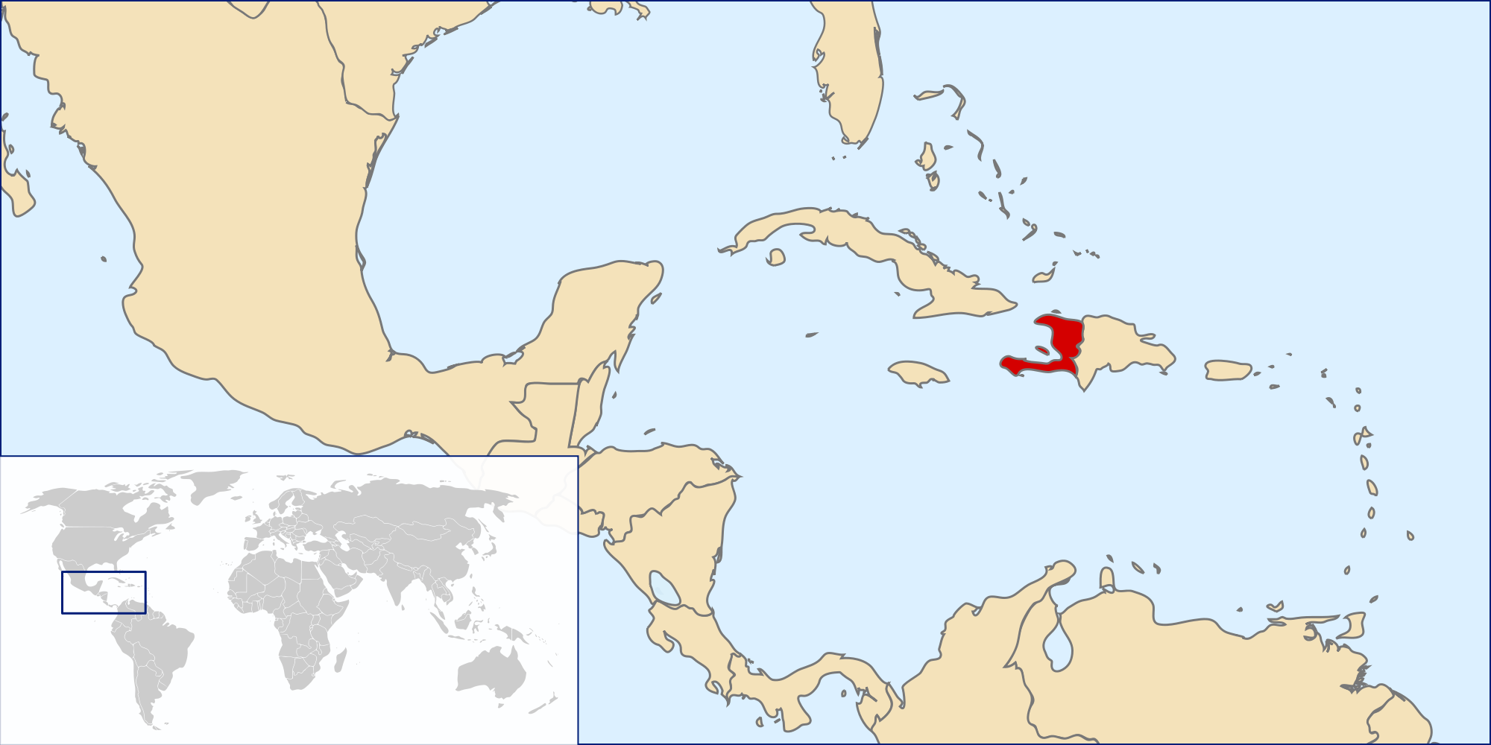  Map of Haiti in the Caribbean created by Varidon is licensed under the Creative Commons 3.o license.
1. Based on the excerpt, why did the mulattoes resent the French?

2. Based on the excerpt, why did the enslaved Africans resent the French?

3. What impact did the French Revolution have on the start of the Haitian revolution?

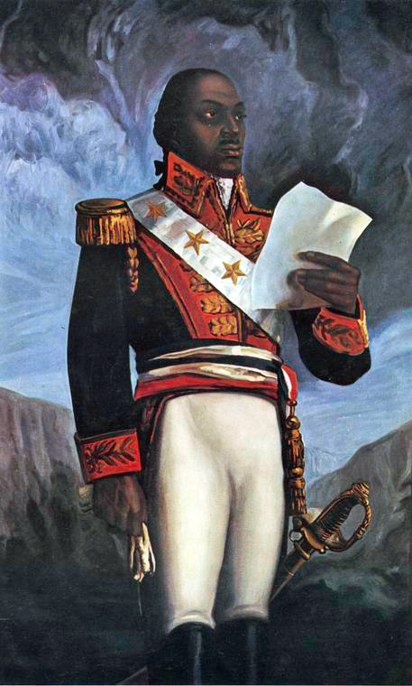  Painting of General Toussaint Louverture by unknown painter  Image is courtesy of wikimedia commons and is public domain | Revolutionary Leader: Toussaint L'Ouverture  Years: 1743-1803  Country: Haiti  Colonial Power Fought: France  Toussaint L’Ouverture used this letter to rally the blacks in San Domingo (Haiti), August 29, 1793.  Brothers and friends.  I am Toussaint L’Ouverture, my name is perhaps known to you. I have undertaken vengeance. I want Liberty and Equality to reign in San Domingo. I work to bring them into existence. Unite yourselves to us, brothers, and fight with us for the same cause, etc. . . .  Source: C. L. R. James, Lettres de Toussaint L’Ouverture, The Black Jacobins, The Dial Press (adapted) from the NYS Global History and Geography Regents Exam, January 2009.
Toussaint L'Ouverture was one of the leaders of the Haitian revolution and the first black man to become governor of a colony.

Toussaint L’Ouverture was born into slavery in approximately 1743 in the French colony of Saint Domingue. He belonged to a small and privileged class of slaves employed by masters as personal servants. The Count de Breda, Toussaint’s owner, actively encouraged him to learn to read and write. He developed a passion for books and his readings were to become a great influence in his political life. L’Ouverture was freed from slavery at around the age of 33 and colonial records show that he became a land and slave owner himself.
 | 4. How did Toussaint L'Ouverture learn to read?
The French Revolution of 1789 had a powerful impact on Saint Domingue. A complex civil war broke out in 1790 when free men of color claimed that they too were French citizens and should be allowed to enjoy the rights proclaimed in the Declaration of the Rights of Man.
5. A complex civil war broke out in 1790 when free men of color claimed that they too were French citizens. What does this reveal about the influence of the French Revolution on Haitians?
The following year, on August 22, 1791, L’Ouverture was one of the main organizers of a slave revolt that would eventually be known as the Haitian Revolution, the first and only victorious slave revolt in history.
In 1793, representatives of the French revolutionary government in Paris offered freedom to slaves who joined them in the fight against counter-revolutionaries and foreign invaders. The following year these orders were ratified by the revolutionary legislature in Paris, which abolished slavery throughout all French territories. This was a determining factor in L’Ouverture’s decision to join the French army. Under his increasingly influential leadership, the French defeated the British and Spanish forces that invaded Saint Domingue.
6. Why did the French revolutionary government offer freedom to slaves in Haiti?

7. What impact did this decision have on L’Ouverture? What role did L’Ouverture play in the French revolutionary wars against the British and Spanish?

Having made himself ruler of the island, L’Ouverture did not wish to surrender power to Paris and ruled Saint Domingue as its own country. In 1801 he issued a Constitution for the island, which provided for autonomy and established himself as governor for life. It abolished slavery and aspired to put in place a multiracial society composed of blacks, whites and mulattos.
8. What was significant about the constitution that L’Ouverture created for Haiti? How did the rights promised differ from life under French rule?
When Napoleon Bonaparte came to power in France, he aimed to return the Caribbean colonies to their earlier profitability as plantation colonies. In 1802, he dispatched an expedition of French soldiers to the island, led by his brother in law Charles Leclerc, to reestablish French authority and slavery. Leclerc arrested L’Ouverture and deported him to France where he was imprisoned in Fort de Joux and died on April 7, 1803.
9. What happened to Haiti when Napoleon Bonaparte came into power?
For a few months the island remained under Napoleonic rule. However, the French soldiers soon fell victim to weapons and disease and surrendered to the Haitians in November 1803. On January 1, 1804, the colony became the first black republic under the name of Haiti.
Adapted from: “Toussaint Louverture,” UNESCO.org.

Contextualize | Discontent in Latin America  ➡Directions: Read the text and examine the diagram below, then answer the accompanying questions.

How did the social and ethnic structures in Spanish
colonies lead to discontent?

- Creoles → resented being treated as second class citizens by the Peninsulares
- Mestizos and Mulattoes → angered that they were not treated
as citizens and did not have the same power as whites
- Native Americans and Africans → angered by enslavement and inhumane treatment

1. Was everyone in the Spanish colonies angry for the same reasons? Explain.

In the 1700s, educated creoles read the work of Enlightenment thinkers. Many creoles were sent to Europe to study as well. While there, they were inspired by the ideals of a revolution and national sovereignty or the authority of a state to govern itself or another state. | 2. How did many creoles come into contact with ideas of revolution and freedom?
In 1808, Napoleon invaded Spain, ousted the Spanish king and placed his brother Joseph in control of Spain and its colonies. Many in Latin America saw this as a moment of weakness and an opportunity to reject foreign rule and demand freedom from the colonial crown. | 3. Why did Latin American leaders decide to fight for their freedom after 1808 instead of an earlier time?

Contextualize | José de San Martín  Years: 1778-1850  Country: Argentina, Chile, Peru  Colonial Power Fought: Spain

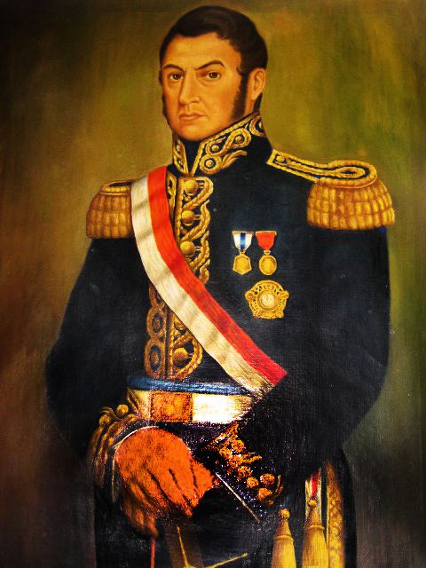  Painting of José de San Martín by unknown painter  Image is courtesy of Wikimedia Commons | José de San Martín was a South American soldier and statesman who played an important role in winning the independence of several South American countries from Spain. José de San Martín was born at Yapeyú, a village on the northern frontier of Argentina, where his father was an official of the Spanish colonial government. At the age of 7, San Martín returned to Spain with his parents. He entered the Royal Academy as a cadet and was educated there with sons of the nobility of Spain. As a member of the Spanish army, he fought in some of the campaigns against French forces in the Peninsular War (a part of the Napoleonic Wars) and by 1811 had acquired the rank of lieutenant colonel.  Hearing of the revolt against Spain in his native Argentina, San Martín resigned from the Spanish army in 1812 and sailed for Buenos Aires to join the patriot forces. He took a prominent part in organizing Argentine troops and soon became military governor of the north to organize defense against Spanish troops in Upper Peru. In 1814, he secured the governorship of the province of Cuyo at the foot of the Andes. Here for 3 years he recruited and trained his Army of the Andes, since he believed that Argentina could not be safely independent unless Spanish forces were dislodged from Chile, Peru, and Bolivia.
 | 1. Why is it significant that San Martín resigned from the Spanish army? How might his military training become useful later?
In January 1817, San Martín led his army of Argentines and fugitives from Chile over the Andes and surprised the Spanish army in Chile. He made Chile completely free of Spanish troops by May 15, 1818, and began planning for an invasion of Peru. Within a year San Martín was able to occupy the capital, and on July 28, 1821, he proclaimed the independence of Peru from Spain. On August 3rd, he accepted the position of supreme protector of Peru.
Adapted from: http://www.biography.com/people/simon-bolivar-241196
2. What impact did San Martín have on Latin American Independence movements?

Contextualize | Simón Bolívar  Years: 1783 – 1830  Country: Venezuela, Ecuador, Bolivia, Peru and Colombia  Colonial Power Fought: Spain

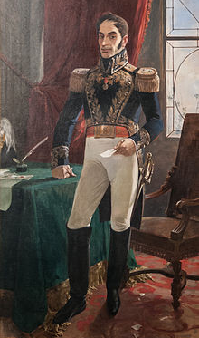  Painting of Simon Bolivar by Arturo Michelena  Image is courtesy of wikimedia commons and is public domain | Simón Bolívar was a Venezuelan military leader who was instrumental in the revolutions against the Spanish Empire. Born into wealth, Bolívar was sent to Spain for his education and quickly got involved in political life in Europe. After France, led by Napoleon Bonaparte, invaded Spain in 1808, he became involved in the resistance movement and played a key role in the Spanish American fight for independence. When Napoleon named Joseph Bonaparte King of Spain and its colonies, which included Venezuela, Bolívar joined the resistance movement. The resistance group based in Caracas gained independence in 1810, and Bolívar traveled to Britain on a diplomatic mission.  Finally, Bolívar returned to Venezuela and began a campaign to take control of that country from the Spanish. He and his followers invaded Venezuela on May 14, 1813. Bolívar was hailed as El Libertador (The Liberator), though civil war soon erupted in the republic, forcing him to flee to Jamaica and seek foreign aid. There he wrote his famous "Letter From Jamaica," detailing his vision of a South American republic with a parliamentary setup modeled after England and a life-long president. In 1825, the "Republic of Bolivia" was created in honor of the inspirational leader, hailed by many as El Libertador.  Adapted from: http://www.biography.com/people/simon-bolivar-241196
 | 1. What impact did the French Revolution and Napoleon have on Simon Bolivar and Venezuela’s independence movement?
 | 2. What impact did Bolívar have on South American independence movements?

Contextualize | Father Hidalgo  Years: 1753-1811  Country: Mexico  Colonial Power Fought: Spain

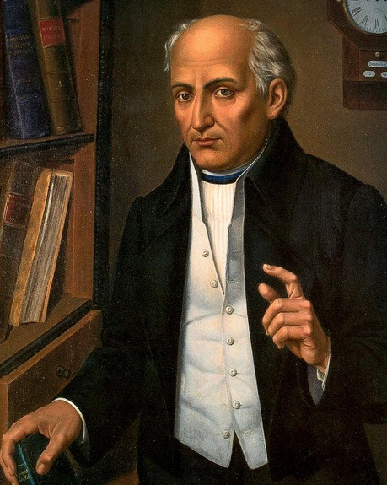  Painting of Father Hidalgo by anonymous painter  Image is courtesy of wikimedia commons and is public domain. | On September 16, 1810, Father Miguel Hidalgo y Costilla, a Roman Catholic priest from the small town of Dolores, Mexico delivered a speech known as the Grito de Dolores ("Cry of/from Dolores") at his church. The event became the start of the Mexican War of Independence (1810-1822) and the Grito de Delores became the battle cry of the Mexican War of Independence.  “My Children, a new dispensation [system of government] comes to us today…Will you free yourselves? Will you recover the lands stolen 300 years ago from your forefathers by the hated Spaniards? We must act at once.”  - Father Hidalgo, Sept 16, 1810  Adapted from: http://www.tamu.edu/faculty/ccbn/dewitt/adp/archives/documents/hidalgo.html, http://www.loc.gov/wiseguide/sept09/independence.html  The events of the French Revolution and the Napoleonic Wars had an influence on the Mexican War for Independence as it did in Haiti and other parts of Latin America. In 1808, Napoleon defeated Spain in Europe and briefly took over the Spanish colonies including Mexico, which was then called “New Spain.” In response, the city council of Mexico City rebelled against the new government and some were jailed. Those who were not and others who supported them created small rebel groups in other parts of Mexico.
 | 1. What impact did the French Revolution have on events in Mexico that led to the Mexican War for Independence?
Miguel Hidalgo y Costilla who led the Mexican independence movement against Spanish rule in 1810 was a part of one of these rebel groups. Born in May 1753 in Guanajuato, Hidalgo entered the priesthood in 1779. For the next quarter of a century, he performed his duties as a spiritual shepherd, but also read texts on political theory including the works of Enlightenment Thinkers. Hidalgo’s underground independence group read books and discussed emerging ideas on nationalism and political liberty.
2. How might reading political texts have influenced Hidalgo’s future role as a revolutionary leader?
When authorities moved to arrest him, he gathered together his followers and his parishioners and issued the “Grito de Dolores” on September 16, 1810. He quickly gathered an insurgent army that rampaged through central Mexico. His army, made up of almost 90,000 poor farmers and civilians was defeated by well trained Spanish troops and Hidalgo was taken prisoner by the Spanish and executed, but others continued the fight for Mexican Independence.

Inspired by Hidalgo and other revolutionaries like José María Morelos and Vicente Guerrero, and the ideals of the Enlightenment and French Revolution, upper class Creoles who once supported Spain, started to support Mexican Independence. In 1821, an alliance of the Creole upper class, rebel leaders, and the clergy came together led by the general Agustín de Iturbide to drive the Spanish out of Mexico and declared independence on September 27, 1821.
Adapted from:http://www.pbs.org/kera/usmexicanwar/biographies/hidalgo_costilla.html and https://www.history.com/this-day-in-history/spain-accepts-mexican-independence
3. Based on this excerpt, what finally made the Mexican War for Independence successful?

FA | SQ 15. What led to independence movements in the Western Hemisphere in the 18th and 19th centuries?
Connect Cause and Effect  Contextualize | ➡ Directions: Based on what you have learned, complete the task below.  Example: The Mongol Empire gained, consolidated, and maintained power throughout Asia during the 13th century.  Who? individuals, groups of people, regions, nations involved Roman Empire  When? date, year, era, “before __,” “after __” 476 CE  Where? continents, regions, countries, geographic features nearby, describe the geography if relevant Europe and North Africa  Why? use words and phrases like “led to,” because, and so to show connections between events and to explain why political turmoil, invasions, introduction of Christianity  How did this event lead to a turning point in history?/How is this event a turning point? the end of a 500 year empire, the splitting into western Europe and Byzantine empire, birth of the dark ages  Combined Contextualization Example 1 In 476 CE, the Roman Empire which stretched across Europe and North Africa, collapsed because of political turmoil, invasions, and tensions caused by the introduction of Christianity. The fall of the Roman Empire ended a 500 year empire, birthing the dark ages and a Europe divided between the West and the Byzantine empire. Writing Strategies Used: Prepositional phrase (In 476 CE) Conjunctions (because, and)  Combined Contextualization Example 2 The Roman Empire, an expansive state that stretched across Europe and North Africa, collapsed in 476 CE due to political turmoil, invasions, and tensions caused by the introduction of Christianity. The fall of the Roman Empire ended a 500 year empire, birthing the dark ages and a Europe divided between the West and the Byzantine empire. Writing Strategies Used: Appositives (...,an expansive state that stretched across Europe and North Africa,...) Conjunctions (due to, and)  Content and Vocabulary Checklist  Use the checklist below to assess the use of important content and vocabulary in the unit.  Self Yes/No Teacher Yes/No Did you use the content and vocabulary below in your response?  French Revolution  Napoleon  Toussaint Louverture, Simón Bolívar, José de San Martín, or Father Hidalgo  independence  Event: The Independence Movement in Haiti, South America, or Mexico  Who?  individuals, groups of people, regions, nations involved  When?  date, year, era, “before __,” “after __”  Where?  continents, regions, countries, geographic features nearby, describe the geography if relevant  How?  describe the process that took place  Why?  use words and phrases like “led to,” because, and so to show connections between events and to explain why  Combined Contextualization  Why did it happen when and where it happened?

