COMMACK HIGH SCHOOL PEER LEADERS
WILL PROVIDE HOMEWORK ASSISTANCE
AND TUTORING TO STUDENTS IN GRADES 6-8 AFTER SCHOOL ON THURSDAY AFTERNOONS
IN THE NEW CAFETERIA (2:50pm-3:30pm)
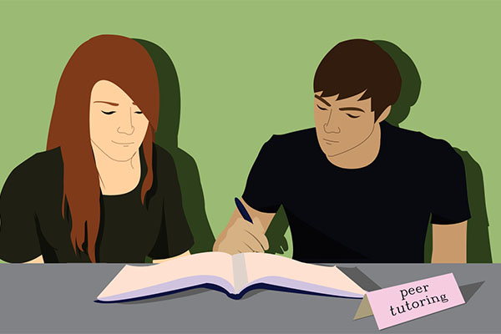
Sessions will be held on:
11/29, 12/6, 12/13, 1/3, 1/10, 1/17, 1/24, 1/31, 2/7,
3/7, 3/14, 3/21, 3/28, 4/4, 4/11, 5,2, 5/9, 5/16
ALL STUDENTS ARE WELCOME!!
Please see Mr. Schwartz in the CMS Counseling Center if you have any questions.
PLtutoringflyer1819.docx - Word

