Name: ______________________ Period: _________
Government Date: __________

Aim: Where do I fall on the political spectrum?

Do Now: Define the following terms below based upon your knowledge of the United States’ Government.

Word | Your Definition | Actual Definition
Liberal

Moderate

Conservative

Political Spectrum

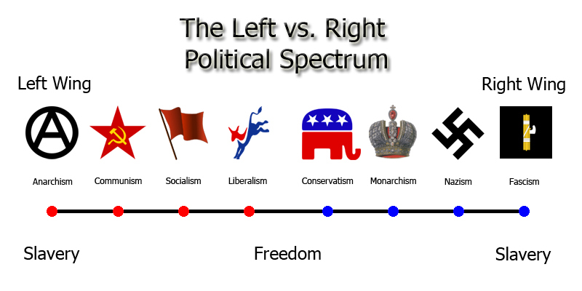

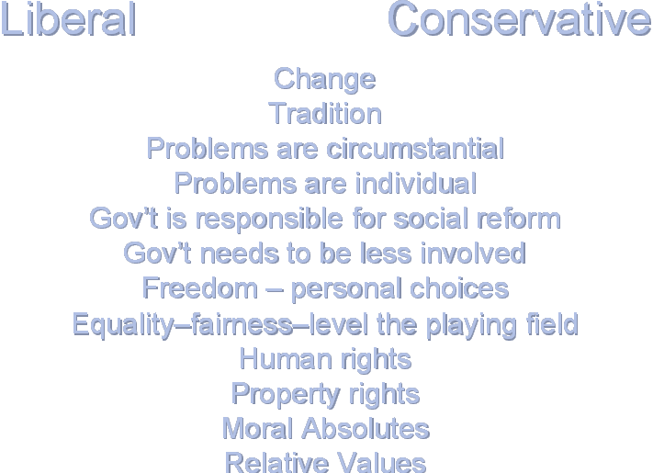

Political Parties

Political parties are groups of people who share similar beliefs about how the government should be run and how the issues facing our country should be solved. By organizing into political parties, people have more power to make their voices heard than they would have if they acted alone. Political parties are powerful organizations that fight to get the government to act in ways the political party believes is best. Political parties are organized at every level of government, from the national level right down to your own neighborhood.

Questions:
1. What are the two major political parties in America today?

2. What are the platforms of the two major political parties in America?

3. What other political parties exist in America? What are their platforms?

How Many Parties Are There?

Countries can have different numbers of political parties. Some countries have no political parties at all. Most of these countries are either very small or are controlled by military or theocratic governments. Countries with a single-party system have one major political party. These countries are not considered democracies because there is no opposition or choice in candidates. China is an example of a single-party system. Countries with a two-party system have two major political parties that hold all of the power. Third parties may exist, but they hardly ever gain enough support to win elections. This is the least common system around the world. In the United States we have a two-party system. Countries with multi-party systems have three or more political parties with members holding office in the government. (Some countries have as many as 20 or more)! Usually no party gains control of the government, so parties must work together to get things done.

Task: Complete the chart below based on the reading and your knowledge of the United States Government. You will then share your responses with a partner and discuss the questions that follow the chart.

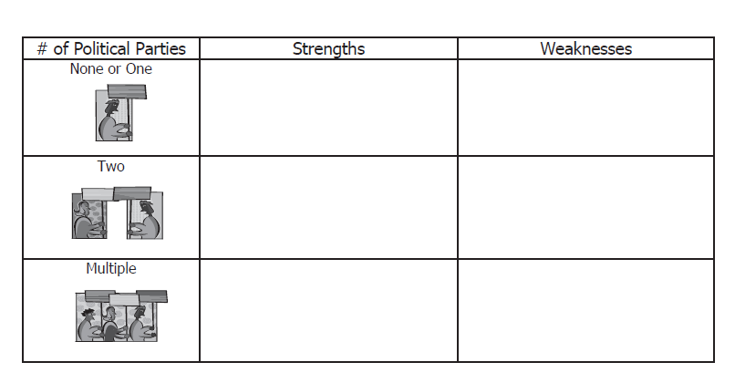

Which political party system do you believe would make the government run most effectively? Why?

Which political party system do you believe would be the best for the all the citizens of the country? Why?

Formation of the Two Party System

1. _______________________ - Fight over ratification of US Constitution created two groups and caused beginning of two-party system
- Federalists- Wanted the Constitution
- Anti-Federalists- Did not want the Constitution

2. ____________________ - Nation started with two-parties so people accept that this is the way it has always been.

3. ____________________ - US is made up of a broad group of people, yet most political views can be shared with one of two parties.

What are the major differences between the political parties?
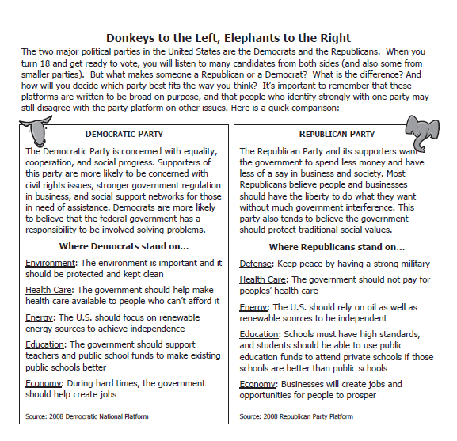
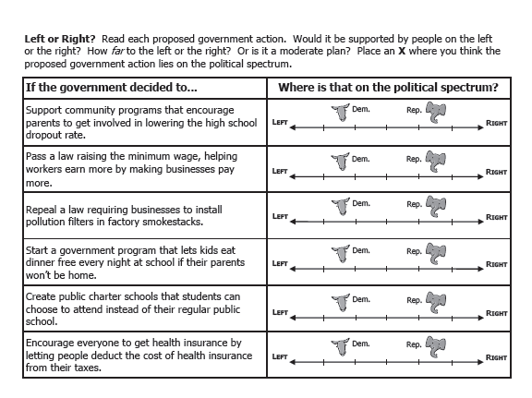
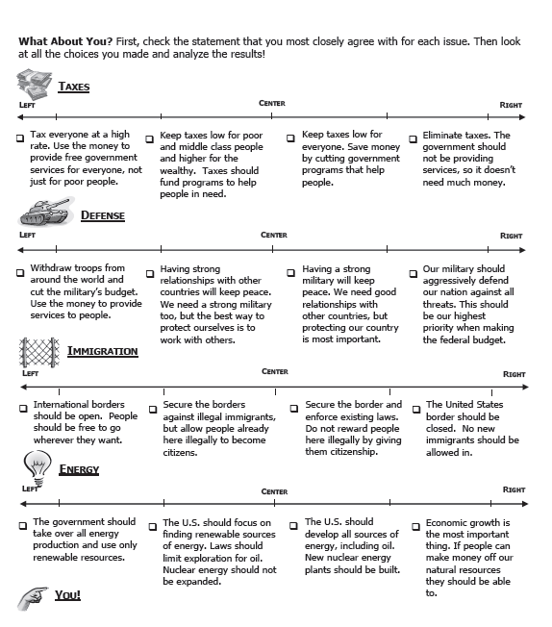

Do all your answers fall on the same place along the spectrum? ________________________

Were most of your answers on the same side of the spectrum? ________________________

Do people’s responses usually fall in the same place along the spectrum? __________________

Why or why not? ___________________________________________________________
________________________________________________________________________
________________________________________________________________________

