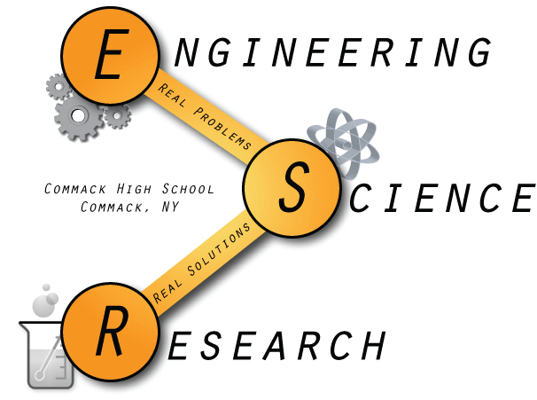
Commack High School
Research Class of 2015

Rachel Aitchison
University of Oregon, Eugene, OR
The Effect of Light Irradiation on the Production of Hydrogen Peroxide from Titanium Dioxide

“Yes, I am in research.”

Jason Bak
Carnegie Mellon University, Pittsburgh, PA
Experimental Assessment of Screen Bias in an Early Arctic Air Temperature Time Series

“Never give yourself an excuse to fail because all that does is make you not try as hard as you could.”

Eric Bass
University of Wisconsin-Madison, Madison, WI
The Effects of Environmental and Seasonal Changes on the Diel Vertical Migration of Zooplankton

Ryan Chan
William E. Macaulay Honors College, New York City, NY
The Use of DNA Barcoding and Taxonomical Techniques to Identify and Catalog Organisms in the Inner Harbor of Cold Spring Harbor, New York

“Chimdi swallowed flies… he became a fly #thuglife.”

Jianna Cressy
Johns Hopkins University, Baltimore, MD
Drawing a Correlation Between Multiple Myeloma Incidence, Agricultural Income and Pesticide Usage

“You know you’re a true researcher when you call Mr. Kurtz more than your mom.”

Claire Drotman
The College of New Jersey, Ewing Township, NJ
The Design and Construction of a Device to Aid Emergency Service Personnel in Utilizing a Bag-Valve-Mask

“True life: My research partner WILL never ask me to research prom.”

Colleen Flynn
A Study of Antifungal Agents in the Nepenthes ventricosa x sibuyanensis Pitcher Plant

“Over the past few years, I have partied pretty hard. Partying as in 3 A.M. runs to Starbucks to finish research boards and spotting Mr. Kurtz to make sure that he did not only drop the hose but himself out the window. Good times, it’s been real. #MACKSCI2015

William Furst
Rensselaer Polytechnic Institute, Troy, NY
The Design and Construction of a Device to Aid Emergency Service Personnel in Utilizing a Bag-Valve-Mask

“If you ain’t FURST, you’re last!!!”

Gabriel Green
Cornell University, Ithaca, NY
The Effects of Environmental and Seasonal Changes on the Diel Vertical Migration of Zooplankton

“Some of my best high school nights have been spent in the research room with the greatest educator to ever live. Thank you Mr. Kurtz ♥.”

Daniel Hosseinian
University of California, Los Angeles
Experimental Assessment of Screen Bias in an Early Arctic Air Temperature Time Series

Chris Huaman
New York Institute of Technology, Old Westbury, NY
Soilless Substrates: Future of Farming

Brian Huang
Johns Hopkins University, Baltimore, MD
The Development of a Model to Describe the Effects of Alcohol and Acetaminophen on NAFLD Livers
“When Mr. Kurtz calls on New Year’s Eve…”

Anthony Jao
Stony Brook University, Stony Brook, NY
Soilless Substrates: Future of Farming

“Did you feed the shrimp...???” “Oh…………”

Andrew Kim
University of California, Berkeley
Bacterial Cellulose Membrane for the use of Air Filtration Masks

“What’s a T-Test????”

Gloria Kim
Stony Brook University, Stony Brook, NY
Synthesis and Characterization of Tetragonal as a Prospective Thermoelectric Material

“You know it’s serious stuff when you are crushing blackworms.”

Angela Kubik
State University of New York at Geneseo
A Study of Antifungal Agents in the Nepenthes ventricosa x sibuyanensis Pitcher Plant

Brianna Kubik
State University of New York at Geneseo
A Study of Antifungal Agents in the Nepenthes ventricosa x sibuyanensis Pitcher Plant

“That moment when you spend 20 minutes presenting your research and the first question the judge asks you is, ‘Are you twins…?’”

Scott Massa
University of Pennsylvania, Philadelphia, PA
The Importance of Endocytosis to Neuregulin1 Back Signaling: Implications in Neuropsychiatric and Neurodegenerative Disorders

“Hours spent in research>hours spent in other rooms of school>hours spent sleeping”

Ryan McCaffrey
Princeton University, Princeton, NJ
Creation of a Drug Delivery Mechanism for Dexamethasone Differentiation of Dental Pulp Stem Cells

“Cut from LISEF? No problem.”

Marin Nagelberg
Pennsylvania State University, University Park, PA
Drawing a Correlation Between Multiple Myeloma Incidence, Agricultural Income and Pesticide Usage

“I made up for not being in research the past three years between the hours of 11 to 2 A.M.”

Andrea O’Brisky
Rensselaer Polytechnic Institute, Troy, NY
Understanding Resonance Effects Involved in Creating Single Bubble Sonoluminescence

Matthew O’Connell
Stanford University, Stanford, CA
Analysis of El Niño- Southern Oscillation Phenomena’s Effect on the Gross Domestic Product of Western Pacific Nations

“Mr. Kurtz’s research class remains the single greatest medium through which a student may become self-empowered to think, for himself or herself, what he or she wants to think and learn. When opportunity doesn’t knock, we must build a door. Research is the door we build in pursuit of growth, knowledge, and truth.”

JinHo Park
Stony Brook University, Stony Brook, NY
Studying the Assembly of the Short Fimbriae of Porphyromonas gingivalis in Escherichia coli

Alinur Rahim
Cooper Union, New York City, NY
The Design of Low Voltage, Nitinol Based Biomimicry Device

“Yes Mr. Kurtz, I’ll have it for you tomorrow…”

Laxshika Raveendran
Fordham University, New York City, NY
An Examination of Regional Differences of Colorectal Cancer Screening and Mortality in the United States

Eric Rizzo
Stony Brook University, Stony Brook, NY
Swim Performance and Stress in Radio-Tagged Brook Trout

“This year I’ll definitely finish my board over the break.”

Nakul Thampy
Fordham University, New York City, NY
Developing Drugs against a Master Regulator of Cancer Cell Behavior: Targeting NF-kB
“If I knew what I was doing, it would not be called research, would it?”

Thomas Vetere
Stony Brook University, Stony Brook, NY
The Analysis of OCD Perceptions and the Stigma that Surrounds Mental Illness

“I’ve learned countless life lessons through research, though it’s been a lot of work. I just remind myself that I didn’t choose the research life, the research life chose me.”

John Voiklis
Hofstra University, Hempstead, NY
Swim Performance and Stress in Radio-Tagged Brook Trout

“I don’t know what’s more sad: the Islanders leaving Long Island or me leaving research.”

Chantel Yang
Stanford University, Stanford, CA
Icephobic Properties of Nanostructure Surfaces Defined by Self-assembling Block Copolymers

“Humans of Science Research would be a dope page.”

