**Review**

1. Construct an angle bisector for the given angle:
2. Construct a hexagon (in pencil) and an equilateral triangle (in pen) inscribed in circle T shown below. [Leave all construction marks.]

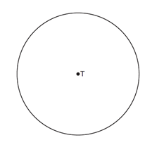

1. Locate, by construction, the Midpoint of segment DE below. Label it M.

D E

1. A) Construct a line through P, perpendicular to the given line.

●P

B) Construct a 45o angle using your construction above

1. Construct an angle congruent to the given angle
2. Construct a line perpendicular through  through point P



1. Construct an isosceles triangle with given base and side lengths.

Base:

Side:

1. Construct an equilateral triangle (or a 600 angle) from the side length given.

Side:

1. (a) find the Midpoint of line segment , and call the Midpoint ***M***.

(b) with a straightedge, connect point B to point M, and call it the Median

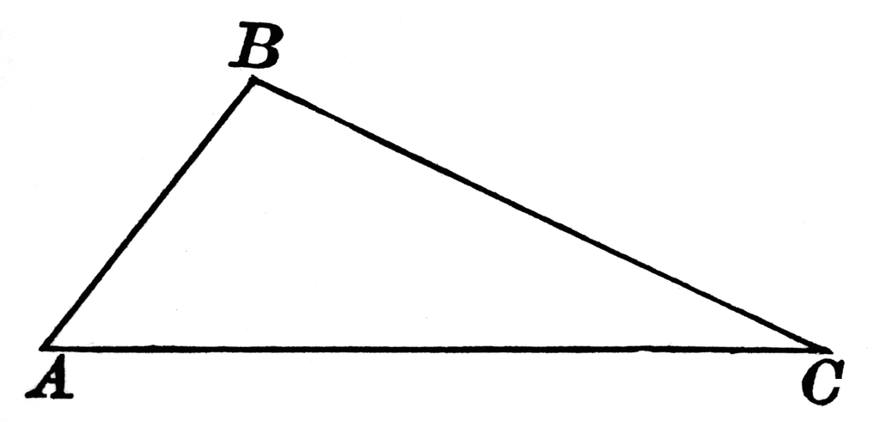

1. Construct an altitude of Triangle ABC. (hint, this is similar to question #4)

