Global History I
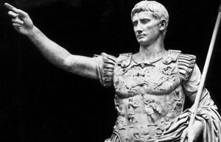
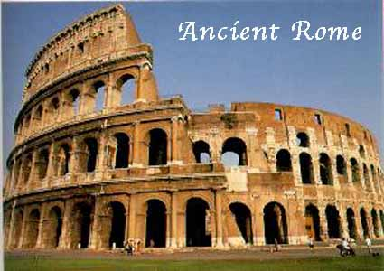
Unit 3: Ancient Rome
(500 B.C.E – C.E. 500)
Essential Questions:
Are all empires destined to decline?
What is the most effective government for an empire?

Section I
- Republic- A form of government in which power rests with citizens who have the right to vote for their leaders.
- Patricians- In Rome, the wealthy landowners who held most of the power.
- Plebeians- In Rome, the common farmers, artisans, and merchants who made up the majority of the population. Plebeians were citizens of Rome with the right to vote, however they were barred by law from holding most important government positions.
- Tribunes- in ancient Rome, an official elected by the plebeians to protect their rights.
- Twelve Tables- written code of law that established the idea that all free citizens had a right to the protection of the law.
- Consuls- In the Roman republic, one of the two powerful officials elected each year to command the army and direct the government.
- Senate- In ancient Rome, the supreme governing body, originally made up only of aristocrats.
- Dictator- In Rome, a leader who had absolute power to make laws and command the army. A dictator’s power lasted for only six months. They were chosen by the consuls and then elected by the senate.
- Legions- A military unit of the ancient Roman army, made up of about 5,000 foot soldiers and a group of soldiers on horseback.
- Punic Wars- A series of three wars between Rome and Carthage (264-146 BC) resulted in the destruction of Cartage and Rome’s dominance over the western Mediterranean.
- Hannibal- Leader of Carthage during the Punic Wars against Rome.
- Civil War- Conflict between groups within the same country.

Section II
- Julius Caesar- Military leaders who was appointed dictator of Rome for life. He issued many reforms but was assassinated by those afraid of his power and popularity.
- Triumvirate- A group of three rulers.
- Augustus- Emperor of Rome; stabilized Rome’s government and ruled during the beginning of the Pax Romana.
- Pax Romana- “Roman Peace”; a period of peace and prosperity in Rome that lasted for 207 years.
- Gladiators- Professional fighters who fought to the death in public contests.
- Inflation- A decline in the value of money, accompanied by a rise in the prices of goods and services.
- Mercenaries- A soldier who is paid to fight in a foreign army.
- Diocletian- Emperor who divided the Roman Empire into the Greek-speaking East and the Latin-speaking West.
- Constantine- Emperor who ruled Eastern and Western Rome and moved the capital city from Rome to Byzantium (later renamed Constantinople).
- Constantinople- Capital of Rome under Constantine. It survived against invasions by the Huns and Germanic tribes, and flourished as a preservation of Roman and Greek culture.
- Huns- Mongol nomads from central Asia
- Attila- Chieftain of the Huns, who terrorized both the eastern and western halves of the Roman Empire.
- Greco-Roman culture- The mixing of elements of Greek, Hellenistic, and Roman culture. Also called “classical civilization.”
- Tacitus-Roman historian, notable for presenting facts accurately.
- Aqueducts- Designed by Roman engineers to bring water into cities and towns.
- Colosseum- A huge arena that could hold 50,000 people. Both the rich and poor went to the Colosseum to view games, races, mock battles, and gladiator contests.

