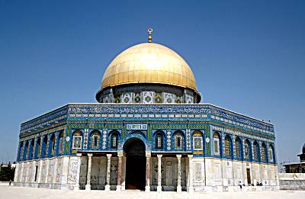
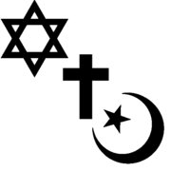

Monotheistic Religions

Judaism:

- Judaism:
Worlds first monotheistic religion.

- Prophet:
messenger of god.

- Abraham:
founder of Judaism

- Moses:
an important prophet of Judaism, he freed the Jews out of slavery in Egypt and sets up a Jewish homeland in Israel. It is also believed that God gave Moses the Torah and 10 Commandments.

- Hebrews:
Gods chosen people

- Covenant:
a binding agreement

- Ten Commandments:
Set of biblical laws relating to ethics and worship, which play a fundamental role in Judaism and Christianity.

- Torah:
the sacred texts or holy books of Judaism.

- Rabbi:
Jewish holy man who leads services and prayers.

- Temple:
a Jewish place of worship.

- Diaspora:
Jewish people were forced to scatter or move around the world after they were forced to leave their homeland in Israel by the Romans.

- Jerusalem:
The holy city of Judaism. It is where the Jews believe that Abraham founded the first temple or synagogue.

Christianity:

- Christianity:
worldwide monotheistic religion based on the life and teachings of the prophet Jesus of Nazareth. The world’s largest monotheistic religion.

- Messiah:
savior or liberator of a people in the Jewish, Christian or Islamic faiths.

- Jesus:
founder of Christianity, whom Christians believe is the Messiah and son of God.

- Bible:
sacred or religious text of Christianity which is made up of the Old Testament (Torah) and the New Testament (Gospels).

- Martyr:
somebody who suffers persecution and death for refusing to renounce, or accept, a belief or cause, usually religious.

- Pope:
the Bishop of Rome and the leader of the worldwide Roman Catholic Church.

- Sacraments: holy rituals that Christians believe in.

- Priest:
holy man who leads the Roman Catholic mass and performs sacraments.

- Heresy:
Religious belief that is contrary to the official teachings of the Church.

- Church:
a Christian place of worship.

- Jerusalem:
a holy city to Christians. It is where they believe Jesus was killed by the Romans and rose from the dead.

Islam:

- Islam:
Monotheistic religion; the world’s second largest religion.

- Muslim:
Term for individuals who practice the Islamic Faith.

- Muhammad:
Founder (prophet) of Islam.

- Allah:
In Islamic faith, the one and only God, creator and sustainer of the universe.

- Mosque:
A place of worship for followers of Islam.

- Koran (Qur’an): sacred or religious text of Islam.

7. Five Pillars of Islam:
Religious duties that must be carried out by every able-bodied Muslim who can afford to do so at least once in his or her lifetime.
- Belief in only one God “Allah”
- Pray five (5) times a day facing the holy city of Mecca
- Give alms ($) to the poor
- Fast during the holy month of Ramadan
- Pilgrimage (visit to a sacred or holy site) -Visit the holy city of Mecca at least once in their lifetime if they can afford it.

- Hajj:
The largest regularly occurring pilgrimage in the world, and is one of the five pillars of Islam.

- Jihad:
Religious duty of Muslims. In Arabic it translates to “struggle.”

- Sect:
a group with distinctive religious, political or philosophical beliefs, often an offshoot of a larger religious group.

