Name:___________________ Date:________________
Ancient Rome
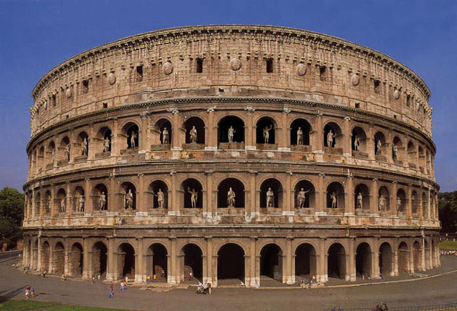
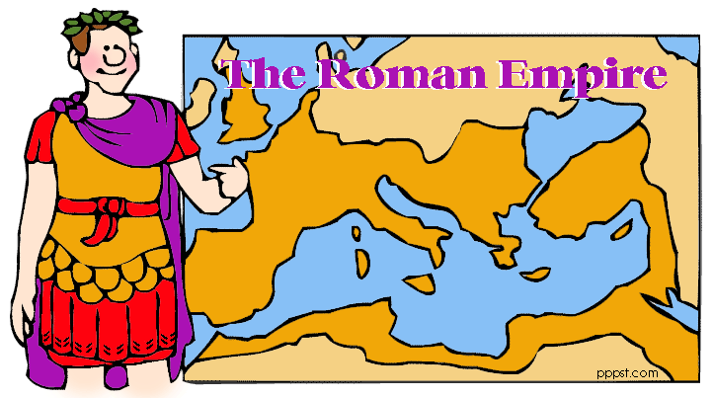

Ancient Rome Review Sheet

1. Give a relative location of Rome.
On the western half of the Italian peninsula.

2. Describe Rome’s geography.
On a fertile plain on the Italian peninsula. It was protected by mountains to the east and the Alps to the north. It was located in the center of the Mediterranean Sea.

3. How did Rome’s geography impact the growth of its empire?
Its location on a fertile plain in the center of the Mediterranean Sea, allowed to natural resources, and easy trade/travel.

4. Why did Rome expand its borders?
To control trade, especially throughout the Mediterranean.

5. Define the following:
A: Republic: A form of government in which power rests with citizens who have the right to vote for their leaders.

B: Senate: In ancient Rome, the supreme governing body, originally made up only of aristocrats.

C: Patricians: In Rome, the wealthy landowners who held most of the power.

D: Plebeians: In Rome, the common farmers, artisans, and merchants who made up the majority of the population. Plebeians were citizens of Rome with the right to vote, however they were barred by law from holding most important government positions.

E: Twelve Tables: written code of law that established the idea that all free citizens had a right to the protection of the law.

6. What was a legionary and why were the legions so important to Rome?
A military unit of the ancient Roman army, made up of about 5,000 foot soldiers and a group of soldiers on horseback. They methodically expanded and defended the Roman Empire, and built roads in the process.

7. What reforms were made by Julius Caesar?
Created a fair tax system, gave land and jobs to the poor and to veterans, brought citizenship to the frontier, expanded the empire, built roads and bridges, created an efficient civil service system.

8. How did the Pax Romana exemplify a Golden Age?
“Roman Peace”; a period of peace and prosperity in Rome that lasted for 207 years. It Pax Romana had achievements in law, engineering, aqueducts, the arch, roads, arts, architecture, math, science, literature, and more.

9. Why did the Roman Empire crumble? Provide at least 3 examples.
Most present-day Roman historians look at the end of Rome as a process rather than an event. New peoples, such as the Germanic tribes, altered the cultural make-up of the empire. New religions, like Christianity, at first challenged and then changed the spiritual outlook of Rome. By the early fifth century CE, there were Romans like Flavius Stilicho who were ethnically German, culturally Roman, and confessed Christianity as their faith. The Roman Empire was perhaps too large to govern effectively. The cost of defense, coupled with economic inflation, political corruption, the influx of Germanic tribes, and periodic imperial instability often led to trouble. Burden of taxes fell to the poor.

10. What was the result of the fall of the Roman Empire?
The Eastern half of the empire rose to become the Byzantine Empire. It carried on the legacy of the ancient Greeks and Romans, and exhibited another Golden Age. The Western half of the empire fell into a period of disruption, with a lack of stability and stable governments (The Dark Ages).

