Name:_________________________________ Date:__________________
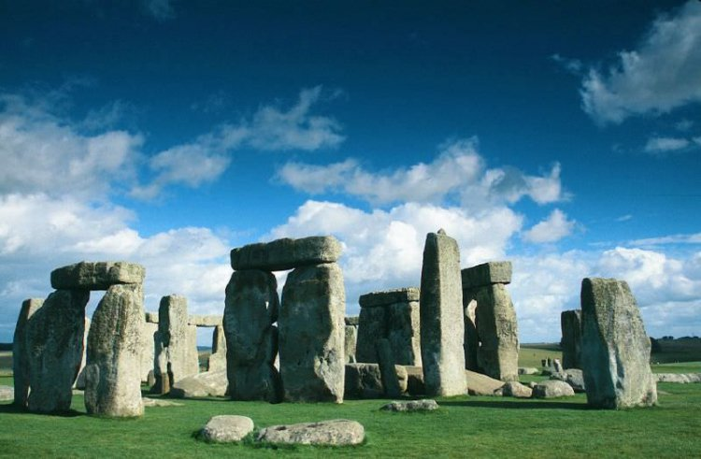
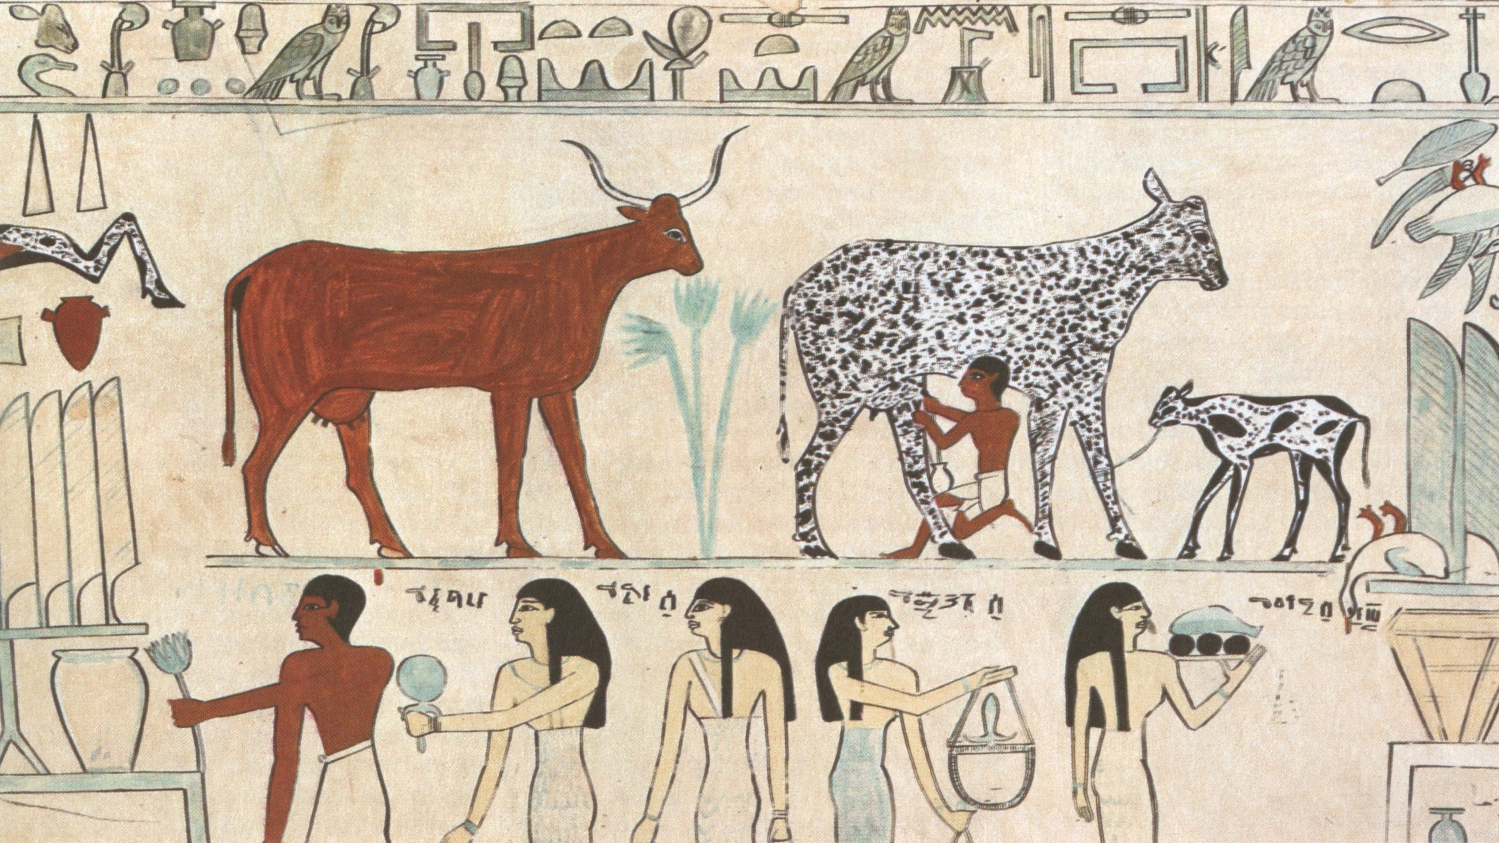
UNIT 1 Vocab List: Technological and Environmental Advances of Early Humans

Unit Essential Question: How are humans impacted by their geography?

Textbook Chapter 1: From Human PreHistory to the Early Civilizations (pgs 7-19)
Textbook Chapter 2: Early Civilizations, 3500-600 BCE (pgs 21-39)

World History Themes:

- Theme 1: Interactions between humans and the environment.
- Theme 2: Development and interaction of cultures.
- Theme 3: State building, expansion, and conflict.
- Theme 4: Creation, expansion, and interaction of economic systems.
- Theme 5: Development and transformation of social structures.

Historical Reasoning Skills Targeted in Unit 1:
- Continuity and Change Over Time: Identify patterns of continuity and change, explain the significance of such patterns, and explain how these patterns relate to larger historical processes or themes.
- Comparison: Compare diverse perspectives; compare different historical individuals, events, developments, and /or processes analyzing broader similarities and differences.
- Causation: Explain long and/or short-term causes and evaluate the relative significant.

Section 1: Introduction to Global History
Vocab Word | Definition
Archaeology | The study and analysis of artifacts and other physical remains.
Artifact | A human-made object, such as a tool, weapon, or piece of jewelry.
Bronze Age | From about 4000 BCE, when bronze tools were first introduced in the Middle East, to about 1500 BCE, when iron began to replace it.
Catal Huyuk | Early urban culture based on sedentary agriculture; located in modern southern Turkey; was larger in population than Jericho, had greater degree of social stratification.
Cultural Diffusion | The spreading of ideas or products from one culture to another.
Culture | Culture is the way of life of a group of people. It includes beliefs, values, and practices. Culture can be handed down from one generation to the next through learning and experience.
Customs and traditions | Rules of behavior. Set of unwritten practices passed down from generation to generation.
Domestication | Taming wild animals for farm use or food.
Ethnocentrism | The belief/attitude that one’s culture is superior to others.
Geography | The study of the earth’s structure, features, products, and the political, economic, and social divisions of human beings.
Homo sapiens sapiens | The humanoid species that emerged as most successful at the end of the Paleolithic period.
Hunting and gathering | The original human economy, ultimately eclipsed by agriculture; groups hunt for meat and forage for grains, nuts, and berries.
Migration | The act of moving from one place to settle in another.
Neolithic Revolution | The succession of technological innovations and changes in human organization that led to the development of agriculture, 8500-3500 BCE
Neolithic/ New Stone Age | The New Stone Age between 8000 and 5000 BCE; period in which adaptation of sedentary agriculture occurred; domestication of plants and animals accomplished.
Nomads | Cattle- and sheep- herding societies normally found on the fringes of civilized societies; commonly referred to as “barbarian” by civilized societies.
Paleolithic/ Old Stone Age | The Old Stone Age ending in 12,000 BCE; typified by use of crude stone tools and hunting and gathering for substance.
Prehistory | Period of time before mankind invented writing.
Sociology | The study of how societies, and the people within in, develop and interact with one another.
Subsistence Farming | Self-sufficient farming, where farmers focus on growing enough food to feed themselves and their families. First emerged during the Neolithic Revolution.

Section II: Early River Valley Civilizations
Aryans | Indo-European nomadic pastoralists who replaced Harappa civilization; militarized society.
Babylonians | Unified all of Mesopotamia circa 1800 BCE; empire collapsed due to foreign invasion circa 1600 BCE.
Barter System | A form of trade in which people exchange goods and services without the use of money.
City-state | A form of political organization typical of Mesopotamian civilizations; consisted of agricultural hinterlands ruled by an urban-based king.
Civilization | Societies distinguished by reliance on sedentary agriculture, ability to produce food surpluses, and existence of non farming elites, as well as merchant and manufacturing groups.
Codified Law | A comprehensive and uniform system of laws, collected and organized in a written system.
Cuneiform | A form of writing developed by the Sumerians using a wedge-shaped stylus and clay tablets.
Delta | A marshy region formed by deposits of silt at the mouth of a river.
Dynasty | A series of rulers from a single family.
Economy | The wealth and resources of a country or region.
Empire | An empire brings together several peoples, nations, or previously independent states under the control of one ruler.
Fertile Crescent | An arc of rich farmland in Southwest Asia, between the Persian Gulf and Mediterranean Sea.
Hammurabi’s Code | Created by Hammurabi, emperor of Babylon, Hammurabi’s Code was a unified set of laws used to help unify the diverse groups and keep order within the Babylonian Empire. Hammurabi’s code consisted of rules, judgments, and laws and was engraved in stone. Copies were places all over the empire.
Harappa | Along with Mohenjodaro, major urban complex of the Harappa civilization; laid out on planned grid pattern.
Hierarchy | A system or organization in which people or groups are ranked according to status or authority.
Hieroglyphics | An ancient Egyptian writing system in which pictures were used to represent ideas and sounds.
Ideographs | Pictographic characters grouped together to create new concepts; typical of Chinese writing.
Indus River | River sources in Himalayas to mouth in Arabian Sea; location of Harappa civilization.
Irrigation | To supply water to land or crops to help growth.
Kush | An African-state that developed along the upper reaches of the Nile circa 1000 BCE; conquered Egypt and ruled it for several centuries.
Mahabharata | Indian epic of war, princely honor, love, and social duty; written down in the last centuries BCE; previously handed down in oral form.
Mesopotamia | Literally “between the rivers”; the civilizations that arose in the alluvial plain of the Tigris and Euphrates river valleys.
Middle Kingdom (China) | Because the Chinese saw their country as the center of the civilized world, their own name for China was the Middle Kingdom.
Monarchy | A government in which power is in the hands of a single person.
Monotheism | The exclusive worship of a single god; introduced by the Jews into Western civilization.
Monsoon | A wind that shifts in direction at certain times of each year.
Mummification | A process of embalming and drying corpses to prevent them from decaying.
Oracle Bones | Animal bones or tortoise shells used by ancient Chinese priests to communicate with the gods.
Papyrus | A tall reed that grows in the Nile delta, used by the ancient Egyptians to make a paper-like material for writing on.
Pharaoh | Title of kings of ancient Egypt, considered gods as well as political and military leaders.
Phoenicians | Seafaring civilization located on the shores of the eastern Mediterranean; established colonies throughout the Mediterranean.
Polytheism | A belief in many gods.
Pyramids | Monumental architecture typical of Old Kingdom Egypt; used as burial sites for pharaohs.
Ramayana | One of the great epic tales from classical India; teaches adventures of King Rama and his wife, Sita; written 4th to 2nd centuries BCE.
Scribes | Professional record keepers.
Shang Dynasty | First Chinese dynasty for which archeological evidence exists; capital located in Oreos bulge of the Huanghe; flourished 1600 to 1046 BCE.
Subcontinent | A large landmass that forms a distinct part of a continent.
Sumerians | People who migrated into Mesopotamia circa 4000 BCE; created first civilization within region; organized area into city-states.
Theocracy | (1) A government in which the ruler is viewed as a divine figure. (2) A government controlled by religious leaders.
Yellow River | Also known as the Huanghe; site of development of sedentary agriculture in China.
Ziggurat | Massive towers usually associated with Mesopotamian temple complexes.

What is geography?
The study of geography is attributed in the Western world to the ancient Greek scholar Erastosthenes. “Geo” means “earth” and “graphy” means to write. However today, the study of geography encompasses more than just the features of the Earth’s surface and their locations. Studying geography also includes human origins, activities, migrations, cultures, religions, natural resources, climates, and vegetation. Geography will be embedded in all of the topics studied throughout this course.

TASKS:
- On your map, label: (a) seven continents; (b) four oceans; (c) Brazil, China, Egypt, India, Iran, United Kingdom, United States; (d) Baghdad, Beijing, Cuzco, Jakarta, London, Mexico City, Rome, Samarkand, Tokyo; (e) Andes Mountain, Asian Steppe, Caribbean Sea, Himalayan Mountains, Mediterranean Sea, Nile River, Ural Mountains, Sahara Desert. [35 pts]

- On your map, circle and label: (a) Latin America; (b) Middle East Region; (c) Southeast Asia Region; (d) briefly explain what factors constitute each region (for example: why did you circle this region and label it “Middle East”). [6 pts]

- In 2018, the top 5 religions of the contemporary world are Christianity, Islam, Hinduism, Buddhism, and Daoism/Taoism. On your map: (a) create a key and represent each religion with a distinct color; (b) color in one region or country where each religion is the majority belief system. Each continent must be represented by at least one religion. Some religions may be used more than once. [12 pts]

How YOU represent human geography:
- On your map, label:
- Where you were born; [1 pt]
- Where your ancestors are from? [1 pt]
- What place means the most to you and why? Label on the map, and describe why on the back of the map. [2 pts]
- Describe an example of a cultural tradition that you observe, and label and analyze what region this tradition originates from. Describe and analyze on the back of the map. [3 pts]
- Label major cities that you’ve lived in or traveled to. [1 pt]
- Chart the path that your immediate ancestors used to travel to the United States. [1 pt]
- What is your favorite food? What region does the food or its ingredients originate from? Describe on the back of the map. [3 pts]
- How do you “support the economy”? You can think of this as the national (United States) economy or the global economy. [5 pts]

Comments:

______________/70 Pts Total

Congratulations!

You have just won a free vacation to the city of Port Angeles.

When you are done celebrating, list five (serious) questions that you have about your destination to help you plan your vacation.

1.________________________________________________________________________________________

2.________________________________________________________________________________________

3.________________________________________________________________________________________

4.________________________________________________________________________________________

5.________________________________________________________________________________________

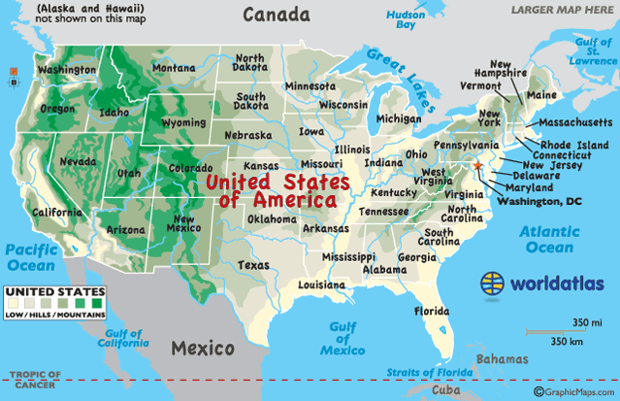
TASK: Identify which of the geographic themes each statement refers to. Some statements may refer to more than one theme. Then, use each statement to locate where you’ll be traveling to on your vacation.

1. The people of Port Angeles lay on the beach of the Pacific Ocean in the summer.

2. People have recently built new lifts to the local mountain peaks where they can enjoy some of the best snowboarding and skiing in the nation.

3. In the summer, the ocean waves are perfect for surfing. Hiking trails have diverse wildlife, such as bears, mountain lions, foxes, and deer.

4. During the volcanic explosion of Mount St. Helen’s, thousands of Americans fled Port Angeles.

5. In the summer, people of Port Angeles enjoy road trips up to British Columbia. In the winter, you might as well travel by dog-sled.

6. The people of Port Angeles speak English and Japanese languages.

7. By building dams on rivers, the people of Port Angeles have harnessed the power of water.

8. Port Angeles exports a lot of timber and seafood to other regions of the nation.

9. In what region of the United States do you think Port Angeles is located?

World Theme 1: How do humans interact with the environment?
Themes of Geography
Location | Place | Human-Environment Interaction | Movement | Regions
Location may be referred to as “absolute” or “relative.”  Absolute Location is described in terms of latitude and longitude. On a map, lines of latitude are drawn horizontally, while lines of longitude are drawn vertically.  Ex: Paris is 48°51’ North Latitude and 2°20’ East Latitude.  Relative Location is less precise and is described by using landmarks, time, direction, associations, or distance from one place to another.  Ex: Paris is in northern France, near the Seine River. | Places have both human and physical characteristics.  Physical characteristics include mountains, rivers, soil, beaches, wildlife, etc.  Human characteristics are derived from the ideas and actions of the people in that place, such as buildings, roads, clothing, and food habits.  The image people have of a place is often based on their experiences. People’s descriptions of a place reveal their values, attitudes, and perceptions. | Humans change or modify the environment, and then sometimes Mother Nature changes it back. | The movement of people, the import and export of goods, and the mass communication of ideas have all played major roles in shaping world history. | A region is an area that is distinct from other neighboring areas. Regions may share common features such as style of government, religion, language, or geographic features (mountains, plains, forests, deserts, etc). Regions can be based on perception.
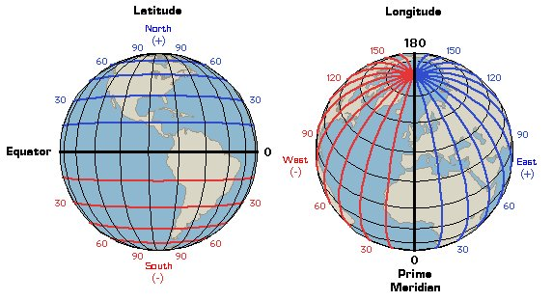
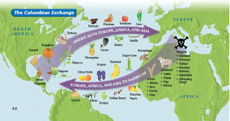

The BIG Ideas
- How do historians construct an understanding of events that range from hours ago to potentially millions of years ago? In order to construct accurate understandings, historians rely on sources.

FIRST: Consider the type of source being examined. Is it a:
Primary source
Documents or physical objects that were written or created during the time period being studied.

Secondary source
Documents or physical objects created after the time period being studied. Secondary sources are based on evidence compiled by primary sources and/or other secondary sources.

OR

- Based on the definitions above, identify each of the documents below as either “primary” or “secondary.”
1. A journal entry written by Christopher Columbus describing his voyage across the Atlantic Ocean. |  | 2. A biography of Napoleon Bonaparte (died in 1821) written by historian in 2013. |  | 3. Winston Churchill’s autobiography about the first thirty years of his life, which he wrote later in his life. |  | 4. A sword that was made in 1095.
Circle one: |  | Circle one: |  | Circle one: |  | Circle one:
Primary | Secondary | Primary | Secondary | Primary | Secondary | Primary | Secondary

- Both primary and secondary sources possess advantages (values) and disadvantages (limitations).
Values of secondary sources?

Limitations of secondary sources?

Values of primary sources?

Limitations of primary sources?

- Therefore, in order to create the most accurate picture of history, it is best for scholars to:
______________________________________________________________________________________________________________________________________________________________________________________________________________________________________________________________________________________________________

SECOND:
- Historians consider various factors to determine a source’s point of view, as well as its reliability. We often use the acronym OPCVL when evaluating both primary and secondary sources.
Consider the following article, published in The New York Times¸ as an example of this type of evaluation. After you read the article, complete the the middle and the right columns.
In Youth Sports, Participation Trophies Send a Powerful Message  Parker Abate, a sophomore athlete who studies communications at Misericordia University in Dallas, Pa., has been involved in youth sports since he was 5 years old, as a player and then as a coach.  OCTOBER 6, 2016  In our competitive, sports-laden society, the better athletes play through high school and the elite go on to play in college. These athletes do not care about participation trophies. Their goals are mementos that say “Champions.”  But what about those children who will never get to play competitive sports after the age of 14? Despite knowing that they are not particularly talented, these children go out and participate, generally to the best of their ability. They learn about teamwork, sportsmanship and they learn the importance of exercise. Those are all great things to know.  Self-esteem is a big part of one’s childhood. Watching a peer receive a trophy and not receiving one yourself can be degrading. Any kind of honor can make a young kid feel as if he or she meant something to the team, and that could boost the child’s self-confidence -- children today need as much of that as they can get in our society…these kids dedicate time, effort and enthusiasm, and they deserve to have something tangible to make them feel that their participation was worthwhile. It could be the only form of athletic recognition they ever receive. | - Origin. Researchers try to answer the following questions:  - Who is the author/creator?  - When was it written/created?  - Where was it published?  - What were the historical circumstances at the time of its creation, writing, or publishing? | 1. What is the Origin of the article to the left?
 | - Purpose. Researchers try to analyze what the author’s intent was in creating the source. This includes evaluating the author’s main idea or message (his or her “central thesis”), as well who the author’s intended audience was. | 2. What is the Purpose of the article to the left? What is the author’s main idea? Who is his intended audience? What is his intent?
 | Content. This refers to the supporting evidence used within the source.
 | Values. What advantages does this source have to researchers? What questions does it help to answer or address? What does it help researchers to understand? Is the article significant in creating a larger understanding of a topic? | 3. State one value of the article to the left.
 | Limitations. What disadvantages does this source contain? What questions does the article leave out? What specific information does the article leave out? What points of view are not addressed? What parts of the article may be suspect to researchers? | 4. State one limitation of the article to the left.

The Neolithic Revolution, c. 1250 BCE
Task:
- Read and annotate through each of the document sets below: “Paleolithic Life” and “Neolithic Life.”
- After you read each document, categorize it using a PERSIAN grouping. Keep in mind that you want to try to incorporate at least three different PERSIAN groupings.
- When you have completed the documents, begin to work on the graphic organizer entitled “Paleolithic vs. Neolithic Life.” This will help you to address the question: What changes to human societies were experienced from the Paleolithic to the Neolithic Ages?

Paleolithic Life

Grouping: _____________________________
Document 1
Paleolithic Era (Old Stone Age)
2,000,000 B.C.E. - 8,000 B.C.E.
Lifestyle | Nomadic; in groups of up to 50; tribal society; hunters and gatherers
Economy | There was no concept of private property
Art | Cave paintings, pottery
Technology | Fire; Rough stone tools
Food | Hunted and gathered for food; people followed animal herds that they hunted and moved locations when wild plants in other areas were ripe
Source: Dates from Bulliet, Crossley, Headrick, Hirsch, and Johnson. The Earth and Its Peoples, Cengage Learning, p. 20. Table adapted from http://www.diffen.com/difference/Neolithic_vs_Paleolithic

Grouping: _____________________________
Document 2

“What Hunters Do for a Living”

A woman gathers on one day enough food to feed her family for three days, and spends the rest of her time resting in camp, doing embroidery, visiting other camps, or entertaining visitors from other camps. For each day at home, kitchen routines, such as cooking, nut cracking, collecting firewood, and fetching water, occupy one to three hours of her time. This rhythm of steady work and steady leisure is maintained throughout the year. The hunters tend to work more frequently than the women, but their schedule is uneven. It is not unusual for a man to hunt avidly for a week and then do no hunting at all for two or three weeks. Since hunting is an unpredictable business and subject to magical control, hunters sometimes experience a run of bad luck and stop hunting for a month or longer. During these periods, visiting, entertaining, and especially dancing are the primary activities of men.
Source: Richard Lee, “What Hunters Do for a Living,” in Man the Hunter, eds. R.B. Lee and I. DeVore (Chicago: Aldine, 1968) adapted from The Big History Project
Grouping: _____________________________
Document 3
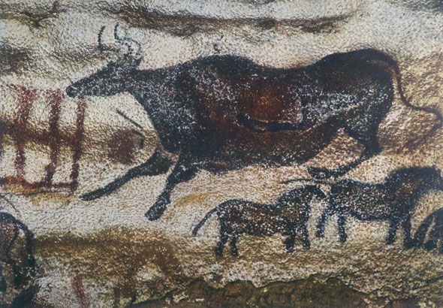
A Paleolithic cave painting in the Lascaux Cave in France depicting a bull and horses, animals that were important to the nomadic hunters that created the images.
Source: International Committee for Preservation of Lascaux. Photo credit: Has Hins. http://www.savelascaux.org/Gallery_photo18.php

Grouping: _____________________________
Document 4
Tools from Hunter-Gatherer Societies

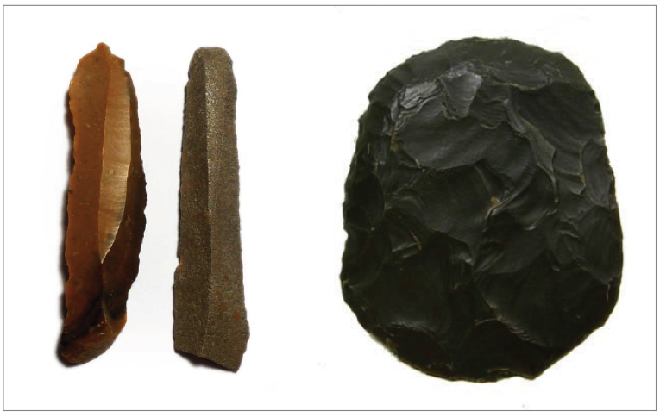
Hunter-gathering societies have used various types of stones, as well as bone and antler, to make a variety of tools such scrapers, blades, arrows, spearheads, needles, awls, fishhooks, and harpoons. The 6.5- to 6.7-cm (2.5- to 2.6-inch) flint blades on the left are from North Africa, dating from 5000–4500 BCE. The 5.7- x 4.6-cm (2.2- x 1.8-inch) scraper on the right is made of green jasper, dates from 5200 to 2500 BCE, and was found in the south-central Sahara Desert.
Source: http://www.worldmuseumofman.org/display.php?item=1167;
http://www.worldmuseumofman.org/display.php?item=434 adapted from The Big History Project.
Grouping: _____________________________
Document 5
The images below are murals from the Lubbock Lake Landmark in Lubbock, Texas. Based on archaeological evidence, an artist created these images to show the Paleolithic lifestyle that humans living in this area of engaged in from circa thirteen thousand years ago.
Document 4a  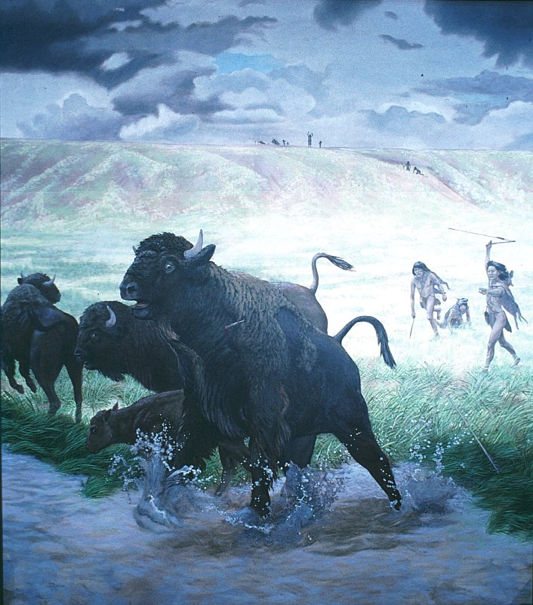 | Document 4b  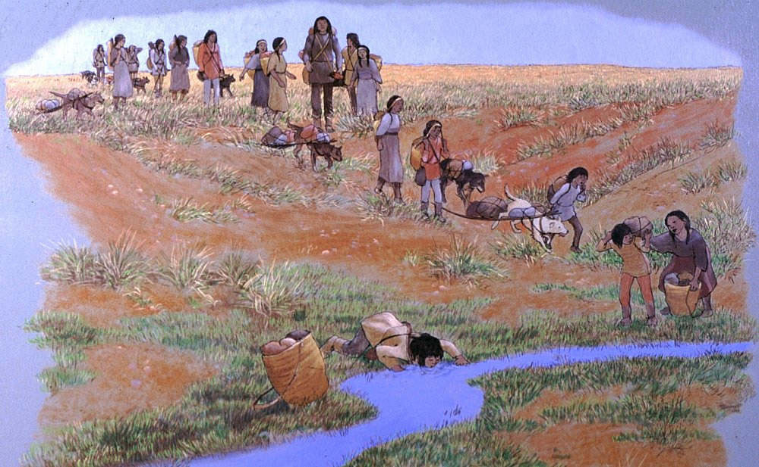l
Source: “Lubbock Lake Landmark” University of Texas at Austin. www.texasbeyondhistory.net/lubbock/images/lubbock-m23.html

Grouping: _____________________________
Document 6
Should you be Eating like a Caveman?
…Dr. Eaton, a radiologist, and Dr. Cordain, an exercise physiologist… believe evolutionary forces dictate that we will live healthiest when we consume a diet similar to what early man ate 2.5 million years ago during the hunter-gatherer days of the Paleolithic Era. This diet included more low-fat proteins and healthy fats than most of us eat today, and fewer carbohydrates, mainly because Paleo man ate no wheat, rice, or corn whatsoever. These modern grains were not "invented" until 10,000 years ago. In other words, throughout 99.6 percent of our evolutionary history, we ate no bread, pancakes, pasta, or chow mein. As a result, [Dr. Eaton and Dr. Cordain] say, we aren't adapted to process them healthfully.
… Cordain first learned about Paleo nutrition in 1985 when the New England Journal of Medicine published a "Special Article" by Dr. Eaton and his colleague Melvin Konner. In that article, the authors concluded that the Paleo diet contained vastly more vitamin C, fiber, calcium, iron, folate, and essential fatty acids than our current supermarket-based fare. It also contained far less sugar, salt, and saturated fats. They concluded: "The diet of our remote ancestors may be a reference standard for modern human nutrition and a model for defense against certain 'diseases of civilization.'"

It’s easy to make fun of the Paleo diet. Right away, everyone says, “Sure, and how long did your basic caveman live?” About 20 to 25 years, it turns out. But primitive hunter-gatherers didn't die from heart disease, diabetes, and high blood pressure like we do. They died from germs, viruses, and traumas. We live longer today, in large part, because we have sewers, inoculations, and amazing (if expensive) health-care systems.
Source: Amby Burfoot, “Should you be Eating like a Caveman?” Runner's World (Dec 2005)
NEOLITHIC LIFE
Grouping: _____________________________
Document 7
. . . The Neolithic Revolution also changed the way people lived. In place of scattered hunting communities, the farmers lived in villages. Near groups of villages, small towns grew up, and later cities too. Thus the Neolithic Revolution made civilization itself possible. (The Ancient Near East)

Within the villages, towns and cities, it was possible for people to specialize in the sort of work they could do best. Many stopped producing food at all, making instead tools and other goods that farmers needed, and for which they gave them food in exchange. This process of exchange led to trade and traders, and the growth of trade made it possible for people to specialize even more. . . .
Source: D. M. Knox, The Neolithic Revolution, Greenhaven Press from the NYS Global History and Geography Regents, Jan. 2004.

Grouping: _____________________________ Grouping: _________________________

Document 8a Document 8b
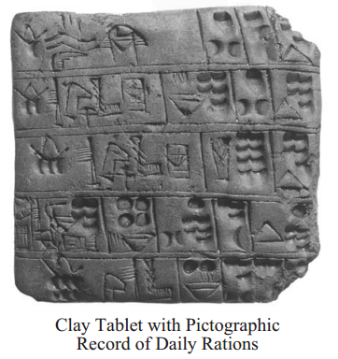  Source: The Visual Dictionary of Ancient Civilizations, Dorling Kindersley (adapted) from the NYS Global History and Geography Regents Exam, January 2010. | 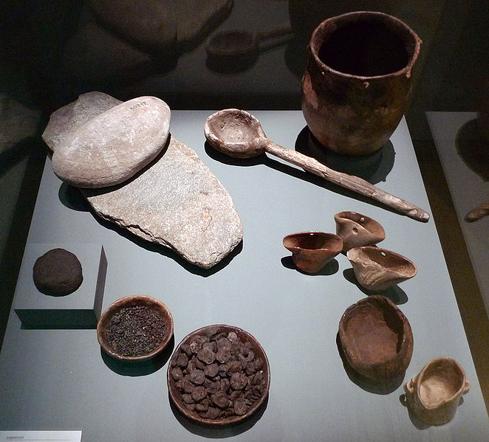  Neolithic cutlery and foodstuffs found at sites in Switzerland. The items include: millstones, charred bread, grains and small apples, a clay cooking pot, and containers made of antlers and wood  Source:https://en.wikipedia.org/wiki/File:HMB_Essen_und_Kochger%C3%A4t_Jungsteinzeit.jpg

Grouping: ____________________________
Document 9
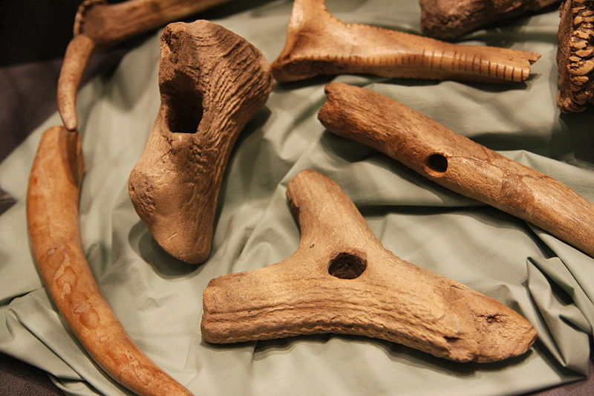
These tools were used by Neolithic farmers to plough fields, plant crops, and harvest the plants. The tools are made out of deer antler.
Source: https://en.wikipedia.org/wiki/File:CucuteniAgriculture.JPG
Grouping: _____________________________
Document 10
. . . The first archaeological evidence for the domestication of cereals, and some of the earliest evidence for the domestication of animals, comes from a broad region stretching from Greece and Crete in the west to the foothills of the Hindu Kush south of the Caspian in the east. Here are found the wild plants from which wheat and barley were domesticated, whilst it is only in this zone that the wild progenitors [ancestors] of sheep, goats, cattle and pigs were found together, for the latter two had a much broader distribution than wild sheep and goats. By the tenth millennium B.C. peoples who relied upon hunting and gathering were reaping wild barley and wild wheat with knives, grinding the grain and using storage pits. By the sixth millennium there is evidence of village communities growing wheat and barley, and keeping sheep and goats, in Greece and Crete in the west, in southern Turkey, the Galilean uplands of the eastern littoral [coastal region] of the Mediterranean, in the Zagros mountains of Iran and Iraq, the interior plateaux of Iran, and in the foothills southeast of the Caspian. Subsequently the number of domesticated plants grown was increased, including flax, for its oil rather than for fibre, peas, lentils and vetch [plants used for food]. By the fourth millennium the olive, vine and fig, the crops which give traditional Mediterranean agriculture much of its distinctiveness, had been domesticated in the eastern Mediterranean. Cattle and pigs are thought to have been domesticated after sheep and goats. Cattle were used as draught animals, and for meat; not until the late fourth millennium is there evidence of milking in South West Asia. . . .
Source: D. B. Grigg, The Agricultural Systems of the World, Cambridge University Press from the NYS Global History and Geography Regents Exam, January 2004.
Grouping: _____________________________
Document 11
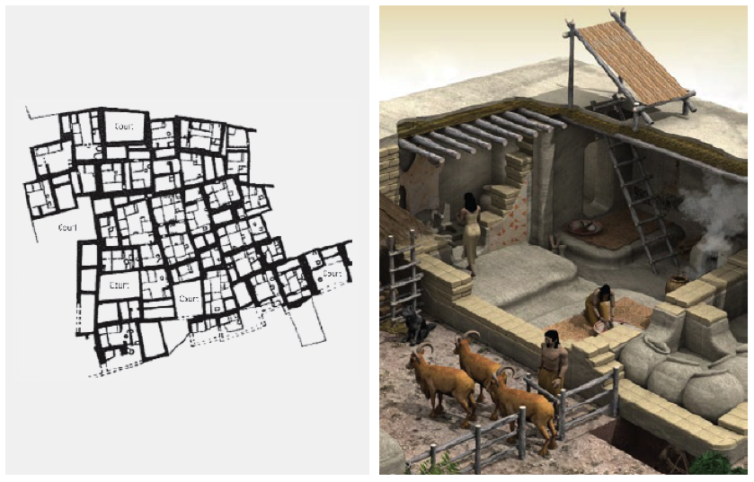
Catal Huyuk, in modern Turkey, was one of the first places in the world where humans lived in dense settlements. From about 7500 to 5700 BCE, an estimated average of between 5,000 and 8,000 people lived in mud-brick houses with rooftops serving as streets. James Mellaart, the British archaeologist who excavated Catal Huyuk in 1958, produced this drawing of the settlement’s layout. Alongside is an artist’s illustration of an individual dwelling.
Source:http://makingmaps.net/2008/10/13/cartocacoethes-why-the-worlds-oldest-map-isnt-a-map/;http://www.ediciona.com/portafolio/image/5/2/0/5/casa_catal_huyuk_5025.jpg adapted from The Big History Project.

Grouping: _____________________________

Document 12
Specialization of Labor
Within the villages, towns and cities, it was possible for people to specialize in the sort of work they could do best. Many stopped producing food at all, making instead tools and other goods that farmers needed, and for which they gave them food in exchange. This process of exchange led to trade and traders, and the growth of trade made it possible for people to specialize even more…
Source: D.M. Knox, The Neolithic Revolution, Greenhaven Press, adapted from the January 2004, NYS Regents Exam.

PALEOLITHIC VS. NEOLITHIC LIFE
The BIG Ideas:
- Evaluate the “Big Idea” of the Paleolithic Age of early man (3.3 million years ago to 11,650 BCE) _______________________________________________
____________________________________________________________________________________________________________________________________
- Evaluate the “Big Idea” of the Paleolithic Age of early man (3.3 million years ago to 11,650 BCE) _______________________________________________
____________________________________________________________________________________________________________________________________

Connecting documents:
- Grouping: a way of connecting documents or ideas by showing common characteristics.
- Continuity: a characteristic or idea that stays the same.
- Change: a characteristic or idea that is altered over time.

TASK: Create three groupings by using both the Paleolithic and Neolithic documents. The purpose is to show continuities and changes that occurred from the Paleolithic era to the Neolithic era. These changes and continuities are organized through your use of groupings. When creating your groupings, include both Paleolithic and Neolithic documents to show one change and one continuity per grouping. Each group must have a minimum of two documents within it. Documents can be used in more than one grouping.

Group #1  PERSIAN element: | Group #2  PERSIAN element: | Group #3  PERSIAN element:
Documents included in this group:  - Document # ________  - Document # ________  - Document # ________  What changed?  What stayed the same (continued)? | Documents included in this group:  - Document # ________  - Document # ________  - Document # ________  What changed?  What stayed the same (continued)? | Documents included in this group:  - Document # ________  - Document # ________  - Document # ________  What changed?  What stayed the same (continued)?

The Worst Mistake in the History of the Human Race

By Jared Diamond
University of California at Los Angeles Medical School
To science we owe dramatic changes in our smug self-image. Astronomy taught us that our earth isn't the center of the universe but merely one of billions of heavenly bodies. From biology we learned that we weren't specially created by God but evolved along with millions of other species. Now archaeology is demolishing another sacred belief: that human history over the past million years has been a long tale of progress. In particular, recent discoveries suggest that the adoption of agriculture, supposedly our most decisive step toward a better life, was in many ways a catastrophe from which we have never recovered. With agriculture came the gross social and sexual inequality, the disease and despotism, that curse our existence.
At first, the evidence against this revisionist interpretation will strike twentieth century Americans as irrefutable. We're better off in almost every respect than people of the Middle Ages, who in turn had it easier than cavemen, who in turn were better off than apes. Just count our advantages. We enjoy the most abundant and varied foods, the best tools and material goods, some of the longest and healthiest lives, in history. Most of us are safe from starvation and predators. We get our energy from oil and machines, not from our sweat. What neo-Luddite among us would trade his life for that of a medieval peasant, a caveman, or an ape?
For most of our history we supported ourselves by hunting and gathering: we hunted wild animals and foraged for wild plants. It's a life that philosophers have traditionally regarded as nasty, brutish, and short. Since no food is grown and little is stored, there is (in this view) no respite from the struggle that starts anew each day to find wild foods and avoid starving. Our escape from this misery was facilitated only 10,000 years ago, when in different parts of the world people began to domesticate plants and animals. The agricultural revolution spread until today it's nearly universal and few tribes of hunter-gatherers survive.
From the progressivist perspective on which I was brought up, to ask "Why did almost all our hunter-gatherer ancestors adopt agriculture?" is silly. Of course they adopted it because agriculture is an efficient way to get more food for less work. Planted crops yield far more tons per acre than roots and berries. Just imagine a band of savages, exhausted from searching for nuts or chasing wild animals, suddenly grazing for the first time at a fruit-laden orchard or a pasture full of sheep. How many milliseconds do you think it would take them to appreciate the advantages of agriculture?
The progressivist party line sometimes even goes so far as to credit agriculture with the remarkable flowering of art that has taken place over the past few thousand years. Since crops can be stored, and since it takes less time to pick food from a garden than to find it in the wild, agriculture gave us free time that hunter-gatherers never had. Thus it was agriculture that enabled us to build the Parthenon and compose the B-minor Mass.
While the case for the progressivist view seems overwhelming, it's hard to prove. How do you show that the lives of people 10,000 years ago got better when they abandoned hunting and gathering for farming? Until recently, archaeologists had to resort to indirect tests, whose results (surprisingly) failed to support the progressivist view. Here's one example of an indirect test: Are twentieth century hunter-gatherers really worse off than farmers? Scattered throughout the world, several dozen groups of so-called primitive people, like the Kalahari bushmen, continue to support themselves that way. It turns out that these people have plenty of leisure time, sleep a good deal, and work less hard than their farming neighbors. For instance, the average time devoted each week to obtaining food is only 12 to 19 hours for one group of Bushmen, 14 hours or less for the Hadza nomads of Tanzania. One Bushman, when asked why he hadn't emulated neighboring tribes by adopting agriculture, replied, "Why should we, when there are so many mongongo nuts in the world?"
While farmers concentrate on high-carbohydrate crops like rice and potatoes, the mix of wild plants and animals in the diets of surviving hunter-gatherers provides more protein and a bettter balance of other nutrients. In one study, the Bushmen's average daily food intake (during a month when food was plentiful) was 2,140 calories and 93 grams of protein, considerably greater than the recommended daily allowance for people of their size. It's almost inconceivable that Bushmen, who eat 75 or so wild plants, could die of starvation the way hundreds of thousands of Irish farmers and their families did during the potato famine of the 1840s.
So the lives of at least the surviving hunter-gatherers aren't nasty and brutish, even though farmes have pushed them into some of the world's worst real estate. But modern hunter-gatherer societies that have rubbed shoulders with farming societies for thousands of years don't tell us about conditions before the agricultural revolution. The progressivist view is really making a claim about the distant past: that the lives of primitive people improved when they switched from gathering to farming. Archaeologists can date that switch by distinguishing remains of wild plants and animals from those of domesticated ones in prehistoric garbage dumps.
How can one deduce the health of the prehistoric garbage makers, and thereby directly test the progressivist view? That question has become answerable only in recent years, in part through the newly emerging techniques of paleopathology, the study of signs of disease in the remains of ancient peoples.
In some lucky situations, the paleopathologist has almost as much material to study as a pathologist today. For example, archaeologists in the Chilean deserts found well preserved mummies whose medical conditions at time of death could be determined by autopsy (Discover, October). And feces of long-dead Indians who lived in dry caves in Nevada remain sufficiently well preserved to be examined for hookworm and other parasites.
Usually the only human remains available for study are skeletons, but they permit a surprising number of deductions. To begin with, a skeleton reveals its owner's sex, weight, and approximate age. In the few cases where there are many skeletons, one can construct mortality tables like the ones life insurance companies use to calculate expected life span and risk of death at any given age. Paleopathologists can also calculate growth rates by measuring bones of people of different ages, examine teeth for enamel defects (signs of childhood malnutrition), and recognize scars left on bones by anemia, tuberculosis, leprosy, and other diseases.
One straight forward example of what paleopathologists have learned from skeletons concerns historical changes in height. Skeletons from Greece and Turkey show that the average height of hunger-gatherers toward the end of the ice ages was a generous 5' 9'' for men, 5' 5'' for women. With the adoption of agriculture, height crashed, and by 3000 B. C. had reached a low of only 5' 3'' for men, 5' for women. By classical times heights were very slowly on the rise again, but modern Greeks and Turks have still not regained the average height of their distant ancestors.
Another example of paleopathology at work is the study of Indian skeletons from burial mounds in the Illinois and Ohio river valleys. At Dickson Mounds, located near the confluence of the Spoon and Illinois rivers, archaeologists have excavated some 800 skeletons that paint a picture of the health changes that occurred when a hunter-gatherer culture gave way to intensive maize farming around C.E. 1150. Studies by George Armelagos and his colleagues then at the University of Massachusetts show these early farmers paid a price for their new-found livelihood. Compared to the hunter-gatherers who preceded them, the farmers had a nearly 50 per cent increase in enamel defects indicative of malnutrition, a fourfold increase in iron-deficiency anemia (evidenced by a bone condition called porotic hyperostosis), a theefold rise in bone lesions reflecting infectious disease in general, and an increase in degenerative conditions of the spine, probably reflecting a lot of hard physical labor. "Life expectancy at birth in the pre-agricultural community was bout twenty-six years," says Armelagos, "but in the post-agricultural community it was nineteen years. So these episodes of nutritional stress and infectious disease were seriously affecting their ability to survive."
The evidence suggests that the Indians at Dickson Mounds, like many other primitive peoples, took up farming not by choice but from necessity in order to feed their constantly growing numbers. "I don't think most hunger-gatherers farmed until they had to, and when they switched to farming they traded quality for quantity," says Mark Cohen of the State University of New York at Plattsburgh, co-editor with Armelagos, of one of the seminal books in the field, Paleopathology at the Origins of Agriculture. "When I first started making that argument ten years ago, not many people agreed with me. Now it's become a respectable, albeit controversial, side of the debate."
There are at least three sets of reasons to explain the findings that agriculture was bad for health. First, hunter-gatherers enjoyed a varied diet, while early fanners obtained most of their food from one or a few starchy crops. The farmers gained cheap calories at the cost of poor nutrition, (today just three high-carbohydrate plants -- wheat, rice, and corn -- provide the bulk of the calories consumed by the human species, yet each one is deficient in certain vitamins or amino acids essential to life.) Second, because of dependence on a limited number of crops, farmers ran the risk of starvation if one crop failed. Finally, the mere fact that agriculture encouraged people to clump together in crowded societies, many of which then carried on trade with other crowded societies, led to the spread of parasites and infectious disease. (Some archaeologists think it was the crowding, rather than agriculture, that promoted disease, but this is a chicken-and-egg argument, because crowding encourages agriculture and vice versa.) Epidemics couldn't take hold when populations were scattered in small bands that constantly shifted camp. Tuberculosis and diarrheal disease had to await the rise of farming, measles and bubonic plague the appearnce of large cities.
Besides malnutrition, starvation, and epidemic diseases, farming helped bring another curse upon humanity: deep class divisions. Hunter-gatherers have little or no stored food, and no concentrated food sources, like an orchard or a herd of cows: they live off the wild plants and animals they obtain each day. Therefore, there can be no kings, no class of social parasites who grow fat on food seized from others. Only in a farming population could a healthy, non-producing elite set itself above the disease-ridden masses. Skeletons from Greek tombs at Mycenae c. 1500 B.C.E. suggest that royals enjoyed a better diet than commoners, since the royal skeletons were two or three inches taller and had better teeth (on the average, one instead of six cavities or missing teeth). Among Chilean mummies from c. C.E. 1000, the elite were distinguished not only by ornaments and gold hair clips but also by a fourfold lower rate of bone lesions caused by disease.
Similar contrasts in nutrition and health persist on a global scale today. To people in rich countries like the U.S., it sounds ridiculous to extol the virtues of hunting and gathering. But Americans are an elite, dependent on oil and minerals that must often be imported from countries with poorer health and nutrition. If one could choose between being a peasant farmer in Ethiopia or a bushman gatherer in the Kalahari, which do you think would be the better choice?
Farming may have encouraged inequality between the sexes, as well. Freed from the need to transport their babies during a nomadic existence, and under pressure to produce more hands to till the fields, farming women tended to have more frequent pregnancies than their hunter-gatherer counterparts -- with consequent drains on their health. Among the Chilean mummies for example, more women than men had bone lesions from infectious disease.
Women in agricultural societies were sometimes made beasts of burden. In New Guinea farming communities today I often see women staggering under loads of vegetables and firewood while the men walk empty-handed. Once while on a field trip there studying birds, I offered to pay some villagers to carry supplies from an airstrip to my mountain camp. The heaviest item was a 110-pound bag of rice, which I lashed to a pole and assigned to a team of four men to shoulder together. When I eventually caught up with the villagers, the men were carrying light loads, while one small woman weighing less than the bag of rice was bent under it, supporting its weight by a cord across her temples.
As for the claim that agriculture encouraged the flowering of art by providing us with leisure time, modern hunter-gatherers have at least as much free time as do farmers. The whole emphasis on leisure time as a critical factor seems to me misguided. Gorillas have had ample free time to build their own Parthenon, had they wanted to. While post-agricultural technological advances did make new art forms possible and preservation of art easier, great paintings and sculptures were already being produced by hunter-gatherers 15,000 years ago, and were still being produced as recently as the last century by such hunter-gatherers as some Eskimos and the Indians of the Pacific Northwest.
Thus with the advent of agriculture and elite became better off, but most people became worse off. Instead of swallowing the progressivist party line that we chose agriculture because it was good for us, we must ask how we got trapped by it despite its pitfalls.
One answer boils down to the adage "Might makes right." Farming could support many more people than hunting, albeit with a poorer quality of life. (Population densities of hunter-gatherers are rarely over on person per ten square miles, while farmers average 100 times that.) Partly, this is because a field planted entirely in edible crops lets one feed far more mouths than a forest with scattered edible plants. Partly, too, it's because nomadic hunter-gatherers have to keep their children spaced at four-year intervals by infanticide and other means, since a mother must carry her toddler until it's old enough to keep up with the adults. Because farm women don't have that burden, they can and often do bear a child every two years.
As population densities of hunter-gatherers slowly rose at the end of the ice ages, bands had to choose between feeding more mouths by taking the first steps toward agriculture, or else finding ways to limit growth. Some bands chose the former solution, unable to anticipate the evils of farming, and seduced by the transient abundance they enjoyed until population growth caught up with increased food production. Such bands outbred and then drove off or killed the bands that chose to remain hunter-gatherers, because a hundred malnourished farmers can still outfight one healthy hunter. It's not that hunter-gatherers abandoned their life style, but that those sensible enough not to abandon it were forced out of all areas except the ones farmers didn't want.
At this point it's instructive to recall the common complaint that archaeology is a luxury, concerned with the remote past, and offering no lessons for the present. Archaeologists studying the rise of farming have reconstructed a crucial stage at which we made the worst mistake in human history. Forced to choose between limiting population or trying to increase food production, we chose the latter and ended up with starvation, warfare, and tyranny.
Hunter-gatherers practiced the most successful and longest-lasting life style in human history. In contrast, we're still struggling with the mess into which agriculture has tumbled us, and it's unclear whether we can solve it. Suppose that an archaeologist who had visited from outer space were trying to explain human history to his fellow spacelings. He might illustrate the results of his digs by a 24-hour clock on which one hour represents 100,000 years of real past time. If the history of the human race began at midnight, then we would now be almost at the end of our first day. We lived as hunter-gatherers for nearly the whole of that day, from midnight through dawn, noon, and sunset. Finally, at 11:54 p. m. we adopted agriculture. As our second midnight approaches, will the plight of famine-stricken peasants gradually spread to engulf us all? Or will we somehow achieve those seductive blessings that we imagine behind agriculture's glittering facade, and that have so far eluded us?

Jared Diamond, "The Worst Mistake in the History of the Human Race," Discover Magazine, May 1987, pp. 64-66.

Name: ______________________________ Period: _________

The Worst Mistake in the History of the Human Race
- Origin. Researchers try to answer the following questions:  - Who is the author/creator?  - When was it written/created?  - Where was it published?  - What were the historical circumstances at the time of its creation, writing, or publishing? | 1. What is the Origin of “The Worst Mistake in the History of the Human Race”?
- Purpose. Researchers try to analyze what the author’s intent was in creating the source. This includes evaluating the author’s main idea or message (his or her “central thesis”), as well who the author’s intended audience was. | 2. What is the Purpose of Diamond’s article? What is the Diamond’s main idea? Who is his intended audience? What is his intent?
Content. This refers to the supporting evidence used within the source. Highlight and annotate relevant supporting evidence in the article.
Values. What advantages does this source have to researchers? What questions does it help to answer or address? What does it help researchers to understand? Is the article significant in creating a larger understanding of a topic? | 3. State two values of Jared Diamond’s article.
Limitations. What disadvantages does this source contain? What questions does the article leave out? What specific information does the article leave out? What points of view are not addressed? What parts of the article may be suspect to researchers? | 4. State two limitations of Jared Diamond’s article.
Art and Religion in Early Societies
Task: Use the sources below to hypothesize and analyze characteristics of religion in ancient societies.

Source 1 | Source 2
Animism is the world’s oldest religion, and predated any form of “organized” religion. It dates back to the Paleolithic Age, and is the religious beliefs that objects, places and creatures all possess a distinct spiritual essence, all connected with the “Spirit of Nature.” According to religious historian Reza Aslan, versions of deities like the one depicted above exist in nearly every part of the world- from Eurasia to North America to Mesoamerica.  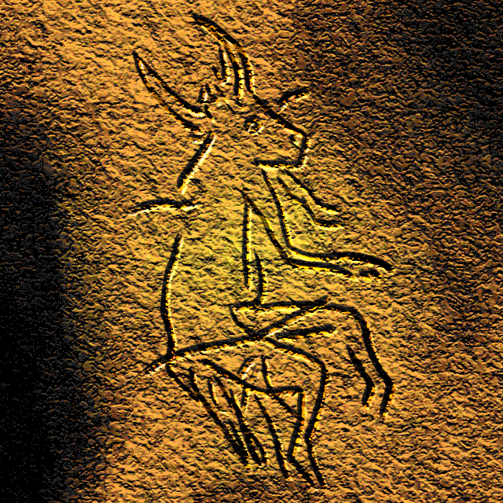  The engraving of a half-animal half-human, dubbed “The Sorcerer,” in a Paleolithic cave painting in Dordogne, France. | The excerpt below is from The Epic of Gilgamesh, an epic poem written in Mesopotamia, circa 2100 BCE.  Vocabulary:  Sumer: Mesopotamian city-state.  Enlil: In ancient Sumer, the great god, the counselor of the gods.  Enki: The Sumerian god of knowledge and water.  “The noise of mankind has become too much,” Enlil snapped. “I am losing sleep.”  A divine assembly of the gods was convened, and there it was decided by all to make a great flood that would wipe humanity from the face of the earth so that the gods could finally be free of the clamor.  Now, down on the earth, there was a pious man named Atrahasis, whose ear was open to his own god, Enki. He would speak with Enki, and Enki would speak with him.  In a dream, Enki came to Atrahasis and made his voice heard. “Dismantle your house and build a boat,” the wise god Enki warned. “Leave all your possessions and put aboard the seed of all living things. Draw out the boat that you will make on a circular plan…Make upper decks and lower decks.”  So Atrahasis built a boat and loaded it with the seed of all living things. He put on board his kith and kin. He put on board the birds flying in the heavens. He put on board cattle from the open country, wild beasts from the open country, wild animals from the steppes. Two by two they entered the boat. Then Atrahasis too, entered the boat and shut the door.  Then the flood came. The winds howled. The darkness was total; there was no sun. No man could see his fellow, no people could be distinguished from the sky. Even the gods were afraid of the deluge.  For seven days and seven nights the torrent, the storm, the flood came on. The tempest overwhelmed the land. When the seventh day arrived, the storm…blew itself out…The boat came to rest atop Mount Nimush and Atrahasis exited. He released a dove.

Questions:
- What can we learn about early religions based upon these sources?

- Based on the point of view of the Epic of Gilgamesh, what is suggested about the gods in this society?

Source 3: Last judgment of Hunefer, Book of the Dead, 1275 BCE, c. 19 Dynasty, New Kingdom (Egypt); created on papyrus.

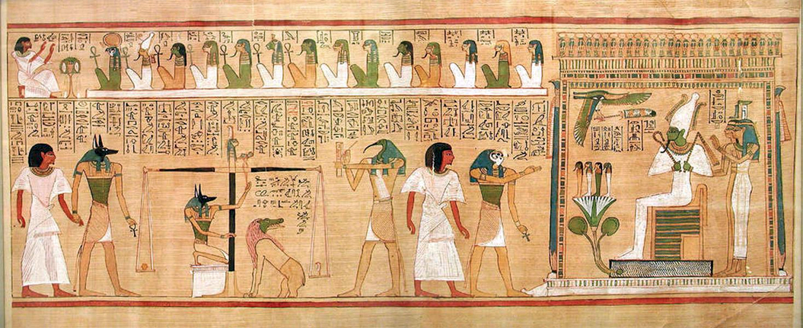

Label and explain the significance of key figures in the Egyptian painting above:

Label | Description | Significance
A | Scale:
B | Crook and flail:  - farming tools  - held by Osiris, god of underworld and afterlife, in the painting | The crook and flail are sometimes thought to represent two of the functions of the king: the crook stands for the shepherd, carer of the people, while the flail as scourge symbolizes the punishments deemed necessary to sustain society
C | Egyptian gods:  - Anubis (jackal-head): god of the dead, and funerals.  - Horus (pointed bird head): god for war, life.  - Ra (falcon-head): King of the gods.  - Osiris: god of the underworld and afterlife.

Questions:
- What can we learn about Egyptian religion based upon this artwork?

- Based on the point of view of the artist, what is the artist suggesting about Egyptian leaders through this artwork?

Source 4: Artifact of the Israelites and the Foundations of Judaism
“I am Yahweh, and there is no other. I form light and create darkness, I make peace and create evil. I, Yahweh, am the maker of all these things” (Isaiah 45:6-7).

A 4th century BCE coin, believed to be depicting Yahweh and his human-like characteristics.  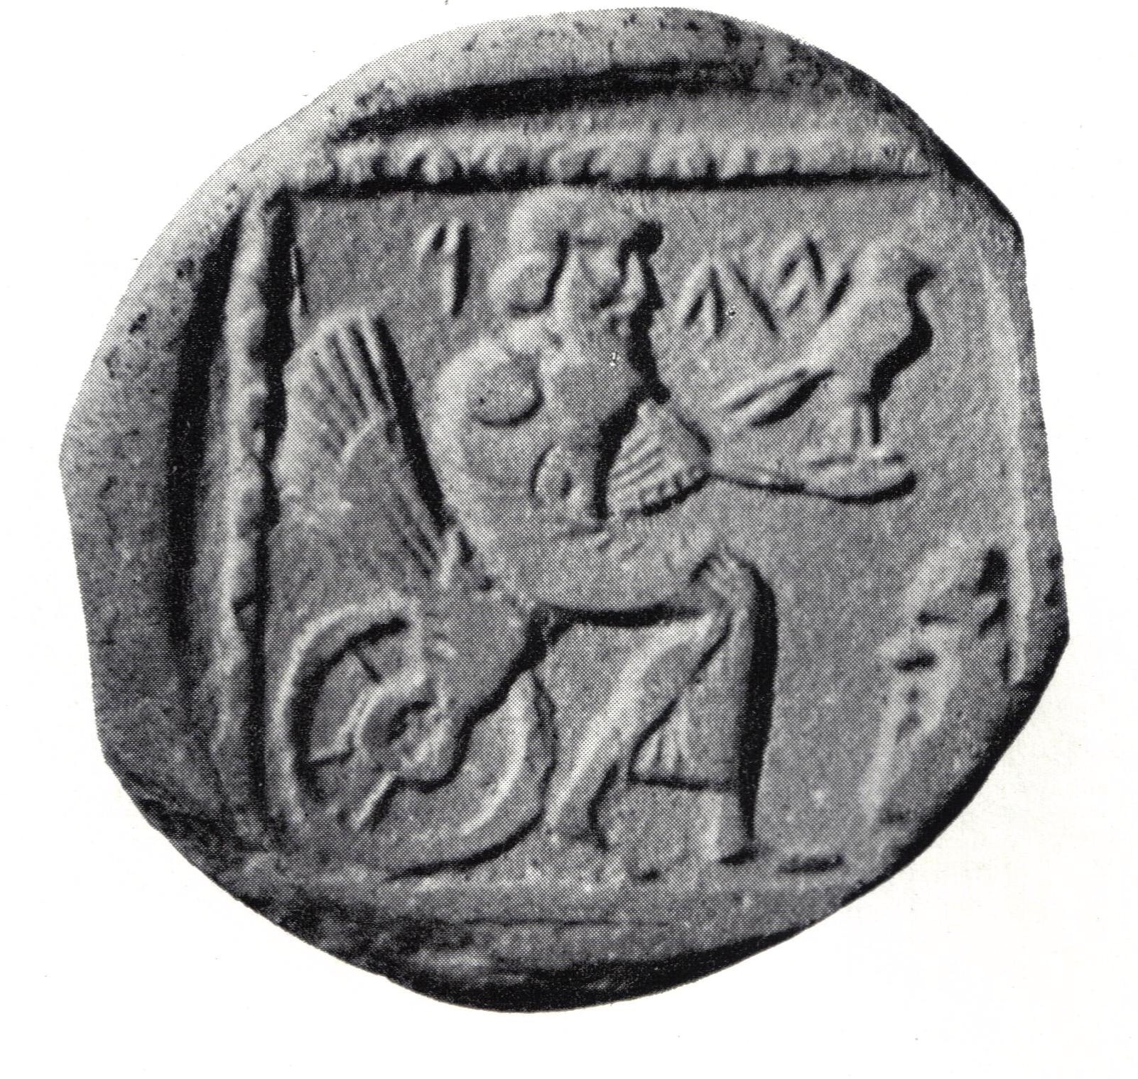 | 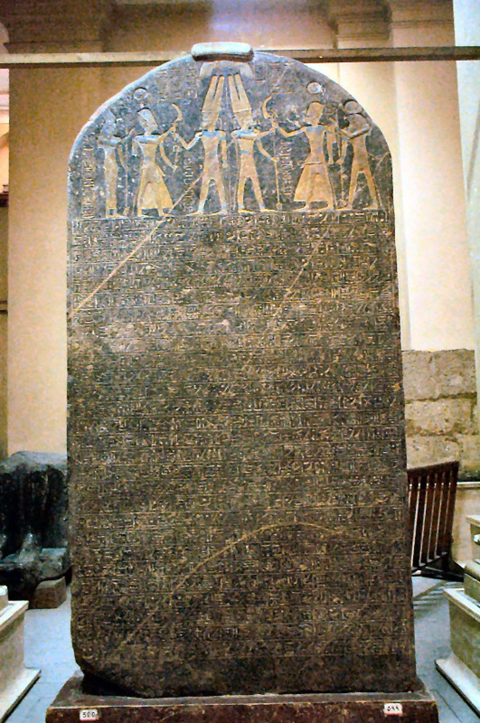  Believed to date back to 1208 BCE, the Merneptah Stele emerging from ancient Egypt, represents the earliest textual reference to the Israelites, referring to them as a nomadic group.

Questions:
5. What can we learn about the Israelite’s religion (Judaism) based upon this artwork?

6. Based on the point of view of the author and artists, what do the Biblical excerpt and the coin’s engraving suggest about the Israelite god?

Summary Questions:

1. What similarities can be found between the religions of each of these societies? What do you think may be the causes of these similarities?

2. From the Paleolithic Age to Neolithic civilizations, what changed in human religions? What do you think may be the causes of these changes?

