Name:________________________________ Date:_________________

Ancient China

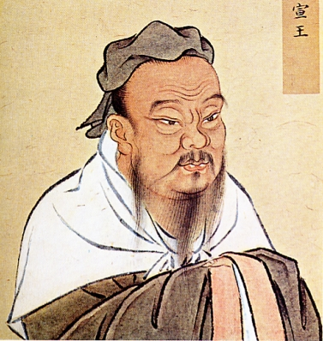

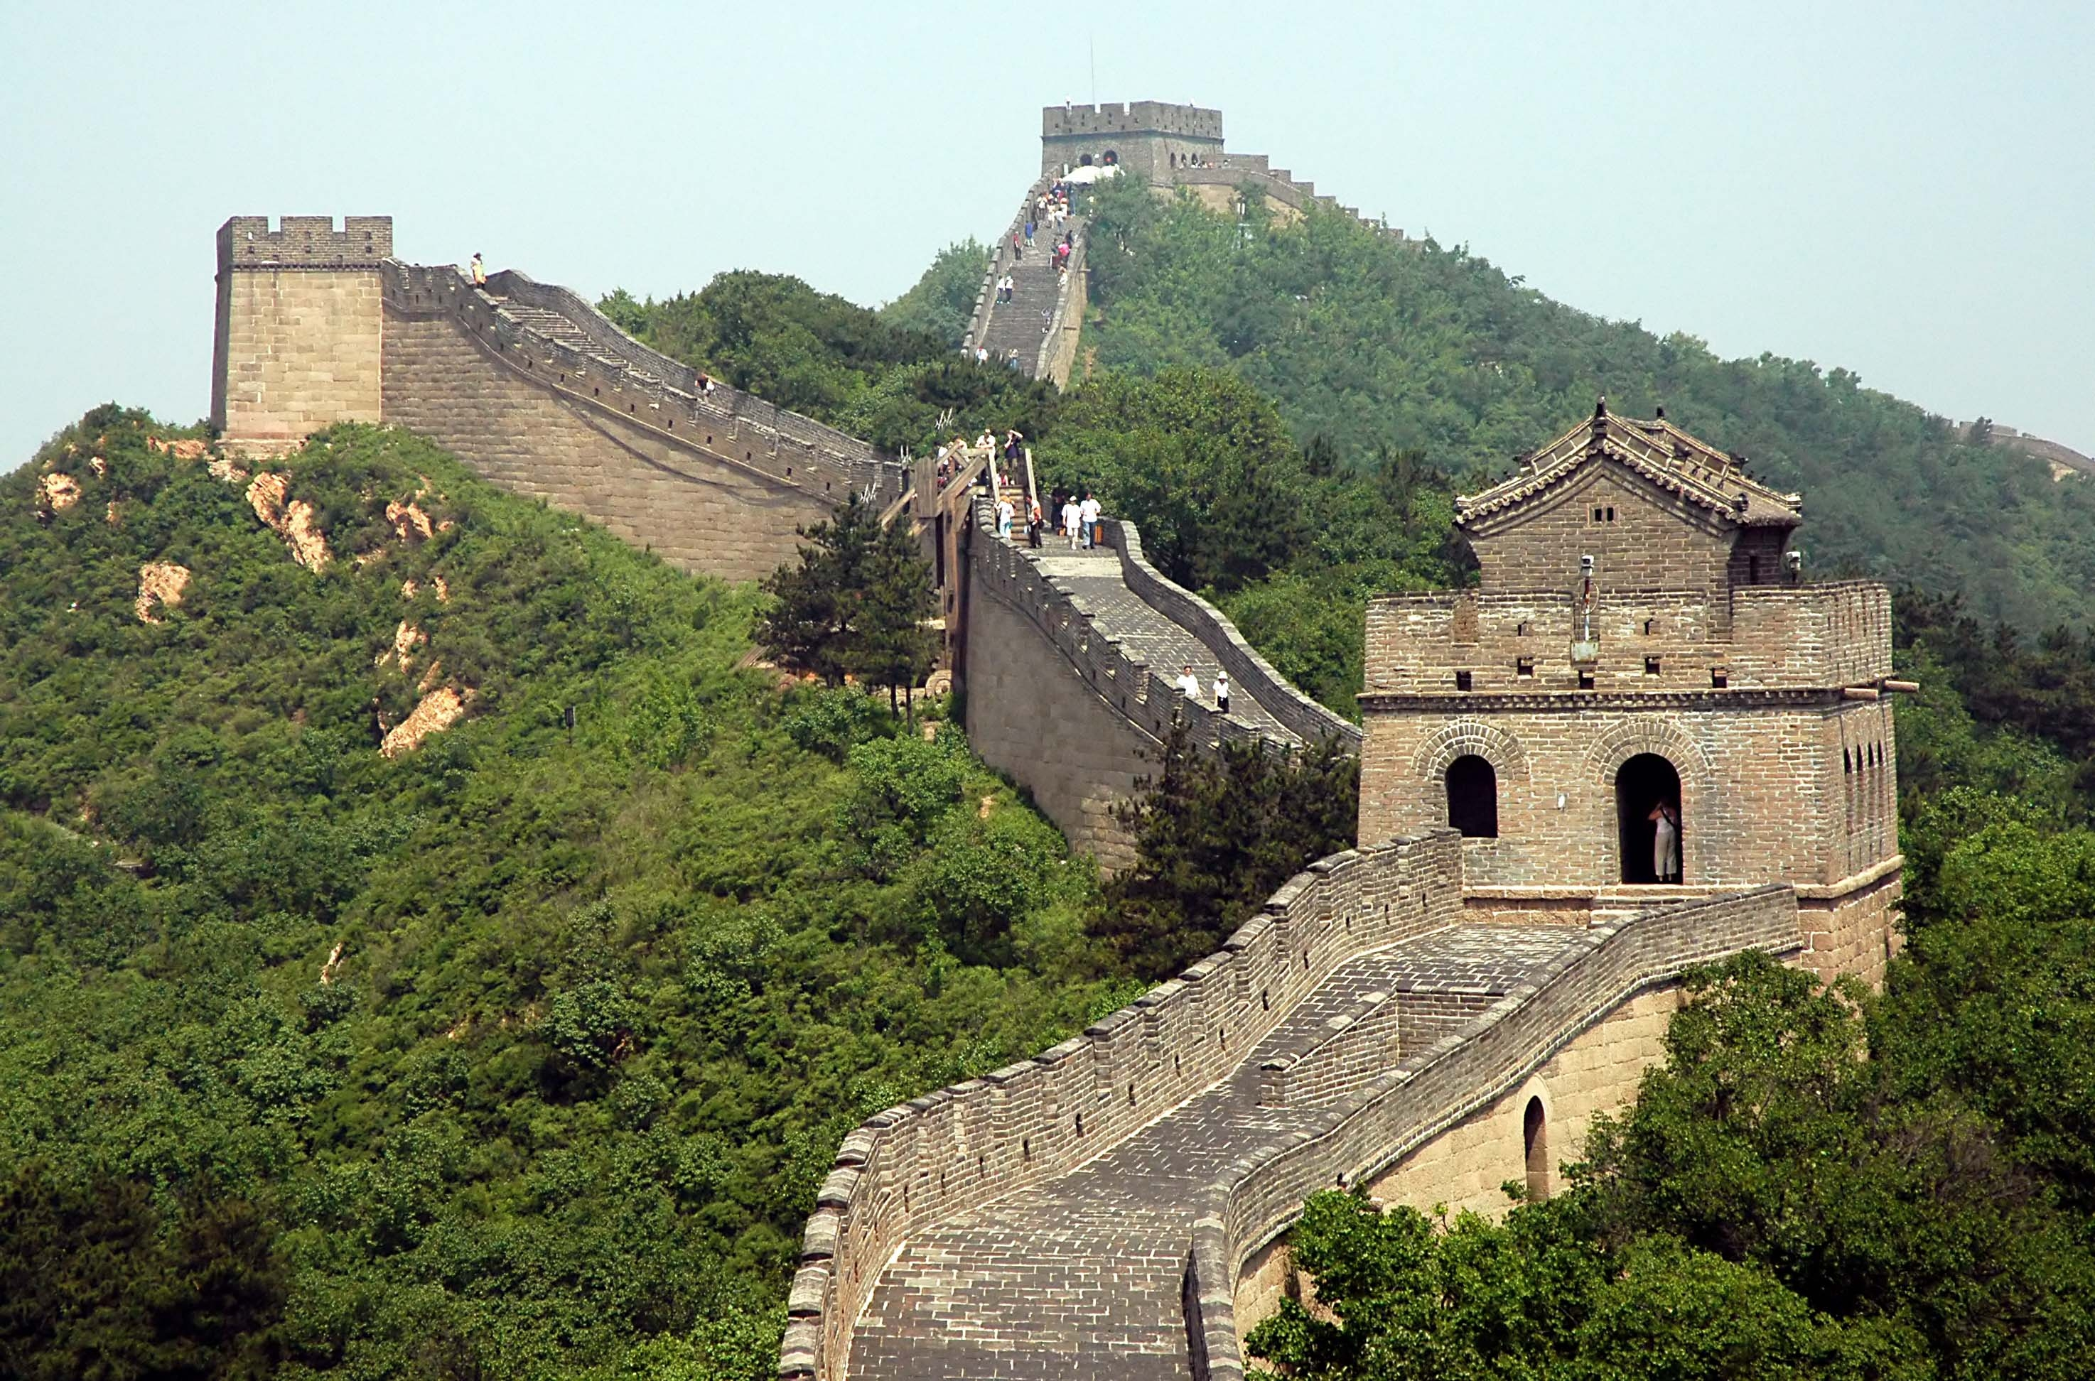 **China Establishes an Empire**

**(1027 BCE- CE 1644)**

SECTION I: Vocab Words

1. ***Analects:*** The collection of sayings and ideas attributed to the Chinese philosopher Confucius and his contemporaries, traditionally believed to have been written by Confucius’ followers.
2. **Assimilation:** The adoption of a conqueror’s culture by a conquered people.
3. **Autocracy:** A government in which the ruler has unlimited power and uses it in an arbitrary manner.
4. **Bureaucracy:** A system of departments and agencies formed to carry out the work of government.
5. **Centralized Government:** A government in which power is concentrated in a central authority to which local governments are subject.
6. **Civil Service:** The administrative departments of a government- especially those in which employees are hired on the basis of their scores on examinations.
7. **Confucius:** China’s most influential scholar. He believed China society should be based around five basic relationships: (1) ruler and subject, (2) father and son, (3) husband and wife, (4) older brother and younger brothers, and (5) friend and friend.
8. **Daoism:** A philosophy based on the ideas of the Chinese thinker Laozi, who taught that people should be guided by a universal force called the Dao (Way).
9. **Dynastic cycle:** The historical pattern of the rise, decline, and replacement of dynasties.
10. **Feudalism:** A political system in which nobles are granted the use of lands that legally belong to their king, in exchange for their loyalty, military service, and protection of the people who live on the land.
11. **Filial piety:** Respect shown by children for their parents and elders.
12. **Foot binding:** The custom of applying painfully tight binding to the feet of young girls to prevent further foot growth.
13. **Han Dynasty:** A Chinese dynasty that ruled from 202 BC to AD 9, and again from AD 23 to 220.
14. **Legalism:** A Chinese political philosophy based on the idea that a highly efficient and powerful government is the key to social order.
15. **Mandate of Heaven:** In Chinese history, the divine approval thought to be the basis of royal authority.
16. **Monopoly:** A group’s exclusive control over the production and distribution of certain goods.
17. **Qin Dynasty:** A short-lived Chinese dynasty that replaced the Zhou Dynasty in the third century BC.
18. **Shi Huangdi:** Qin ruler who unified China, and who led the construction of the Great Wall of China.
19. **Silk Roads:** A system of ancient caravan routes across Central Asia, along which traders carried silk and other trade goods.
20. **Yin and yang:** In Chinese thought, the two powers that govern the natural rhythms of life.
21. **Zhou Dynasty:** A Chinese dynasty that overthrew the Shang in 1027 BC. The Zhou adopted much of the Shang culture, and justified their right to rule through a Mandate of Heaven.

Section II: Dynasties

1. **Zhou Dynasty 5. Song Dynasty**
2. **Qin Dynasty 6. Mongols (Yuan Dynasty)**
3. **Han Dynasty 7. Ming Dynasty**
4. **Tang Dynasty**