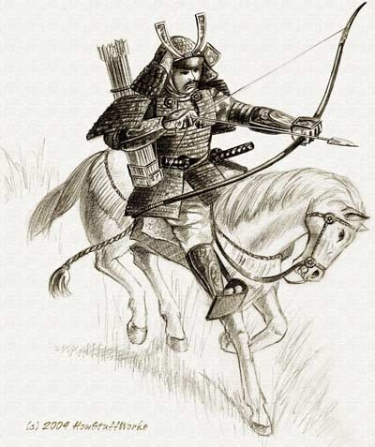
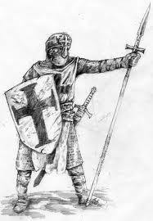
The Middle Ages and Japanese Feudalism Vocab Sheet
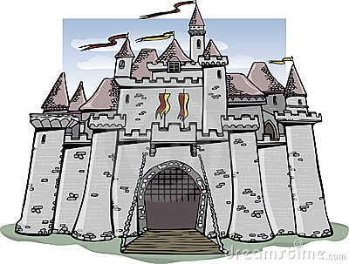

Essential Unit Question: To what extent are people dependent
upon one another for survival?

SECTION I:

- Bubonic Plague: A deadly disease that spread across Asia and Europe in the mid-14th century, killing millions of people.
- Canon Law: The body of laws governing the religious practices of a Christian church.
- Charlemagne: King of the Franks and the first Holy Roman Emperor. He promoted the arts, education, and Christianity.
- Chivalry: A code of behavior for knights in medieval Europe, stressing ideals such as courage, loyalty, and devotion.
- Commercial Revolution: The expansion of trade and business that transformed European economies during the 16th and 17th centuries.
- Crusades: Expeditions in which medieval Christian warriors sought to recover control of the Holy Land from Muslims.
- Excommunication: The taking away of a person’s right of membership in a Christian church.
- Feudalism: A political system in which nobles are granted the use of lands that legally belong to their king, in exchange for their loyalty, military service, and protection of the people who live on the land.
- Fief: An estate granted to a vassal by a lord under the feudal system in medieval Europe.
- Guild: A medieval association of people working at the same occupation, which controlled its members’ wages and prices.
- Heresy: A belief or opinion contrary to that of orthodox religious doctrine.
- Inquisition: A Roman Catholic tribunal for investigating and prosecuting charges of heresy- especially the one active in Spain during the 1400s.
- Knight: In medieval Europe, an armored warrior who fought on horseback.
- Magna Carta: “Great Charter”- a document guaranteeing basic political rights in England, drawn up by nobles and approved by King John in 1215 CE.
- Manor: A lord’s estate in feudal Europe.
- Missionaries: A person sent on a religious mission; to promote a religion in a certain country.
- Noble: A heredity class with a high social or political status.
- Pope Urban II: Head of the Catholic Church, who is best known for starting the First Crusade, which lasted from 1096-1099.
- Saladin: The Sultan of Egypt and Syria from 1174-1193 CE. He re-conquered Jerusalem from the Christians in 1187 but he was defeated by King Richard the Lionheart of England in 1191.
20. Secular: Concerned with worldly rather than spiritual matters.
21. Serf: A medieval peasant legally bound to live on a lord’s estate.
22. Tithe: A family’s payment on one-tenth of its income to a church.
23. Vassal: In feudal Europe, a person who received a grant of land from a lord in exchange for a
pledge of loyalty and services.

SECTION II:

- Archipelago: A group of islands.
- Code of Bushido: The strict code of behavior followed by samurai warriors in Japan.
- Daimyo: A Japanese feudal lord who commanded a private army of samurai.
- Emperor: A sovereign ruler of great power and rank.
- Kami: A divine spirit in the Shinto religion.
- Ring of Fire: The zone of volcanic and earthquake activity surrounding the Pacific Ocean.
- Samurai: One of the professional warriors who served Japanese feudal lords.
- Shinto: The native religion of Japan.
- Shogun: In feudal Japan, a supreme military commander who ruled in the name of the emperor.
- Tokogwa Shogunate: A dynasty of shoguns that ruled a unified Japan from 1603 to 1867.
- Zen Buddhism: A Japanese school of Buddhism emphasizing the values of meditation, and the strict discipline of the mind and body. It especially influenced the samurai.

