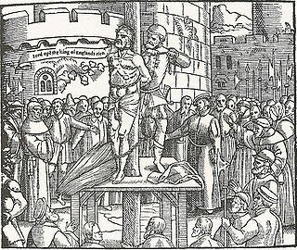
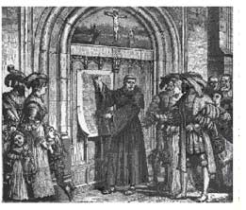
THE PROTESTANT REFORMATION
And the
CATHOLIC COUNTER-REFORMATION

SECTION I
- 95 Theses: Martin Luther’s 95 grievances against the selling of indulgences and the corruption of the Church, famously nailed to the front door of Wittenberg Castle.
- Annul: Declare invalid.
- Calvinism: A body of religious teachings based on the ideas of the reformer John Calvin.
- Henry VIII: King of England and founder of the Anglican Church. Henry VIII split England from the Catholic Church so that he could divorce his wife, Catherine of Aragon. Henry hoped to remarry in order to have a male heir.
- The Elect: Those who John Calvin preached were already predestined to be saved.
- Indulgence: A release from all or part of a punishment for sins by the Catholic Church, reducing time in purgatory after death.
- John Calvin: Founder of Calvinism. Believed that God has known since the beginning of time who will be saved. He created a theocracy in Geneva, Switzerland.
- Martin Luther: A German monk who played a large role in the spread of the Protestant Reformation. Luther’s 95 Theses helped to demonstrate how corrupt the Catholic Church had become throughout the Middle Ages and the Renaissance. He believed that faith alone was the key to salvation.
- Nepotism: The practice of favoring relatives or friends by giving them jobs.
- Predestination: The doctrine that God has decided all things beforehand, including which people will be eternally saved.
- Protestant: A member of a Christian church founded on the principles of the Reformation.
- Reformation: A 16th century movement for religious reform, leading to the founding of Christian churches that rejected the pope’s authority.
- Relic: Objects used by important religious figures, or the remains of the figures themselves. The Church taught that pilgrimages to sites of relics and holy places were acceptable ways of making up for one’s sins. Members of the clergy would often charge money to people who wanted to see relics.
- Simony: The selling or buying of a position in a Christian church.
- Theocracy: A government controlled by religious leaders.

SECTION II
- Catholic Counter-Reformation: A 16th century movement in which the Roman Catholic Church sought to make changes in response to the Protestant Reformation.
- Council of Trent: A meeting of Roman Catholic leaders, called by Pope Paul III to rule on doctrines criticized by the Protestant reformers.
- Elizabeth I: Daughter of Henry VIII and his second wife, Ann Boleyn, who took the English throne in 1558. She restored the Protestant (Anglican) Church of England.
- Ghetto: City neighborhoods in which European Jews were forced to live.
- Heretic: A person who holds beliefs that differ from official Church teachings
- Inquisition: A Roman Catholic tribunal for investigating and prosecuting charges of heresy- especially the one active in Spain during the 1400s.
- Jesuits: Members of the Society of Jesus, a Roman Catholic religious order founded by Ignatius of Loyola.
- Mary Tudor: Daughter of Henry VIII and his first wife Catherine of Aragon. Mary took the throne after Henry VIII’s death, and returned England to Catholicism and the rule of the pope.
- Persecution: The subjecting of a race or group of people to cruel or unfair treatment because of their ethnic origin or religious beliefs.
- Recant: To withdraw something previously said.

