Name: _______________________ Period: _____________
Government Date: ______________

Aim: How are voter’s behaviors influenced?
Do Now
What do you believe is the biggest factor that influences people’s decision when they vote? Why?

How do observers learn about voting behavior?
- They study the results of particular elections.
- They conduct and study public opinion polls.
- They try to understand __________________________ – all of the complex influences that go into how people see the political world and their role in it.
Political Socialization
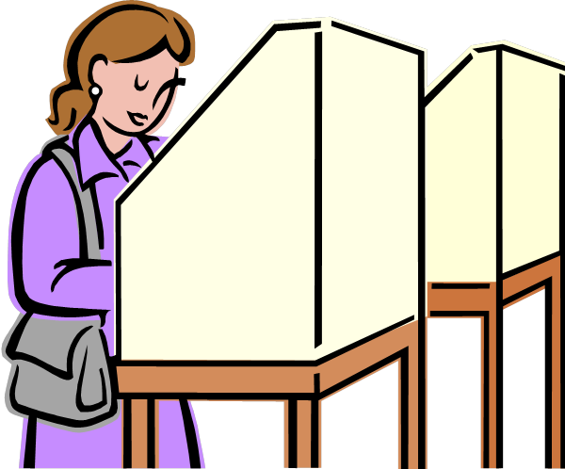
Political Socialization
- The process by which people gain their political _________ & __________.
  - Begins in early childhood
  - All of the experiences & relationships that lead people to see the political world
- _______________________________– include a voter’s personal social characteristics, such as age, race religion etc.
- _______________________________ – include how a particular voter sees parties, candidates, and issues in an election.
Sociological Factors
Voter’s social & economic life
  - Personal _________, ___________, ____________, __________, ____________, &
____________.
  - Group affiliations: family, co-workers, friends, etc.

Income & Occupation
- Voters in the middle to upper income brackets are more likely to be ______________. Ex. Professional & business people.
- Voters with lower incomes are more likely to be _____________. Ex. Manual workers.

Education
- ___________ graduates vote for Republicans in higher percentages than high school graduates.
- ___________ graduates vote more often Republican than do those without a high school diploma.

Gender, Age
- Generally men have been no more or less likely to favor one party than have women.
- However, men do vote differently than women when issues of _______________ and ____________ or _________________ are prominent in an election.
- Since 1980, women have been _____________ likely to vote Republican in presidential elections.
- Younger voters have been __________________ likely to be Democrats. (Under 30)

Religious & Ethnic Background
- Historical factors account for religious patterns:
    - Northern Protestants = ________________________
    - Catholics & Jews more likely to be _____________________
    - __________________ groups are more likely to vote Republican
    - Non-whites more likely to be _________________ since 1930

Geography
  - South used to be consistently ____________________but over the past 30 years it has become increasingly ______________________
  - North & East are primarily _______________________
  - Republican voters dominate the __________________
  - Maine, Vermont, Kansas and the Dakotas are consistently Republican

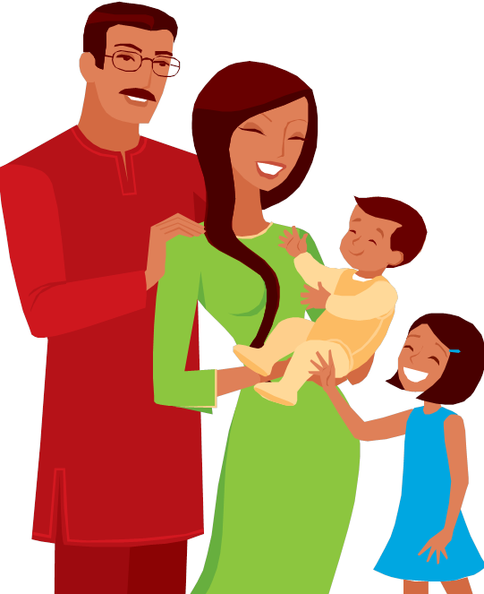
Family & Group Affiliations
- 2 out of 3 voters follow the political attachments of their ________________________
  - 9 out of 10 married couples ______________________ the same partisan leanings
  - Co-Workers/Friends: Those who work together tend vote very much __________________________.
Psychological Factors
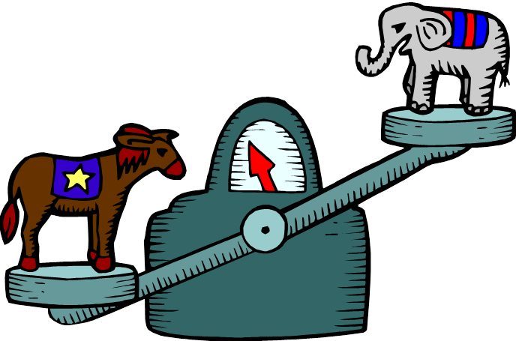
Party Identification
- __________-ticket voting
- Long-term factor
- Lost impact in recent years with an increase in __________________ voters.

Candidates & Issues
- ________-ticket voting
- Short-term Factor

Apply your knowledge
What factors influence how people vote?

