**War of attrition:**

**The Schlieffen Plan:**

**The Battle of the Marne:**

**Total War:**

**THE WESTERN FRONT**

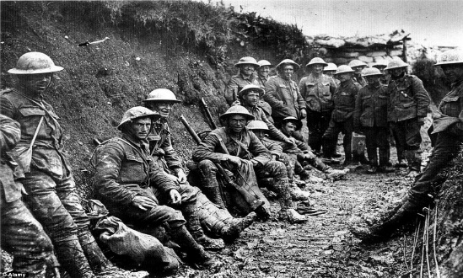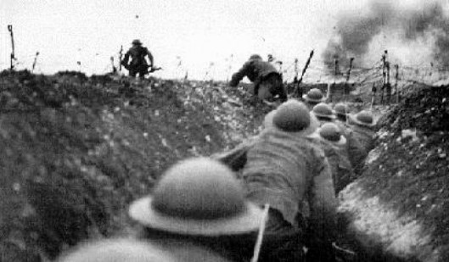

**In The Trenches**

When news of the war came, volunteers rushed to join the armed forces. Soldiers marched through the streets of their cities. Civilians cheered and threw flowers. Young and old alike marched off to the battlefields with a song on their lips. All were convinced that they would soon return victorious and covered with glory.

What did the soldiers of World War I experience when they finally reached the battlefields? What does this story, set in Verdun, France, tell us about the war?

**Verdun 1916**

**Narrator 1:** Thousands of German solders were in their trenches waiting for the signal to attack. For several hours German artillery fire had been hitting the French positions. Now the shelling had stopped. Every German soldier knew that he would soon be given the order to leave his trench and try to capture the French stronghold. The Germans would try to break the deadlock with a huge assault on the French forces at Verdun.

Several soldiers with worried faces were talking. The nervously waited for the attack to begin.

**ERIC:** “John, are you afraid?”

**JOHN:** “Of course, I’m afraid. I’m not a fool or mad.”

**PETER:** “Well, I’m not afraid. Anything, even death, is better than living like this!”

**JOHN:** “Peter don’t talk like a fool!”

**PETER:** “Why shouldn’t I? Aren’t we all fools? Who but a fool would volunteer to spend two years living in mud and fighting with rats for scraps of bread?”

**ERIC:** “Enough! Remember, you are a German soldier. You have taken an oath to protect the Fatherland. It is our duty to suffer, if suffering will bring peace to our country. Let us not complain like weak old people. Good soldiers must learn to hide their feelings.”

**PAUL:** If only I could still believe these things.”

**Narrator 1:** Suddenly, the command “Charge!” was given. Hans and Eric picked up their weapons and pulled themselves over the trench wall. Now they somehow had to find their way across “no man’s land,” the area between the German and French trenches. Shells were exploding all around them. Suddenly, there was the smell of gas in the air. The soldiers stopped and quickly put on their gas masks. But some waited too long. Their lungs filled with the poison gas. They choked to death.

**Narrator 2:** The men approached the enemy trenches. There was barbed wire everywhere. They began to cut their way through. There was a burst of machine gun fire; rows of men fell in their tracks. Through all the noise and confusion, John heard a scream. It was Eric. The scream was the last sound he would ever make. Eric’s arms and legs had been shot away. The rest of his body was caught on the barbed wire.

**Narrator 3:** John stumbled forward and jumped into the enemy trench. He fired blindly, shooting at everything that moved. He saw a French soldier who was seriously wounded. The man looked at John, a plea for mercy in his eyes. John hesitated. There was a lump in his throat. He began to back away. Suddenly the madness of the moment gripped him once again. He ran his bayonet through the fallen soldier.

Later, when the battle was over, the German general congratulated his soldiers.

**MICHAEL:** “Men, I am proud of you. You have done your duty as soldiers of the Fatherland. Thanks to you, Germany is one step closer to peace!”

**Narrator 1:** At these words, John began to cry.

**POSTSCRIPT**

Fighting was intense on the Western Front in 1916. Trench warfare led to enormous losses on both sides. In the battle of Verdun, the French rallying cry had been “They shall not pass,” and they did not- but at a tremendous cost. Over nine months, more than 900,000 French and German soldiers were killed. Survivors recovered fewer than 160,000 identifiable bodies. The rest were unrecognizable or had been blown to bits by high explosives and sucked into the mud. In spite of the heavy fighting, however, neither side was able to advance more than a few miles. To relieve the pressure on Verdun, British forces counterattacked at the Somme, and by November they had gained a few thousand yards at the cost of 420,000 casualties. In the end neither side gained any strategic advantage. The **stalemate** continued through 1916 and 1917.

The Germans met with much greater success on the **Eastern Front**, where Austrian and German forces overran Serbia, Albania, and Romania. The Central Powers defeated the Russian army in battle after battle. Poorly trained and inadequately supplied, over a million Russian soldiers died, and the army was near collapse. Each defeat undermined the popularity of the Russian Tsar Nicholas II and his government, and played a significant role in fostering revolution within Russia. In 1917, the Russian army was spared further bloodshed when a Communist revolution overthrew the Czarist government. The new government signed a humiliating treaty with Germany, the **Treaty of Brest-Litovsk**, which took Russia out of the war.

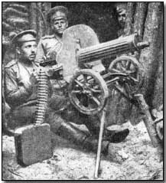**New Technology and Weapons in World War I**

**Long-range artillery and machine guns –** prior to this war, a gun shot only a single round and reloading was time-consuming

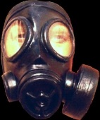

**Poison Gas –** chemical weapons were used for the first time in WWI – men would

throw up bits of their lungs or died for suffocation – soldiers wore gas masks to protect themselves from poison gas - although it was outlawed by international agreement –

it was used again by Russians against Afghan resistance fighters and by Iraq against Kurdish rebels

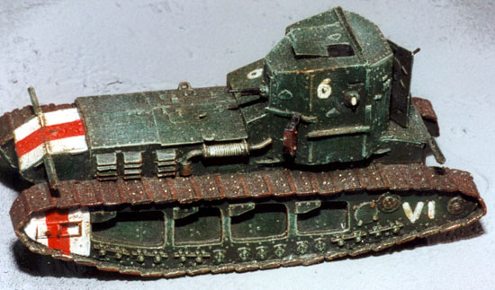

**Tanks** – first developed by the British, these “armored landships” have been used in all wars since. Tanks protected advancing troops as they broke through enemy defenses.

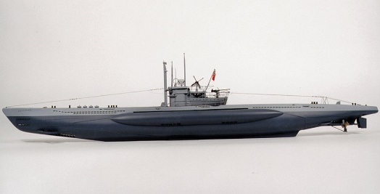

**Submarines** – German U-Boats (Unterseeboot) – underwater ships

that launched torpedoes or guided underwater bombs were used

as surprise attacks – the use of submarines by the Germans

helped bring the U.S. into war.

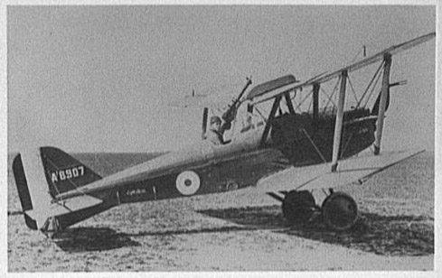

**Airplanes** – one or two seat propeller plane equipped with a machine gun. “Flying aces” engaged in individual combat, even though these “dogfights” had little effect on the war.

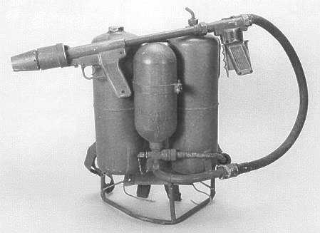

**Flamethrowers** – fired a stream of gasoline or petrol that was

ignited at the muzzle of the flamethrower. It was first used by the

Germans as a shock weapon.

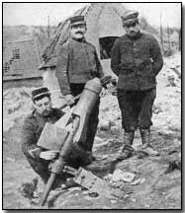

**Mortars** – were used to lob large shells straight into the air so that they would fall directly into an enemy trench and destroy it.