Nombre _________________________ Español- pd. ___
SPANISH ACCENT CODES

To create Spanish letters and symbols:
- Hold down the “Alt” key.

- Type in the codes below using the number pad on the right side of the keyboard.
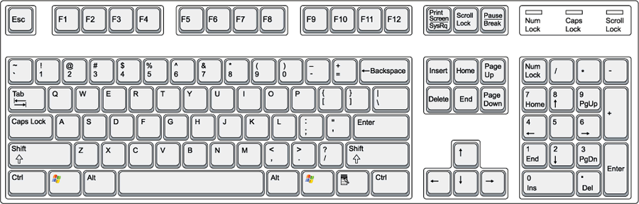

A - 0193
E - 0201
I - 0205
O - 0211
U - 0218
a - 0225
e - 0233
i - 0237
o - 0243
u - 0250

ñ - 0241
¡ - 0161
¿ - 0191

