Name: _____________________________ Date: _____________

**Dilations**

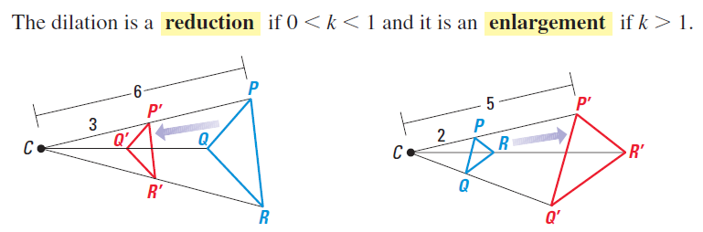

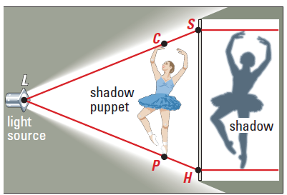

1. What are the coordinates of point ** under dilation ?
2. Triangle *ABC* has vertices , , and . State and label the coordinates of , the image of  after a dilation of .

**

3.



1. Which transformation represents a dilation?

|  |  |
| --- | --- |
| 1) |  |
| 2) |  |
| 3) |  |
| 4) |  |

1. The image of point *A* after a dilation of 3 is . What was the original location of point *A*?
2. The point ** maps onto  under a dilation with respect to the origin. What is the constant of dilation?

