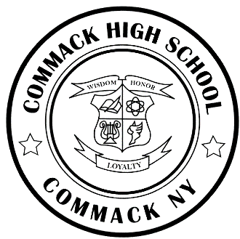
COMMACK HIGH SCHOOL Leslie H. Boritz
Principal
One Scholar Lane
Commack, New York 11725 Andrea Allen
Phone: (631) 912-2100 Matthew P. Keltos
Fax: (631) 912-2250 Susan Shapiro
www.commack.k12.ny.us Assistant Principals

An International Baccalaureate School ______________________________________________________________________________________________________

June 2020
Dear IB Student and Parent/Guardian,

Congratulations to all of you on your accomplishments this year! We would like to especially recognize the IB seniors on the completion of the IB Diploma requirements! Please see below for information regarding IB results and upcoming events:

SENIORS:
- The IB Diploma Ceremony to recognize our IB Diploma candidates is on Monday, June 15th at 7:00 PM via Boxcast. The link will be posted on the District webpage. Friends and family members are encouraged to view the broadcast.
- Do you want to send your IB exam scores to your college/university?
- YES: They will automatically be sent to the college/university of your choice as reported in Naviance.
- NO: You may choose not to have your scores sent to your college/university. If you choose this
option, please contact Ms. Bernstein at mbernstein@commack.k12.ny.us by June 14, 2020.
- If you chose the NO option, change your mind about sending your scores after July 5, 2020 or change schools,
you can send your IB scores, for a fee imposed by IBO, following this path:
Commack High School > Advanced Programs>International Baccalaureate> Send IB Scores to College
- Please note:
- You are not able to choose which specific course scores you want sent to your college/university as IBO is
only able to send ALL scores; they cannot separate your scores.
- IB Scores are used by college/universities to determine class placement/credit, not to determine admission to
a college/university.
- IB Personal Code and PIN:
- Results will be posted on July 6, 2020.
- Obtain your results at https://candidates.ibo.org .
- Grades cannot be accessed using an iPhone or iPad.
- Mozilla Firefox is the browser recommended by IB.
- To obtain your log-in information, please log into your IC account and go to the Backpack tab.
- If you are unable to access your log in information, e-mail Ms. Bernstein at mbernstein@commack.k12.ny.us .
JUNIORS:
- IB Personal Code and PIN:
- Results will be posted on July 6, 2020
- Obtain your results at https://candidates.ibo.org.
- Grades cannot be accessed using an iPhone or iPad.
- Mozilla Firefox is the browser recommended by IB.
- To obtain your log-in information, please log into your IC account and go to the Backpack tab.
- If you are unable to access your log in information, e-mail Ms. Bernstein at mbernstein@commack.k12.ny.us .

- IB Writing Workshop:
- To support the EE process, for current Juniors entering their Senior Year in September, 2020.
- In the CHS Library on Thursday, August 20, 2020 and Friday, August 21, 2020.
- You may use this opportunity to consult the databases and/or finish your Extended Essay research.
- You may meet with your EE mentor if the mentor is available and arrangements are made prior to the above dates.
- You may also use this time to get started on your college essays.
- Workshops are optional – you may come when you want and stay for as long as you like.

Best wishes for a relaxing summer vacation and for continued success in your future endeavors.

Warm regards,

Mrs. Shapiro, Dr. O’Brien, Mrs. Price

Mrs. Shapiro, Dr. O’Brien and Mrs. Price
IB Team

