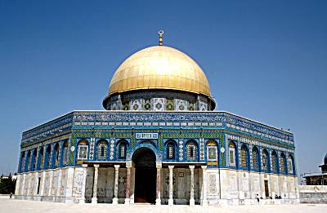
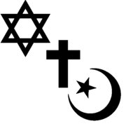
MONTHEISTIC RELIGIONS

Unit Essential Question: How do religious values shape cultural interaction, cultural exchange, and potentially cause conflict?

- Allah: In Islamic faith, the one and only God, creator and sustainer of the universe.
- Bible: Central religious text of Christianity.
- Caliph: Successor to Muhammad as political and religious leader of the Muslims.
- Christianity: Worldwide monotheistic religion based on the life and teachings of the prophet Jesus.
- Covenant: A binding agreement.
- Diaspora: The dispersal of the Jews from their homeland in Palestine- especially during the period of more than 1,800 years that followed the Romans’ destruction of the Temple in Jerusalem in 70 CE.
- Five Pillars: Religious duties that must be carried out by every able-bodied Muslim who can afford to do so at least once in his or her lifetime.
- Golden Rule: In the teachings of Jesus Nazareth, one should treat others, as one would like others to treat oneself.
- Hajj: The largest regularly occurring pilgrimage in the world, and is one of the five pillars of Islam.
- Heresy: Religious belief that is contrary to the official teachings of the Church.
- Hijra: The migration or journey of the Islamic prophet Muhammad and his followers from Mecca to Medina.
- Islam: Monotheistic; second largest world religion.
- Jihad: Religious duty of Muslims. In Arabic it translates to “struggle.”
- Judaism: Worldwide monotheistic religion.
- Koran (Qu’ran): Central religious text of Islam.
- Martyr: Somebody who suffers persecution and death for refusing to renounce, or accept, a belief or cause, usually religious.
- Messiah: Savor or liberator of a people in the Jewish, Christian or Islamic faiths.
- Mosque: A place of worship for followers of Islam.
- Muhammad: Prophet of Islam.
- Muslim: Term for individuals who practice the Islamic Faith.
- Pope: The Bishop of Rome and the leader of the worldwide Catholic Church.
- Prophet: In a religion, an individual who claims to speak the word of god.
- Sect: a group with distinctive religious, political or philosophical beliefs, often an offshoot of a larger religious group.
- Ten Commandments: Set of Biblical laws relating to ethics and worship, which play a fundamental role in Judaism and Christianity.

