**Foundations in Spanish**

Packet 2

* Numbers
* Days of the week
* Months of the Year

Name\_\_\_\_\_\_\_\_\_\_\_\_\_\_\_\_\_\_\_\_\_\_\_\_\_\_\_\_\_\_\_\_\_\_\_\_\_\_\_\_\_\_\_\_\_\_\_\_\_\_\_\_\_\_\_\_\_\_\_\_\_\_\_\_\_\_\_\_\_

Teacher\_\_\_\_\_\_\_\_\_\_\_\_\_\_\_\_\_\_\_\_\_\_\_\_\_\_\_\_\_\_\_\_\_\_\_\_\_\_\_\_\_\_\_\_\_\_\_\_\_\_\_\_\_\_\_\_\_\_\_\_\_\_\_\_\_\_\_

Period\_\_\_\_\_\_\_\_\_\_

**LOS NÚMEROS 0-31**

**Los números 11-31:**

once **\_\_\_\_\_\_\_\_\_**

doce **\_\_\_\_\_\_\_\_\_**

trece **\_\_\_\_\_\_\_\_\_**

catorce **\_\_\_\_\_\_\_\_\_**

quince **\_\_\_\_\_\_\_\_\_**

diez y seis **\_\_\_\_\_\_\_\_\_**

diez y siete **\_\_\_\_\_\_\_\_\_**

diez y ocho **\_\_\_\_\_\_\_\_\_**

diez y nueve **\_\_\_\_\_\_\_\_\_**

veinte **\_\_\_\_\_\_\_\_\_**

veinte y uno **\_\_\_\_\_\_\_\_\_**

veinte y dos **\_\_\_\_\_\_\_\_\_**

veinte y tres **\_\_\_\_\_\_\_\_\_**  
veinte y cuatro **\_\_\_\_\_\_\_\_\_**

veinte y cinco **\_\_\_\_\_\_\_\_\_**

veinte y seis **\_\_\_\_\_\_\_\_\_**

veinte y siete **\_\_\_\_\_\_\_\_\_**

veinte y ocho **\_\_\_\_\_\_\_\_\_**

veinte y nueve **\_\_\_\_\_\_\_\_\_**

treinta **\_\_\_\_\_\_\_\_\_**

treinta y uno **\_\_\_\_\_\_\_\_\_**

**Los números 0-10:**

cero \_\_\_\_\_\_\_\_\_

uno \_\_\_\_\_\_\_\_\_

dos \_\_\_\_\_\_\_\_\_

tres \_\_\_\_\_\_\_\_\_

cuatro \_\_\_\_\_\_\_\_\_

cinco \_\_\_\_\_\_\_\_\_

seis \_\_\_\_\_\_\_\_\_

siete \_\_\_\_\_\_\_\_\_

ocho \_\_\_\_\_\_\_\_\_

nueve \_\_\_\_\_\_\_\_\_

diez \_\_\_\_\_\_\_\_\_

**Reglas (Rules):**

* Numbers 1-15 are all separate numbers.
* Numbers 16 and above follow a pattern.

*For Example:* to write the number

**16** in Spanishtake the word for ten (*diez*) the word for and (*y*) and the next number six (*seis*) to form

***diez y seis.***

* Follow the same pattern for numbers

20-29 and 30-31.

* The numbers 16-29 can also be written as one word.

*For example*: **16** = **dieciséis**

**Dos manitas, diez deditos**



Dos manitas, diez deditos,

dos manitas, diez deditos,

dos manitas, diez deditos,

cuéntalos conmigo.

Uno, dos, tres deditos,

cuatro, cinco, seis deditos,

siete, ocho, nueve deditos,

y uno más son diez.

If you would like to listen to the song at home, go the link below.

**http://tinyurl.com/qfhmazt**

|  |  |
| --- | --- |
| retro-phone-1 | **¿Cuál es tu número de teléfono?**  *What is your phone number?* |
| **Mi número de teléfono es:** seis – tres – uno – cinco – cinco – cinco – dos – cuatro – cero – seis.  *My phone number is 631-555-2406.* |

Now you try! Write out the numbers of your phone number in Spanish.

**¿Cuál es tu número de teléfono?**

**Mi número de teléfono es:**

\_\_\_\_\_\_\_\_\_\_\_\_\_\_\_\_\_\_\_\_\_\_\_\_\_\_\_\_\_\_\_\_\_\_\_\_\_\_\_\_\_\_\_\_\_\_\_\_\_\_\_\_\_\_\_\_\_.



**Did you know...**

Spanish phone numbers have two parts: area code and phone number. The area code is either 2 or 3 digits and begins with either 8 or 9. The phone number is six or seven digits. The area code and phone number always total 9 digits.

**ACTIVIDAD:** Write out the digits of the following phone numbers in Spanish.

Example: 931-812-783

*nueve – tres – uno – ocho – uno – dos – siete – ocho* – *tres*

1. 055-957-023

\_\_\_\_\_\_\_\_\_\_\_\_\_\_\_\_\_\_\_\_\_\_\_\_\_\_\_\_\_\_\_\_\_\_\_\_\_\_\_\_\_\_\_\_\_\_\_\_\_\_\_\_\_\_\_\_\_\_\_\_\_\_\_\_\_\_\_\_\_

1. 06-304-1188

\_\_\_\_\_\_\_\_\_\_\_\_\_\_\_\_\_\_\_\_\_\_\_\_\_\_\_\_\_\_\_\_\_\_\_\_\_\_\_\_\_\_\_\_\_\_\_\_\_\_\_\_\_\_\_\_\_\_\_\_\_\_\_\_\_\_\_\_\_

1. 042-718-631

\_\_\_\_\_\_\_\_\_\_\_\_\_\_\_\_\_\_\_\_\_\_\_\_\_\_\_\_\_\_\_\_\_\_\_\_\_\_\_\_\_\_\_\_\_\_\_\_\_\_\_\_\_\_\_\_\_\_\_\_\_\_\_\_\_\_\_\_\_



**ACTIVIDAD:** You have arrived home from school and see that the answering machine is full. Check the voicemail and record the people who called and their phone numbers so you can relay the information to an adult when they arrive home.

**Voicemail 1:**

Nombre\_\_\_\_\_\_\_\_\_\_\_\_\_\_\_\_\_\_\_\_\_\_\_\_\_\_\_\_\_\_\_\_\_\_\_\_\_\_\_\_\_\_\_\_\_

Número de teléfono: \_\_\_\_\_\_\_\_\_\_\_\_\_\_\_\_\_\_\_\_\_\_\_\_\_\_\_\_\_\_\_\_\_\_\_\_\_\_\_\_\_\_\_\_\_\_\_\_\_\_\_\_\_

**Voicemail 2:**

Nombre\_\_\_\_\_\_\_\_\_\_\_\_\_\_\_\_\_\_\_\_\_\_\_\_\_\_\_\_\_\_\_\_\_\_\_\_\_\_\_\_\_\_\_\_\_

Número de teléfono: \_\_\_\_\_\_\_\_\_\_\_\_\_\_\_\_\_\_\_\_\_\_\_\_\_\_\_\_\_\_\_\_\_\_\_\_\_\_\_\_\_\_\_\_\_\_\_\_\_\_\_\_\_

**Voicemail 3:**

Nombre\_\_\_\_\_\_\_\_\_\_\_\_\_\_\_\_\_\_\_\_\_\_\_\_\_\_\_\_\_\_\_\_\_\_\_\_\_\_\_\_\_\_\_\_\_

Número de teléfono:

\_\_\_\_\_\_\_\_\_\_\_\_\_\_\_\_\_\_\_\_\_\_\_\_\_\_\_\_\_\_\_\_\_\_\_\_\_\_\_\_\_\_\_\_\_\_\_\_\_\_\_\_\_

**ACTIVDAD:** You are a police officer on highway safety patrol. I am your captain and I have asked you for the license plate numbers of the cars who have been caught speeding. Read the following license plates aloud to your partner using the Spanish alphabet and numbers.

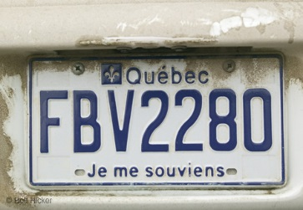

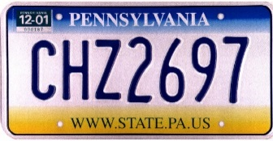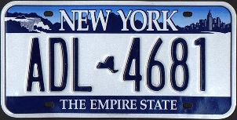1. 2. 3.

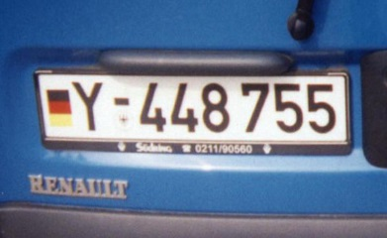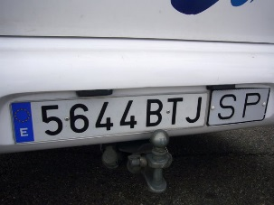4. 5.

**ACTIVDAD:** Write the numeral in English.

1. diez 6. dos

2. quince 7. ocho

3. veinte y cinco 8. onze

4. treinta y uno 9. viente y cinco

5. trece 10. nueve

|  |  |
| --- | --- |
| MC900336122[1] | **¿Cuántos años tienes tú?**  *How old are you? (informal)* |
| **Yo tengo \_\_\_\_\_ años.**  *I am \_\_\_\_ years old.* |
|  |  |

**ACTIVIDAD:** Write how old each person is based on how many candles you count on their cake. Follow the example.

**Example:**

**¿Cuántos años tienes tú?**

Yo tengo dos años

…………………………………………………………………………………………………………………



¿Cuántos años tienes tú?

\_\_\_\_\_\_\_\_\_\_\_\_\_\_\_\_\_\_\_\_\_\_\_\_\_\_\_\_\_\_\_\_\_\_\_\_\_\_\_\_\_\_\_\_\_\_\_\_\_\_\_\_\_\_\_\_\_\_\_\_\_\_



¿Cuántos años tienes tú?

\_\_\_\_\_\_\_\_\_\_\_\_\_\_\_\_\_\_\_\_\_\_\_\_\_\_\_\_\_\_\_\_\_\_\_\_\_\_\_\_\_\_\_\_\_\_\_\_\_\_\_\_\_\_\_\_\_\_\_\_\_\_



¿Cuántos años tienes tú?

\_\_\_\_\_\_\_\_\_\_\_\_\_\_\_\_\_\_\_\_\_\_\_\_\_\_\_\_\_\_\_\_\_\_\_\_\_\_\_\_\_\_\_\_\_\_\_\_\_\_\_\_\_\_\_\_\_\_\_\_

¿Cuántos años tienes tú?



\_\_\_\_\_\_\_\_\_\_\_\_\_\_\_\_\_\_\_\_\_\_\_\_\_\_\_\_\_\_\_\_\_\_\_\_\_\_\_\_\_\_\_\_\_\_\_\_\_\_\_\_\_\_\_\_\_\_\_\_



¿Cuántos años tienes tú?

\_\_\_\_\_\_\_\_\_\_\_\_\_\_\_\_\_\_\_\_\_\_\_\_\_\_\_\_\_\_\_\_\_\_\_\_\_\_\_\_\_\_\_\_\_\_\_\_\_\_\_\_\_\_\_\_\_\_\_\_



¿Cuántos años tienes tú?

\_\_\_\_\_\_\_\_\_\_\_\_\_\_\_\_\_\_\_\_\_\_\_\_\_\_\_\_\_\_\_\_\_\_\_\_\_\_\_\_\_\_\_\_\_\_\_\_\_\_\_\_\_\_\_\_\_\_\_\_

***Los Días de la Semana***

|  |  |  |
| --- | --- | --- |
| ***lunes***  ***martes***  ***miércoles***  ***jueves***  ***viernes***  ***sábado***  ***domingo*** | Monday  Tuesday  Wednesday  Thursday  Friday  Saturday  Sunday | |
| * ***día*** * ***semana*** * ***el fin de semana***   ***¿Qué día es hoy?***   * ***Hoy es \_\_\_\_\_*** * ***¿Qué día es mañana?*** * ***Mañana es \_\_\_\_*** * ***¿Qué día fue ayer?*** * ***Ayer fue \_\_\_\_\_\_\_\_*** | | | * day * week * weekend * What day is today? * Today is \_\_\_\_\_\_ * What day is tomorrow? * Tomorrow is \_\_\_\_\_ * What day was yesterday? * Yesterday was \_\_\_\_ | |

“¡LOS DÍAS DE LA SEMANA!”

(“THE DAYS OF THE WEEK!”)

SUNG TO THE TUNE OF “THE ADDAMS FAMILY”

DAYS OF THE WEEK (SNAP, SNAP)

DAYS OF THE WEEK (SNAP, SNAP)

DAYS OF THE WEEK, DAYS OF THE WEEK, DAYS OF THE WEEK (SNAP, SNAP)

[](http://miscellaneouspages.homestead.com/MusicalNotes_clipart1.jpg)LUNES Y MARTES

MIÉRCOLES Y JUEVES

VIERNES Y SÁBADO

Y DOMINGO

DAYS OF THE WEEK (SNAP, SNAP)

**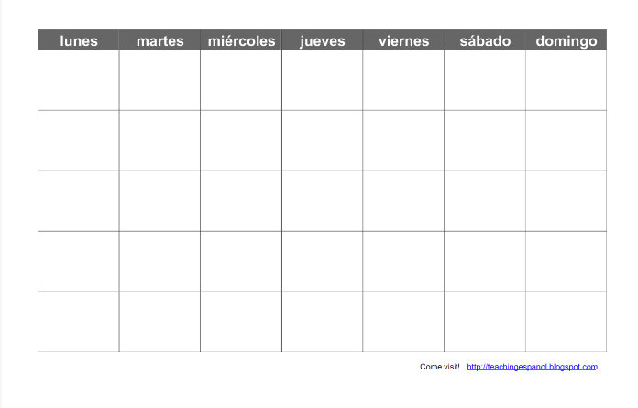\*\* PUNTO CULTURAL \*\***

Calendars in Spanish Speaking

Countries do not start on **Sunday**.

The first day of the week is **Monday**.

Additionally, the days are not

capitalized in Spanish.

**Actividad:** Write the correct days in Spanish. (si = if)

|  |  |
| --- | --- |
| **Si hoy es…** | **Mañana es…** |
| miércoles | \_\_\_\_\_\_\_\_\_\_\_\_\_\_\_\_ |
| sábado | \_\_\_\_\_\_\_\_\_\_\_\_\_\_\_\_ |
| viernes | \_\_\_\_\_\_\_\_\_\_\_\_\_\_\_\_ |
| domingo | \_\_\_\_\_\_\_\_\_\_\_\_\_\_\_\_ |

**¿Qué día es mañana?**

**Actividad:** Write the correct days in Spanish. (si = if)

|  |  |
| --- | --- |
| **Si hoy es…** | **Ayer fue…** |
| jueves | \_\_\_\_\_\_\_\_\_\_\_\_\_\_\_\_ |
| sábado | \_\_\_\_\_\_\_\_\_\_\_\_\_\_\_\_ |
| martes | \_\_\_\_\_\_\_\_\_\_\_\_\_\_\_\_ |
| domingo | \_\_\_\_\_\_\_\_\_\_\_\_\_\_\_\_ |

**¿Qué día es hoy?**

**\_\_\_\_\_\_\_\_\_\_\_\_\_\_\_\_\_\_\_\_\_\_\_\_\_\_\_\_\_\_\_\_\_\_\_\_\_\_\_\_\_\_\_\_\_\_\_\_\_\_\_\_\_\_**

***Los Meses del Año***

|  |  |  |  |
| --- | --- | --- | --- |
| ***enero*** | ***febrero*** | ***marzo*** | ***abril*** |
| ***jan*** | ***feb*** | ***march*** | ***april*** |
| ***mayo*** | ***junio*** | ***julio*** | ***agosto*** |
| ***may*** | ***june*** | ***MC900250592[1]*** | ***MC900232180[1]*** |
| ***septiembre*** | ***octubre*** | ***noviembre*** | ***diciembre*** |
| *sept* | *oct* | *nov* | *dec* |

**\*\*\*Don’t forget - the days and months are NOT capitalized in Spanish\*\*\***

|  |  |
| --- | --- |
| * ***mes*** * ***año*** * ***el último*** * ***el primero*** * ***¿Cuál es la fecha de hoy?*** | * month * year * last * first * What is today’s date? |

**¿Cuál es la fecha de hoy?**

Hoy es el \_\_\_\_\_\_\_\_\_ de \_\_\_\_\_\_\_\_\_\_\_\_\_\_\_\_\_\_\_\_\_\_\_\_.

(#) (month)

La fecha de hoy es el \_\_\_\_\_\_\_\_ de \_\_\_\_\_\_\_\_\_\_\_\_\_\_\_\_\_\_\_

(#) (month)

**\*\* PUNTO IMPORTANTE \*\***

When saying the first of the month, it is important to say

**es el primero de….**

\* July 1st - es el **primero** de julio

**ACTIVIDAD:** ¿Cuál es la fecha de hoy?

Write the date for each calendar. Be sure to use complete Spanish sentences.

|  |  |  |  |  |  |  |  |  |  |  |  |  |  |  |  |  |  |  |  |  |  |  |  |  |  |  |  |  |  |  |  |  |  |  |  |  |  |  |  |  |  |  |  |  |  |  |  |  |  |  |  |  |  |  |  |  |  |  |  |  |  |  |  |  |  |  |  |  |  |  |  |  |  |  |  |  |  |  |  |  |  |  |  |  |  |  |  |  |  |  |  |  |  |  |  |  |  |  |  |
| --- | --- | --- | --- | --- | --- | --- | --- | --- | --- | --- | --- | --- | --- | --- | --- | --- | --- | --- | --- | --- | --- | --- | --- | --- | --- | --- | --- | --- | --- | --- | --- | --- | --- | --- | --- | --- | --- | --- | --- | --- | --- | --- | --- | --- | --- | --- | --- | --- | --- | --- | --- | --- | --- | --- | --- | --- | --- | --- | --- | --- | --- | --- | --- | --- | --- | --- | --- | --- | --- | --- | --- | --- | --- | --- | --- | --- | --- | --- | --- | --- | --- | --- | --- | --- | --- | --- | --- | --- | --- | --- | --- | --- | --- | --- | --- | --- | --- | --- | --- |
| ¿Cuál es la fecha de hoy?   |  |  |  |  |  |  |  | | --- | --- | --- | --- | --- | --- | --- | | **septiembre** | | | | | | | | lunes | martes | miércoles | jueves | viernes | sábado | domingo | |  |  |  |  | **1** | **2** | **3** | | **4** | **5** | **6** | **7** | **8** | **9** | **10** | | **11** | **12** | **13** | **14** | **15** | **16** | **17** | | **18** | **19** | **20** | **21** | **22** | **23** | **24** | | **25** | **26** | **27** | **28** | **29** | **30** |  |   1. \_\_\_\_\_\_\_\_\_\_\_\_\_\_\_\_\_\_\_\_\_\_\_\_\_\_\_\_\_\_  \_\_\_\_\_\_\_\_\_\_\_\_\_\_\_\_\_\_\_\_\_\_\_\_\_\_\_\_\_\_\_\_ | ¿Cuál es la fecha de hoy?   |  |  |  |  |  |  |  | | --- | --- | --- | --- | --- | --- | --- | | **junio** | | | | | | | | lunes | martes | miércoles | jueves | viernes | sábado | domingo | |  |  |  |  | **1** | **2** | **3** | | **4** | **5** | **6** | **7** | **8** | **9** | **10** | | **11** | **12** | **13** | **14** | **15** | **16** | **17** | | **18** | **19** | **20** | **21** | **22** | **23** | **24** | | **25** | **26** | **27** | **28** | **29** | **30** |  |   2. \_\_\_\_\_\_\_\_\_\_\_\_\_\_\_\_\_\_\_\_\_\_\_\_\_\_\_\_\_\_  \_\_\_\_\_\_\_\_\_\_\_\_\_\_\_\_\_\_\_\_\_\_\_\_\_\_\_\_\_\_\_\_ |
| ¿Cuál es la fecha de hoy?   |  |  |  |  |  |  |  | | --- | --- | --- | --- | --- | --- | --- | | **febrero** | | | | | | | | lunes | martes | miércoles | jueves | viernes | sábado | domingo | |  |  |  |  | **1** | **2** | **3** | | **4** | **5** | **6** | **7** | **8** | **9** | **10** | | **11** | **12** | **13** | **14** | **15** | **16** | **17** | | **18** | **19** | **20** | **21** | **22** | **23** | **24** | | **25** | **26** | **27** | **28** |  |  |  |   3. \_\_\_\_\_\_\_\_\_\_\_\_\_\_\_\_\_\_\_\_\_\_\_\_\_\_\_\_\_\_  \_\_\_\_\_\_\_\_\_\_\_\_\_\_\_\_\_\_\_\_\_\_\_\_\_\_\_\_\_\_\_\_ | ¿Cuál es la fecha de hoy?   |  |  |  |  |  |  |  | | --- | --- | --- | --- | --- | --- | --- | | **agosto** | | | | | | | | lunes | martes | miércoles | jueves | viernes | sábado | domingo | |  |  |  |  | **1** | **2** | **3** | | **4** | **5** | **6** | **7** | **8** | **9** | **10** | | **11** | **12** | **13** | **14** | **15** | **16** | **17** | | **18** | **19** | **20** | **21** | **22** | **23** | **24** | | **25** | **26** | **27** | **28** | **29** | **30** | **31** |   4. \_\_\_\_\_\_\_\_\_\_\_\_\_\_\_\_\_\_\_\_\_\_\_\_\_\_\_\_\_\_  \_\_\_\_\_\_\_\_\_\_\_\_\_\_\_\_\_\_\_\_\_\_\_\_\_\_\_\_\_\_\_\_ |
| ¿Cuál es la fecha de hoy?   |  |  |  |  |  |  |  | | --- | --- | --- | --- | --- | --- | --- | | **noviembre** | | | | | | | | lunes | martes | miércoles | jueves | viernes | sábado | domingo | |  |  |  |  | **1** | **2** | **3** | | **4** | **5** | **6** | **7** | **8** | **9** | **10** | | **11** | **12** | **13** | **14** | **15** | **16** | **17** | | **18** | **19** | **20** | **21** | **22** | **23** | **24** | | **25** | **26** | **27** | **28** | **29** | **30** | **31** |   5. \_\_\_\_\_\_\_\_\_\_\_\_\_\_\_\_\_\_\_\_\_\_\_\_\_\_\_\_\_\_  \_\_\_\_\_\_\_\_\_\_\_\_\_\_\_\_\_\_\_\_\_\_\_\_\_\_\_\_\_\_\_\_ | ¿Cuál es la fecha de hoy?   |  |  |  |  |  |  |  | | --- | --- | --- | --- | --- | --- | --- | | **octubre** | | | | | | | | lunes | martes | miércoles | jueves | viernes | sábado | domingo | |  |  |  |  | **1** | **2** | **3** | | **4** | **5** | **6** | **7** | **8** | **9** | **10** | | **11** | **12** | **13** | **14** | **15** | **16** | **17** | | **18** | **19** | **20** | **21** | **22** | **23** | **24** | | **25** | **26** | **27** | **28** | **29** | **30** | **31** |   6. \_\_\_\_\_\_\_\_\_\_\_\_\_\_\_\_\_\_\_\_\_\_\_\_\_\_\_\_\_\_  \_\_\_\_\_\_\_\_\_\_\_\_\_\_\_\_\_\_\_\_\_\_\_\_\_\_\_\_\_\_\_\_ |

**UN POCO DE REAPSO**

1. In Spanish, are the months capitalized? \_\_\_\_\_\_\_\_\_\_\_\_\_\_\_\_\_\_
2. How do you express the first of the month? \_\_\_\_\_\_\_\_\_\_\_\_\_\_\_\_\_\_\_\_\_\_
   * Write the following in Spanish:
     + July 1st \_\_\_\_\_\_\_\_\_\_\_\_\_\_\_\_\_\_\_\_\_\_\_\_\_\_\_\_\_\_\_\_\_\_\_\_
     + October 1st \_\_\_\_\_\_\_\_\_\_\_\_\_\_\_\_\_\_\_\_\_\_\_\_\_\_\_\_\_\_\_\_\_
     + May 1st \_\_\_\_\_\_\_\_\_\_\_\_\_\_\_\_\_\_\_\_\_\_\_\_\_\_\_\_\_\_\_\_\_\_\_\_

**\*\* PUNTO CULTURAL \*\***

**In Spanish Speaking countries when writing out the date, the day is written first, and then the month.**

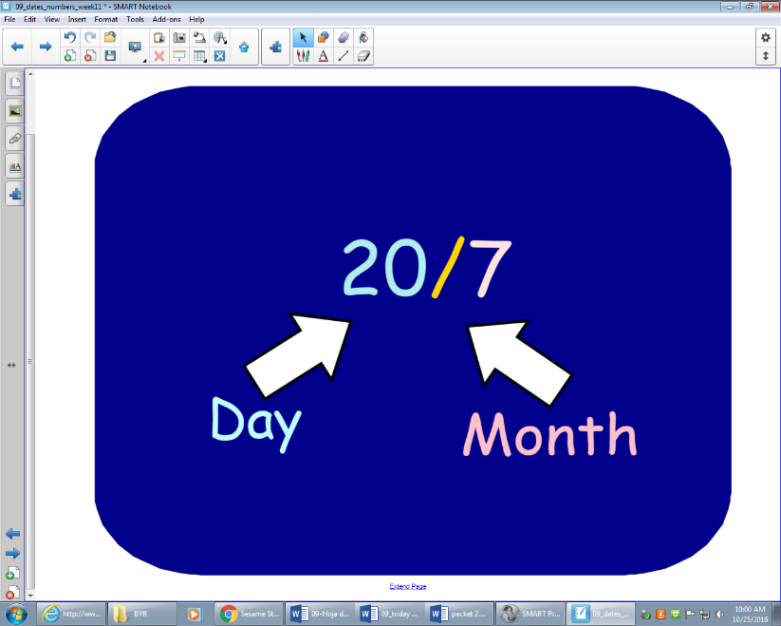

**Hoy es el veinte de julio.**

**ACTIVIDAD:** Match the dates.

1. 20/7
2. 14/1
3. 31/5

\_\_\_\_\_\_ 1. Hoy es el catorce de enero.

\_\_\_\_\_\_ 2. Hoy es el veinte de julio.

\_\_\_\_\_\_ 3. Hoy es el treinta y uno de mayo.

**ACTIVIDAD: Write the numbered date based on the sentence. Follow the example:** *Hoy es el diez y nueve de julio.* *19/7*

1. Hoy es el diez de junio. \_\_\_\_\_\_\_\_\_\_\_\_\_\_\_\_\_\_\_\_\_\_\_\_\_\_
2. Hoy es el catorce de julio. \_\_\_\_\_\_\_\_\_\_\_\_\_\_\_\_\_\_\_\_\_\_\_\_\_\_
3. Hoy es el veintidós de agosto. \_\_\_\_\_\_\_\_\_\_\_\_\_\_\_\_\_\_\_\_\_\_\_\_\_\_
4. Hoy es el quince de septiembre. \_\_\_\_\_\_\_\_\_\_\_\_\_\_\_\_\_\_\_\_\_\_\_\_\_\_
5. Hoy es el nueve de octubre. \_\_\_\_\_\_\_\_\_\_\_\_\_\_\_\_\_\_\_\_\_\_\_\_\_\_
6. Hoy es el dieciséis de noviembre. \_\_\_\_\_\_\_\_\_\_\_\_\_\_\_\_\_\_\_\_\_\_\_\_\_\_
7. Hoy es el primero de diciembre. \_\_\_\_\_\_\_\_\_\_\_\_\_\_\_\_\_\_\_\_\_\_\_\_\_\_

**Write out the date as if you were in Spain. Follow the example.**

**Example:** 19/7: *Hoy es el diez y nueve de julio.*

1. 18/1 \_\_\_\_\_\_\_\_\_\_\_\_\_\_\_\_\_\_\_\_\_\_\_\_\_\_\_\_\_\_\_\_\_\_\_\_\_\_\_\_\_\_\_\_\_\_\_\_\_\_\_\_\_\_\_\_\_\_\_\_\_\_\_\_\_\_\_\_\_\_\_\_\_\_\_\_\_\_\_\_\_\_\_\_\_\_\_\_\_\_\_\_\_\_\_\_\_\_\_\_\_\_\_\_\_\_\_\_\_\_\_\_\_\_
2. 5/2 \_\_\_\_\_\_\_\_\_\_\_\_\_\_\_\_\_\_\_\_\_\_\_\_\_\_\_\_\_\_\_\_\_\_\_\_\_\_\_\_\_\_\_\_\_\_\_\_\_\_\_\_\_\_\_\_\_\_\_\_\_\_\_\_\_\_\_\_\_\_\_\_\_\_\_\_\_\_\_\_\_\_\_\_\_\_\_\_\_\_\_\_\_\_\_\_\_\_\_\_\_\_\_\_\_\_\_\_\_\_\_\_\_\_
3. 31/3 \_\_\_\_\_\_\_\_\_\_\_\_\_\_\_\_\_\_\_\_\_\_\_\_\_\_\_\_\_\_\_\_\_\_\_\_\_\_\_\_\_\_\_\_\_\_\_\_\_\_\_\_\_\_\_\_\_\_\_\_\_\_\_\_\_\_\_\_\_\_\_\_\_\_\_\_\_\_\_\_\_\_\_\_\_\_\_\_\_\_\_\_\_\_\_\_\_\_\_\_\_\_\_\_\_\_\_\_\_\_\_\_\_\_
4. 27/4 \_\_\_\_\_\_\_\_\_\_\_\_\_\_\_\_\_\_\_\_\_\_\_\_\_\_\_\_\_\_\_\_\_\_\_\_\_\_\_\_\_\_\_\_\_\_\_\_\_\_\_\_\_\_\_\_\_\_\_\_\_\_\_\_\_\_\_\_\_\_\_\_\_\_\_\_\_\_\_\_\_\_\_\_\_\_\_\_\_\_\_\_\_\_\_\_\_\_\_\_\_\_\_\_\_\_\_\_\_\_\_\_\_\_
5. 6/5 \_\_\_\_\_\_\_\_\_\_\_\_\_\_\_\_\_\_\_\_\_\_\_\_\_\_\_\_\_\_\_\_\_\_\_\_\_\_\_\_\_\_\_\_\_\_\_\_\_\_\_\_\_\_\_\_\_\_\_\_\_\_\_\_\_\_\_\_\_\_\_\_\_\_\_\_\_\_\_\_\_\_\_\_\_\_\_\_\_\_\_\_\_\_\_\_\_\_\_\_\_\_\_\_\_\_\_\_\_\_\_\_\_\_

**¿Cuándo es tu cumpleaños?**

(When is your birthday?)

Mi cumpleaños es el \_\_\_\_\_\_\_ de \_\_\_\_\_\_\_\_\_\_\_\_\_\_\_\_.

(#) (month)

**----------------------------------------------------------------------**

**¿Cuándo es tu cumpleaños?**

\_\_\_\_\_\_\_\_\_\_\_\_\_\_\_\_\_\_\_\_\_\_\_\_\_\_\_\_\_\_\_\_\_\_\_\_\_\_\_\_\_\_\_\_\_\_\_\_\_\_\_\_\_\_\_\_\_\_\_\_\_\_\_\_\_\_\_\_\_\_

**Answer the following as though you were the following people.**

**Example**:

|  |  |  |  |  |  |  |  |  |  |  |  |  |  |  |  |  |  |  |  |  |  |  |  |  |  |  |  |  |  |  |  |  |  |  |  |  |  |  |  |  |  |  |  |  |
| --- | --- | --- | --- | --- | --- | --- | --- | --- | --- | --- | --- | --- | --- | --- | --- | --- | --- | --- | --- | --- | --- | --- | --- | --- | --- | --- | --- | --- | --- | --- | --- | --- | --- | --- | --- | --- | --- | --- | --- | --- | --- | --- | --- | --- |
| boy_ball  Ángel | |  |  |  |  |  |  |  | | --- | --- | --- | --- | --- | --- | --- | | **marzo** | | | | | | | | **1** | **2** | **3** | **4** | **5** | **6** | **7** | | **8** | **9** | **10** | **11** | **12** | **13** | **14** | | **15** | **16** | **17** | **18** | **19** | **20** | **21** | | **22** | **23** | **24** | **25** | **26** | **27** | **28** | | **29** | **30** | **31** |  |  |  |  | | **¿Cuándo es tu cumpleaños?**  *Mi cumpleaños es el trece de marzo.* |

|  |  |  |  |  |  |  |  |  |  |  |  |  |  |  |  |  |  |  |  |  |  |  |  |  |  |  |  |  |  |  |  |  |  |  |  |  |  |  |  |  |  |  |  |  |
| --- | --- | --- | --- | --- | --- | --- | --- | --- | --- | --- | --- | --- | --- | --- | --- | --- | --- | --- | --- | --- | --- | --- | --- | --- | --- | --- | --- | --- | --- | --- | --- | --- | --- | --- | --- | --- | --- | --- | --- | --- | --- | --- | --- | --- |
| schoolgirl2  Juana | |  |  |  |  |  |  |  | | --- | --- | --- | --- | --- | --- | --- | | **septiembre** | | | | | | | | **1** | **2** | **3** | **4** | **5** | **6** | **7** | | **8** | **9** | **10** | **11** | **12** | **13** | **14** | | **15** | **16** | **17** | **18** | **19** | **20** | **21** | | **22** | **23** | **24** | **25** | **26** | **27** | **28** | | **29** | **30** |  |  |  |  |  | | **¿Cuándo es tu cumpleaños?**  \_\_\_\_\_\_*\_\_\_\_\_\_\_\_\_\_\_\_\_\_\_\_\_\_\_\_\_\_\_\_\_\_\_\_\_\_\_\_\_\_\_\_\_\_\_\_\_\_\_\_\_\_\_\_\_\_\_\_\_\_\_\_* |

|  |  |  |  |  |  |  |  |  |  |  |  |  |  |  |  |  |  |  |  |  |  |  |  |  |  |  |  |  |  |  |  |  |  |  |  |  |  |  |  |  |  |  |  |  |
| --- | --- | --- | --- | --- | --- | --- | --- | --- | --- | --- | --- | --- | --- | --- | --- | --- | --- | --- | --- | --- | --- | --- | --- | --- | --- | --- | --- | --- | --- | --- | --- | --- | --- | --- | --- | --- | --- | --- | --- | --- | --- | --- | --- | --- |
| mama_cook  Marta | |  |  |  |  |  |  |  | | --- | --- | --- | --- | --- | --- | --- | | **febrero** | | | | | | | | **1** | **2** | **3** | **4** | **5** | **6** | **7** | | **8** | **9** | **10** | **11** | **12** | **13** | **14** | | **15** | **16** | **17** | **18** | **19** | **20** | **21** | | **22** | **23** | **24** | **25** | **26** | **27** | **28** | |  |  |  |  |  |  |  | | **¿Cuándo es tu cumpleaños?**  *\_\_\_\_\_\_\_\_\_\_\_\_\_\_\_\_\_\_\_\_\_\_\_\_\_\_\_\_\_\_\_\_\_\_\_\_\_\_\_\_\_\_\_\_\_\_\_\_\_\_\_\_\_\_\_\_\_\_\_\_\_\_* |

**ACTIVIDAD: ¡Leemos!** Read the following passage and answer the questions below in English. Your answers do not need to be in complete sentences. ☺



|  |
| --- |
| ¡Hola! Me llamo Luis. Hoy es jueves, el veinte y dos de abril. Mi cumpleaños es sábado el veinte y cuatro de abril. Sábado yo puedo decir: ¡yo tengo catorce años! ¡Qué chévere! ☺ |

1. What day of the week is it today according to the reading? \_\_\_\_\_\_\_\_\_\_\_\_\_\_\_\_\_\_\_\_\_\_\_\_\_\_\_\_\_\_\_\_\_\_\_\_\_\_\_\_\_\_\_\_\_\_\_\_\_\_\_\_\_\_\_\_\_\_\_\_\_\_\_
2. When is Luis’ birthday (full date)? \_\_\_\_\_\_\_\_\_\_\_\_\_\_\_\_\_\_\_\_\_\_\_\_\_\_\_\_\_
3. What day of the week does Luis’ birthday fall on? \_\_\_\_\_\_\_\_\_\_\_\_\_\_\_\_\_\_\_\_\_\_\_\_\_\_\_\_
4. How old will he be? \_\_\_\_\_\_\_\_\_\_\_\_\_\_\_\_\_\_\_\_\_\_\_\_\_\_\_\_\_\_\_\_\_\_\_\_\_\_\_\_\_\_\_\_\_\_\_\_\_\_\_

**UN POCO DE REPASO**

**Match the following English and Spanish words.**

1. lunes \_\_\_\_\_ a. Monday
2. miércoles \_\_\_\_\_ b. Tuesday
3. viernes \_\_\_\_\_ c. Wednesday
4. sábado \_\_\_\_\_ d. Thursday
5. martes \_\_\_\_\_ e. Friday
6. jueves \_\_\_\_\_ f. Saturday
7. domingo \_\_\_\_\_ g. Sunday

**Write the months of the year in Spanish. Use the word box for correct spelling.**

**marzo enero abril mayo**

**junio diciembre febrero julio**

**agosto noviembre octubre septiembre**

|  |  |  |  |
| --- | --- | --- | --- |
|  | 11. | 14. | 17. |
| jan | feb | march | april |
|  | 12. | 15. | 18. |
| may | june | MC900250592[1] | MC900232180[1] |
|  | 13. | 16. | 19. |
| sept | oct | nov | dec |

Are the days of the week or months of the year usually capitalized in SPANISH? Sí o No