Formulas

Circumference of Circle: _________________ Area of Circle: _________________________

Area of Semicircle: ______________________ Parallelogram: ______________________

Triangle: ________________________ Trapezoid: _________________________

Rectangle: _______________________ Square: ____________________________

1. The diameter of a circle is 48 centimeters. Find the radius.

2. The radius of a circle is 9 inches. Find the diameter.

3. Find the area and circumference for circles below. Use 3.14 for pi. Round your answer to the nearest tenth.

b)

a)

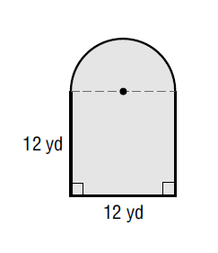

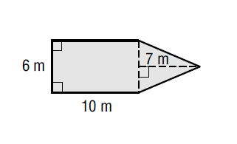4. Find the area of the Composite Figures. Use 3.14 for pi. Round answers to the nearest tenth.

5. Find the area of the shaded region. Use 3.14 for pi. Figures not drawn to scale.

6. John is making a circular table that has a top with a diameter of 24 inches. Find the circumference and area of the table. Use 3.14 for pi. Round to the nearest tenth.

7. In the backyard there is a garden with a fountain in the center. The sides of the garden are 9 yards and 21 yards. The fountain has a diameter of 3 yards. Find the area of the garden to the nearest tenth. If you were to put a fence around the garden, what is the length of fence you need rounded to the nearest tenth.

8) Draw and label the following parts of a circle:

a) center (mid point)

b) radius

c) diameter

d) chord

9) Find the circumference of a circle that has a radius of 8. Express your answer in terms of pi.

10) Find the diameter of a circle if the circumference is 47.1 inches. Use 3.14 for pi.

11) Find the radius of a circle if the area is 153.86 square inches. Use 3.14 for pi.

12) Find the area of the following:

4 in

a) b)

8.5 in

8 in

10 in

16 in

10 in

14 in