essay typing checklist

- Write a heading.
- Double space entire document (or 1.5).
- Use size 12 font. (Any style is fine but NO CAPS!)
- Do NOT title your essay!
- Make sure the title of the novel is underlined.
- Do a spell-check.
- Do a grammar check.
- Reread your essay.
- Have the computer read it to you.
- Edit your response.
- Share with a peer partner.
- Collaborate with your partner listening to his/her advice.
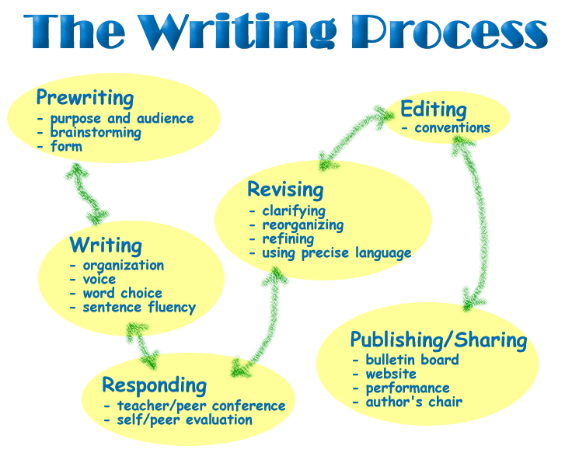
- Decide if you would like to make changes based upon his/her suggestions.
- Edit.
- Reread your response one more time.
- Share with dtrahey@commack.k12.ny.us

